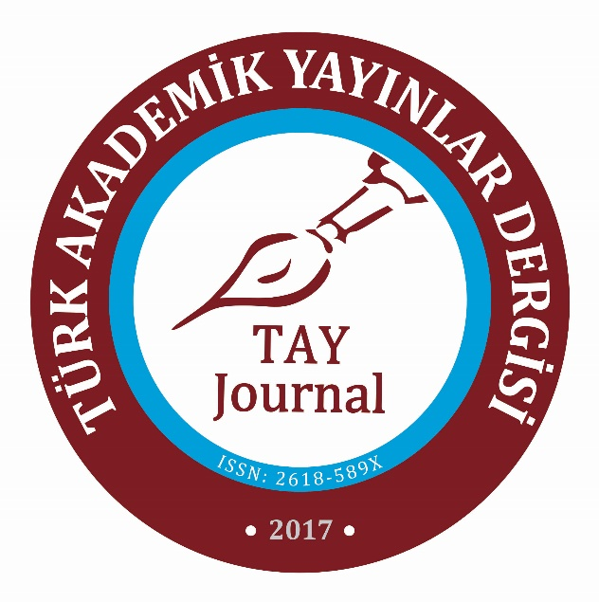
http://www.tayjournal.com
https://dergipark.org.tr/en/pub/tayjournal
Article Title (Centered, Cambria, Bold font 16, Spacing: 30 pt before / after, line spacing 12 pt)
Author1 Name Surname, Title, Corresponding Author
Affiliation, Country
E-mail
Orcid ID:
Author2 Name Surname, Title
Affiliation, Country
E-mail
Orcid ID:
(Left justified, Cambria, 12 font, Spacing: 12 pt before / after, line spacing 12pt)

Article Type: Research Article  Received Date: 01.01.2024  Accepted Date: 01.01.2024  Published Date: 01.01.2024  Plagiarism: This article has been reviewed by at least two referees and scanned via a plagiarism software  Doi: 10.29329/tayjournal.2024. | Citation: Author1 Surname, N. (2024). Article title. Türk Akademik Yayınlar Dergisi (TAY Journal), 8(1), ss-ss.

BIOGRAPHICAL NOTES
Contribution Rate of Researchers
Author 1: XX%
Author 2: XX%
(Indicate the contribution of each of the researchers to the current research as a percentage. For example, if there are two authors, the contribution rate of the 1st author to the research is 60%, and the contribution rate of the 2nd author to the research is 40%. This explanation should be deleted after the rate is written)
Support and Thanks
(In this section, acknowledgments should be given to the institution or people who supported the research. If financial support was provided from any institution or person (project, etc.) within the scope of the research, it should be stated in this section. If there is no contributor or institution, this section should be deleted.)
Conflict Statement
(If there is a material or individual organic link with the person or institution involved in the research, researchers are obliged to express this clearly. If there is no such link, it should be clearly emphasized that there is no conflict of interest in the research.)

