Research Article

Journal of Political Administrative and Local Studies
ISSN : 2636-803X E-ISSN : 2636-7823
Publisher : Sakarya University
Vol. x, No. x, xx-xx, 202x
DOI: https://doi.org/10.17550/jpal/xxxx

Cite as(APA 7): Kücük M., Duyar Akça A. (2023). The first letters in the article title should be written in lower case. Journal of Political Administrative and Local Studies, x(x), xx-xx. https://doi.org/10.17550/jpal/xxxx

This is an open Access paper distributed under the terms of Conditidions of the Creative Commons Attribution-NonCommercial 4.0 International License.

Manuscript Title, Write in Cambria 12 Point Size, with the First Letter of Each Word Capitalized

Meryem Küçük

Sakarya University, Department of Sociology, Sakarya, Türkiye, mkucuk@sakarya.edu.tr

Abstract: The abstract should express the subject briefly and concisely. The abstract must be written in English. The abstract must have a maximum word count of 250 and be written in 9 point font, Cambria font. At least 3 and at most 5 keywords should be written. The abstract should express the subject briefly and concisely. The first letters of keywords should be written in capital letters. The abstract must be written in English. The abstract must have a maximum word count of 250 and be written in 9 point font, Cambria font. At least 3 and at most 5 keywords should be written. The abstract should express the subject briefly and concisely. The first letters of keywords should be written in capital letters. The abstract must be written in English. The abstract must have a maximum word count of 250 and be written in 9 point font, Cambria font. At least 3 and at most 5 keywords should be written. The abstract should express the subject briefly and concisely. The first letters of keywords should be written in capital letters. The abstract must be written in English. The abstract must have a maximum word count of 250 and be written in 9 point font, Cambria font. At least 3 and at most 5 keywords should be written. The abstract should express the subject briefly and concisely. The first letters of keywords should be written in capital letters.
Keywords: Keyword One, Keyword Two, Keyword Three, Keyword Four, Keyword Five
Received: xx.xx.202x
Accepted: xx.xx.202x
Available Online: xx.xx.202x

1. Introduction
The article should be written in Cambria font and 11 point font.
Section headings: Only the first letter of each word in the first heading should be capitalized. The first heading should be left-aligned and written in bold.
Only the first letter of the first word in the second heading should be capitalized. All other words should be written in lowercase. The second heading should be left-aligned and written in bold.
Only the first letter of the first word in the third heading should be capitalized. All other words should be written in lowercase. The third heading should be left-aligned and written in bold.

Tables, Figures and Pictures According to APA 7 Format
The following rules must be followed for table formatting according to APA 7 format:
- Table, Figure and Image numbers should be in plain text, bold and placed above the table.
- There should not be a period at the end of the Table, Figure and Picture number.
- Table, Figure and Picture titles should be written in italics and the first letters should be in capital letters.
- All text in Tables, Figures and Pictures should be written in Cambria 10 point font.
- If the Table, Figure and Picture are not original, the source information must be stated immediately below. Source information should start from the left in line with the table, figure and picture and should be given in Cambria 10 point font.
- There should be no vertical lines in the table and as few horizontal lines as possible.
- Notes to the table should be added only if necessary.
- Notes on Tables, Figures and Pictures should be given in 10-point font with the left-aligned "Notes" heading right under the table.

Table 1
Model policies implemented |  | Model
Population exchange |  | German model
National integration |  | French model
Demographic Characteristics of Participating Students

Figure 1
Codes and Categories
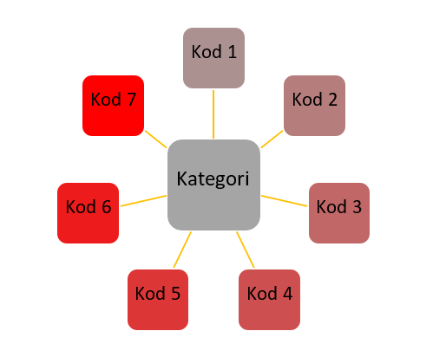
Note: Categories and codes were obtained from research findings.

References
For reference, see the sample reference format on the Writing Rules page.
References should start from a new page.
References should be written alphabetically by surname.
2nd lines in references should start 1.25 cm in.
There should be an automatic space between each bibliography by saying “Add Space After Paragraph”.

For example;
And, M., (2021). Osmanlı tasvir sanatları 1: Minyatür. Yapı Kredi Yayınları.
Arseven, C. E., (1993). Sanat ansiklopedisi. Milli Eğitim Bakanlığı Basımevi, 5, 76.
Atbaş, Z. (2003). Topkapı Sarayı Müzesi Kütüphanesi’ndeki H. 2155 numaralı murakka. [Yayınlanmamış
Yüksek Lisans Tezi, Mimar Sinan Üniversitesi]
Atbaş, Z., (2011). Dağılmış bir Safevi murakkasının, 18.yüzyıla ait bir Osmanlı murakkasında değerlendirilişi. Gelenek Kimlik bileşim: Kültürel kesişimler ve sanat, Günsel Renda’ya armağan. Z. Y. Yamanlar & S. Bağcı (Haz.). Hacettepe Üniversitesi Basımevi.
Chang, C. (2017). Methodological ıssues in advertising research: Current status, shifts, and trends. Journal of Advertising, 46(1), 2-20. https://doi.org/10.1080/00913367.2016.1274924
Cho, C. H., & Khang, H. K. (2006). The state of internet-related research in communications, marketing, and advertising: 1994-2003. Journal of Advertising, 35(3), 143-163.
https://doi.org/10.2753/JOA0091-3367350309

Article information form should be written after the References. It should not be started from a new page.
Article Information Form
Author’s Note: The author would like to express their sincere thanks to the editor and the anonymous reviewers for their helpful comments and suggestions. (If you do not want to write any notes, delete this heading.)
Author’s Approve: The article has a single author. The author has read and approved the final version of the article.
Conflict of Interest Disclosure: No potential conflict of interest was declared by the author.
Copyright Statement: The author owns the copyright of their work published in the journal and their work is published under the CC BY-NC 4.0 license.
Supporting/Supporting Organizations: No grants were received from any public, private or non-profit organizations for this research.
Ethical Approval and Participant Consent: It is declared that during the preparation process of this study, scientific and ethical principles were followed and all the studies benefited from are stated in the bibliography.
Plagiarism Statement: This article has been scanned by iThenticate.

