Arü İlahiyat Araştırmaları Dergisi
Aru Journal Of Theological Studies
Month/15/2024
Article Name
Author Name And Surname
Titr., ……… University Faculty of ……., …….. Department, City/Türkiye
e-mail: ORCID:
Article Information
Article Type: Research Article
Received Date: xx.xx.2024
Accepted Date: xx.xx.2024
Published Date: xx.xx.2024
Pub. Date Season: Haziran/June
DOI:
Plagiarism:
This article has been reviewed by at least two referees and confirmed to be free of plagiarism.
Copyright:
Authors own the copyright of the works published in the journal and their works are licensed under Creative Commons Attribution-NonCommercial 4.0.
It is published under International License (CC BY NC).
Ethics Statement:
It is declared that scientific and ethical principles were followed during the preparation of this study and that all studies used are stated in the bibliography.
Web Address:
arüilahiyataraştırmalarıdergisi.com

Aru Journal Of Theological Studies (Month 2024)
Article Name

Abstract
The article summary should be written in this field in 10-point Times New Roman font. The number of abstract words should be determined as 150-200. The first word in the Keywords section should refer to the Department of Science and should be limited to at least 3 and at most 5 words. Abstracts and other content in both Turkish and English should be justified.

Keywords: Xxxxx, Xxxxxxx, Xxxxxx, Xxxxxx, Xxxxx.

Makale Adı (Tr)
Yazar Adı Soyadı

Öz
Makale özeti, bu alana Times New Roman yazı stilinde 10 punto olacak şekilde yazılmalıdır. Özet sözcük sayısı 150-200 olarak belirlenmelidir. Anahtar Kelimeler kısmında ilk kelime Ana bilim dalını ifade etmelidir ve en az 3 en fazla 5 kelime ile sınırlı tutulmalıdır. Hem Türkçe hem de İngilizce özetler ve diğer içerikler iki yana yaslanmış olarak ayarlanmalıdır.

Anahtar Kelimeler: Xxxxx, Xxxxxxx, Xxxxxx, Xxxxxx, Xxxxx.

Introduction (All Headings Times New Roman 14 Point and Bold 1.25 Indented, Justified, Body Text, Spacing: 6nk-6nk, Line Spacing: 1.5)
Introduction section information (Times New Roman 12 point font, 1.25 per paragraph will be placed in this section.)

Paragraph Layout to Use for Text.
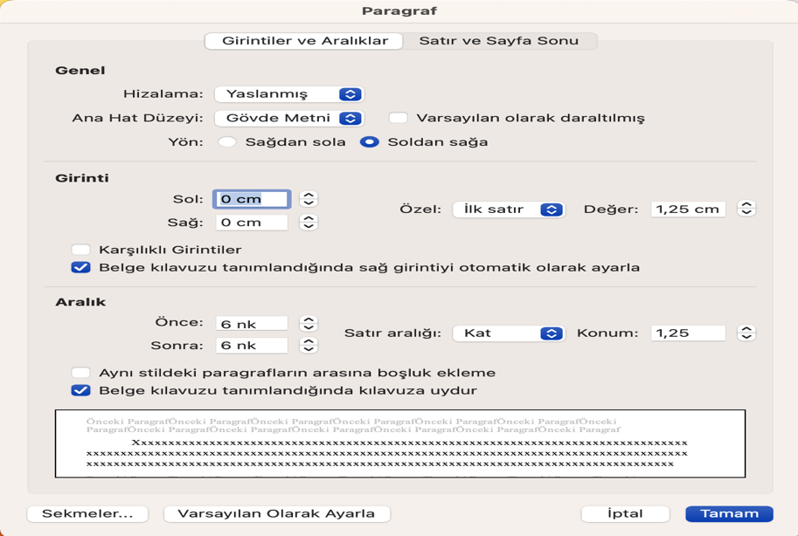
Paragraph Layout to Use for Footnotes
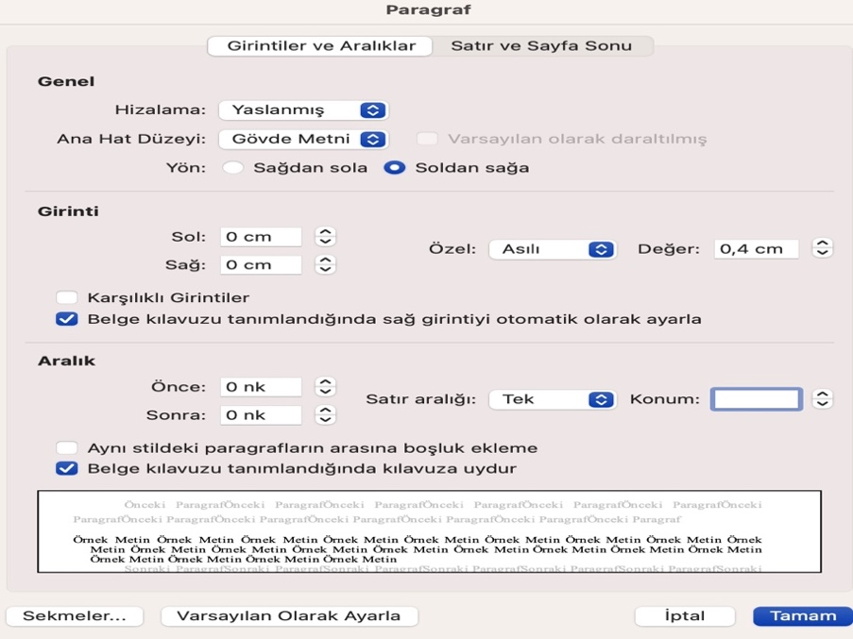

1. Subheading (The above heading rules apply.)
In-text paragraph layout information (Times New Roman 12 point font, 1.25 per paragraph will be included in this section.)

Conclusion (Above title rules apply.)
Findings and recommendations are shared in the conclusion section.

References (Above title rules apply.)
The bibliography should be prepared in 12 font size and according to the Isnad 2nd Edition. The paragraph layout of the bibliography should be set to Hanging 1.25 cm. Spacing should be 6nk-6nk, Line Spacing should be set to “Single”. The following template can be used as an example.
Ali b. el-Medînî. el-’İlel ve ma’rifetü’r-ricâl. Thk. Ebu Ömer Muhammed b. Ali el-Ezherî. Kâhire: el-Fâruku’l-Hadîse, 2005.
Arslantaş, Nuh. Emeviler Döneminde Yahudiler. İstanbul: Gökkubbe Yayınları, 2005.
Avcı, Casim. “Kûfe”. Türkiye Diyanet Vakfı İslâm Ansiklopedisi. 26: 339-342. Ankara: TDV Yayınları, 2002.
Avcı, Casim. “Medâin”. Türkiye Diyanet Vakfı İslâm Ansiklopedisi. 28: 289-291. Ankara: TDV Yayınları, 2003.
Aycan, İrfan. “Haccâc b. Yûsuf b. Matar”. Türkiye Diyanet Vakfı İslâm Ansiklopedisi. 14: 427-428. Türkiye Diyanet Vakfı Yayınları, 1996.
Aycan, İrfan. “Mus’ab b. Zübeyr”. Türkiye Diyanet Vakfı İslâm Ansiklopedisi. 31: 227. İstanbul: TDV Yayınları, 2006.
Belâzürî, Ebü’l-Hasen Ahmed b. Yahyâ. Ensâbu’l-eşrâf. Thk. Süheyl ez-Zekkâr - ve Riyâd ez-Ziriklî. Beyrut: Dâru’l-Fikr, 1996.
Belâzurî, Ebü’l-Hasen Ahmed b. Yahyâ. Fütûhu’l-büldân. Beyrut: Mektebetü’l-Hilâl, 1988.
Canan, İbrahim. “Enes b. Mâlik”. Türkiye Diyanet Vakfı İslâm Ansiklopedisi. İstanbul: Türkiye Diyanet Vakfı Yayınları, 1995.
Dârîmî, Ebu Muhammed Abdullah b. Abdirrahman. Sünen. Thk. ‘Imadu’t-Tayyâr - ve ‘Izzuddîn Dali. Beyrut: Müessesetü’r-Risâle Nâşirûn, 2017.

Halit Özkan, Memlüklerin Son Asrında Hadis (İstanbul: Klasik Yayınları, 2014), 15.

