**Title of the Article (Times New Roman, 14 Font Size, the First Letters Capitalized, Centered and Bold)**

**ARTICLE TYPE (TIMES NEW ROMAN, 9 FONT SIZE, CAPITAL LETTERS, CENTERED AND BOLD)**

**Author’s Full Name1, Author’s Full Name 2**

1 Title, institution, department, e-mail. ORCID number

2 Title, institution, department, e-mail. ORCID number

NOTE: This information about the author(s) should not be included in the anonymous file.

Submitted Date: dd.mm.yyyy Accepted Date: dd.mm.yyyy Early View Date: dd.mm.yyyy DOI: 10.37669/milliegitim.articleID

**Citation:** Surname, N., and Surname, N. (2024). Article title in sentence order. *Milli Eğitim, volume (issue),* pages X-X. DOI: 10.37669/milliegitim.articleID

***Abstract (Times New Roman, 10 font size, italic, bold, single line spacing)***

*It should not exceed two hundred and fifty words. The abstract should reflect the entire article in the shortest and most concise manner (especially the purpose, research method and results of the study). It should be one paragraph and justified. References, figures and charts should not be included in the abstract; at least three and at most eight keywords reflecting the integrity of the study should be given with one line space under the abstract. The Turkish and English abstracst should have the same features.*

***Keywords:*** *Keywords should be written in all lower case (except proper names and abbreviations with capital letters), and the concepts should be ordered from general to specific. The number of keywords should be between 3-8 and no periods should be used at the end.*

**Article Title (Times New Roman, 14 Font Size with Only The Initial Letters Capitalized, Centered and Bold)[1]**

***Abstract***

*You need to insert an English abstract into this section by taking into account exactly the same format. The abstract should not exceed the 250-word limitation.*

*Keywords: keyword 1, keyword 2, keyword 3 (keywords should not exceed 3-8 words)*

Introduction (Times New Roman, 12 font size, bold, centered)

The text should be written in Times New Roman font, 11 pt, 1.5 line spacing, 1.25 paragraph indentation and 6 pt paragraph spacing. A one-letter space should be left after punctuation marks.

The basis of the research topic, conceptual framework, summary information about the parts of the study, its equivalent in the scientific literature, its relationship with previous studies in the field, its unique and different aspects, the importance of the research, the research problem and objectives should be detailed in the introduction.

Expression should be simple, understandable, concise and short. Unnecessary repetitions, unsupported statements and explanations that are not directly related to the subject should be avoided. Very general expressions should not be used in writing. Statements containing judgment or certainty must be based on data/references.

Method (Times New Roman, 12 font size, bold, centered)

The type of research, research group, data collection tools, validity and reliability, data collection techniques, data analysis and limitations should be detailed in this section. If the article is of the review type, the method and method followed for the study should be briefly explained under the method title.

Subheading (Times New Roman, 11 font size, first letter of each word capitalized, bold, left justified)

The problem should be associated with the chosen research method. The theoretical perspective from which the problem is addressed, the research model, the basic characteristics and selection process of the study group, and the measurement tools used should be stated together with their justifications. Development, adaptation, implementation, validity and reliability stages of all data collection tools, scoring, results, etc. should be explained in detail. The methods used in data analysis should be specified. If there will be sub-headings, the headings should be given in the following title and order.

Research Model

Working Group

Data Collection

Validity and Reliability Studies

Data Analysis

Findings (Times New Roman, 12 font size, bold, centered)

The findings obtained in the study should be explained with relevant tables, figures, graphs or pictures in line with the purpose of the study and in support of the problem.

The tables in the article should be given as in the example. The table number should be bold, the table title should be written on the line below the table number, in italics and with the first letters in capital letters. The font of the table should be the same as the one used in the article and the size should be 10 points. The spacing before and after the table title should be 6 pt. The paragraph spacing within the table should be single line and 0 pt. The same format applies for figures and illustrations.

**Table 1**

*Anova Test Results of the Study Group in the Science in Daily Life Subdimension*

|  |  |  |  |  |  |  |
| --- | --- | --- | --- | --- | --- | --- |
| Source of Variance | Sum of Squares | Sd | Mean of Squares | f | P | Significant Difference |
| Between Groups | 91.386 | 3 | 30.462 | 2.395 | .069 | - |
| Within Groups | 2862.159 | 225 | 12.721 |  |  |  |
| Total | 2953.546 | 228 |  |  |  |  |

*p< .05

**Figure 1**

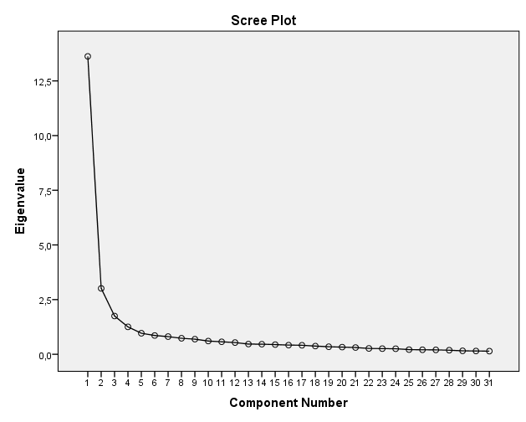*Factor Line Graph of the ACAS*

**Photograph 1**

*Some Applications from the Study*

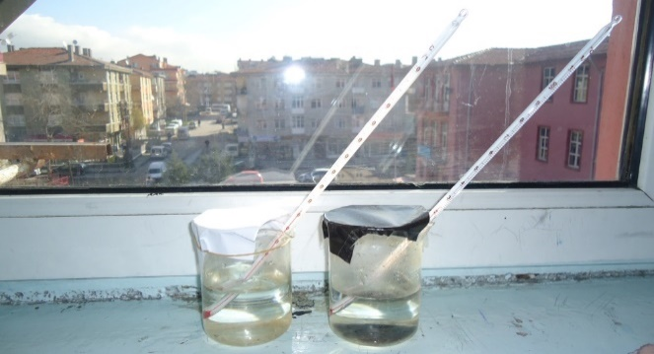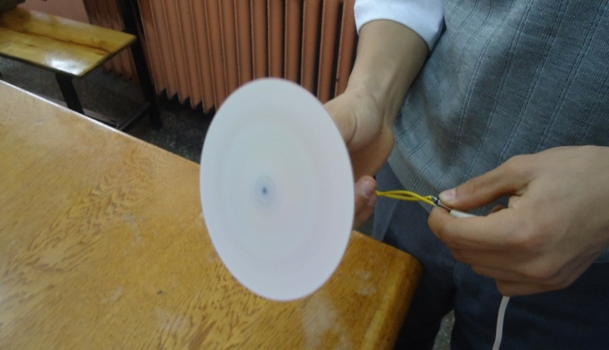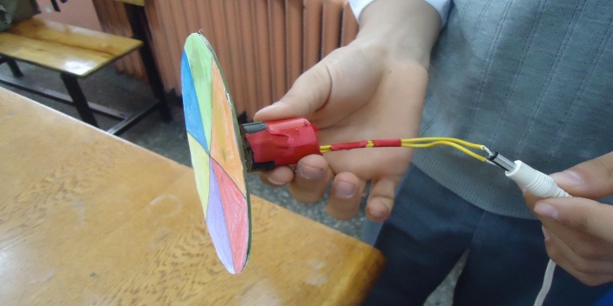

Discussion (Times New Roman, 12 pt, bold, centered)

The findings obtained in the study should be explained according to the relevant literature, taking into account the purpose, problem and hypotheses of the study and discussed with the author's comments. The data obtained in the study should be presented in a way to form an integrity. Other studies in the literature should also be compared and discussed here.

Conclusion (Times New Roman, 12 font size, bold, centered)

In this section, the ideas that emerged in the discussion section should be explained. Only the results of the data obtained should be presented.

Recommendations (12 font size, bold, centered)

Recommendations should be made based on the discussion and conclusion section. Suggestions should contribute to the literature and guide future studies and practices.

"Discussion, Conclusion and Recommendations" can be gathered under a single title or can be given separately.

**Acknowledgments: Not mandatory.**

**Author Contributions:** If articles are written by more than one author, the contribution rate of each author is stated.

**Conflict of Interest:** Authors must declare that there is no conflict of interest between the authors.

**Ethics Statement:** We declare that the rules specified in the "Directive on Scientific Research and Publication Ethics of Higher Education Institutions" were followed in this study and that we did not take any action based on "Actions Contrary to Scientific Research and Publication Ethics". We also declare that all authors contributed to the study, that there is no conflict of interest between the authors, and that all responsibility for all ethical violations belongs to the authors of the article.

**Ethics Committee Permission:** If the research requires ethical approval, information in the ethics approval document such as ethics committee name, ethics committee approval date and document number is stated.

**Funding:** If this research is funded, the name of the funder is stated. If not, the statement "This research did not receive any funding" is written.

**Data Availability Statement:** Data generated or analyzed during this study are available from the authors upon request.

**Copyrights:** The Articles published in Millî Eğitim are licensed under the Creative Commons Attribution-NonCommercial 4.0 International License.

**Use of AI for Writing Assistance:** Authors declare no use of AI for writing assistance.

Extended Summary

A broad abstract of 900-1000 words in Turkish if the language of the article is English and in English if the language of the article is Turkish. This abstract should cover all the main ideas of the article in the following order: purpose, method, findings, discussion and conclusions, and should be given as separate headings in accordance with the order given below, starting from the top of the page.

Introduction

Method

Findings

### Discussion, Conclusion, and Suggestions

References

References should be prepared in accordance with APA 7 referencing principles. Necessary explanations and examples are given in the "Publication Principles" of our journal.

* If the number of authors is two or more commas and (and) or (and) are used before the last author. The & sign is not used.

Appendices

Additional information, plans, tables, figures, graphics and pictures in the study, should be given on a new page after the bibliography. Each appendix should be titled separately (such as Appendix A., Appendix B.). Headings should be given as the main heading and information should be given in the same way as the main text.

References (SAMPLE)

Azer, H. (2017). *Bibliography of printed works in Ottoman Turkish in the archive library of the Ministry of National Education* [Unpublished master's thesis]. Kırıkkale University.

Beyatlı, Y. K. (1985). *Our own sky dome*. Ministry of National Education Publications.

Bozan, M. (2004, February 1). *Regional administration and the concept of education regions*. MoNE. http://www.yayim.meb.gov.tr

Brown, A. L., and Campione, J. C. (1996). Guided discovery in a community of learners. In K. McGilly (Ed.), *Classroom lessons: Integrating cognitive theory and classroom practice* (pp. 229-270). The MIT Press.

Cüceloğlu, D. (2010, October 29). *Being a beautiful person*. Xxxxx Newspaper. https://www.xxxxx.com/yazarlar/dogan-cuceloglu/566361-guzel-insan-olmak

Demiral, Ü., and Güneş Koç, R. S. (2023). Ideal science teaching. In B. Gülbahar and S.Y. Sıvacı (Eds.), *On ideals in education in the 100th year of the Republic* (pp 273-293). Xxx Publication.

Güneş Koç, R. S., and Sarıkaya, M. (2018, September 6-8). *Investigating the effect of context-based teaching method supported by 5E on 7th grade students' achievement regarding light subject* [Oral presentation]. I. ILTER International Learning, Teaching and Educational Research Congress, Amasya University, Amasya.

Kayacan, K. (2017). Frequently used methods in science teaching. In G. Hastürk (Ed.), *Science teaching from theory to practice* (pp 462- 493). Xxxxxx Publishing.

Maier, U., Wolf, N., and Randler, C. (2016). Effects of a computer-assisted formative assessment intervention based on multiple-tier diagnostic items and different feedback types. *Computers and Education*, 95, 85-98. https://doi.org/10.1016/j.compedu.2015.12.002

Miles, M. B., and Huberman, A. M. (1994). *Qualitative data analysis: An expanded sourcebook*. Sage Publications.

Öztürk, N., Bozkurt Altan, E., and Tan, S. (2020). Examining middle school students' evaluations of the contributions of the project "I am preparing for the future, I am looking for solutions to problems". *Milli Eğitim, 49*(225), 153-179. https://dx.doi.org/10.37669/milliegitim.644986

Rayner, A. (2005, September). *Reflections on context based science teaching: A case study of physics students for physiotherapy* [Poster presentation]. Annual UniServe Science Blended Learning Symposium Proceedings, Sydney.

Safran, M. (Ed.) (2019). *Leaders of world education* (Vol. 1-2). Ministry of National Education Publications.

TUBITAK (2020, May 18). *UBYT program and journal list*. <https://ulakbim.tubitak.gov.tr/tr/haber/tubitak-2020-ubyt-programi-ve-dergi-listesi-ilan-edildi>.

1. If this study is a thesis, a part of a project work or a paper presented at a congress, provided that it has not been published before, it should be stated in the footnote. NOTE: When this section is included in the anonymous file, the name of the paper, thesis or project will be closed as xxxx (Ex: This study was created from the author's master's thesis named xxxx).