**TIMES NEW ROMAN TITLE 14 PUNTO**

Name Surname1*C:\Users\user\AppData\Local\Microsoft\Windows\INetCache\Content.Word\indir.png, Name Surname 2C:\Users\user\AppData\Local\Microsoft\Windows\INetCache\Content.Word\indir.png

1University, Faculty, Department, City, Country.

2 University, Faculty, Department, City, Country.

*Corresponding Author: xx@xx.edu.tr

(**Received:** 00.00.2019; **Accepted:** 00.00.2019)

**ABSTRACT:** The Abstract should not exceed 250 words. The Abstract should state the principal objectives and the scope of the investigation, as well as the methodology employed. It should summarize the results and state the principal conclusions. An effective abstract stands on its own - it can be understood fully even when made available without the full paper. To this end, avoid referring to figures or the bibliography in the abstract. Please introduce any acronyms the first time you use them in the abstract (if needed), and do so again in the full paper. About 4 to 6 significant key words should follow the abstract to aid indexing.

**Keywords:** Keywords1, Keywords2, Keywords3, Keywords4.

**1. INTRODUCTION**

An Introduction should provide a review of the recent literature on the topic and sufficient background information to allow the results of the article to be understood and evaluated.

In the Introduction section, state the motivation for the work presented [1] in your paper and prepare readers for the structure of the paper. Write four components, preferably (but not necessarily) in four paragraphs: context, need, task, and objective of the article.

First, provide some context to orient those readers who are less familiar with your topic and to establish the importance of your work [2-5].

Second, state the need for your work, as a comparison between what the scientific community currently has and what it wants [6,9,11].

Third, indicate what you have done in an effort to address the need (this is the task).

Finally, preview the remainder of the paper to mentally prepare readers for its structure, in the objective of the document.

Please note that heading numeration for this chapter starts with 1.

**2. METHODS**

The Methods section details the theoretical or experimental methods used. What justifies using a given method? What is special, unexpected, or different in your approach? If you use a standard or usual procedure, mention that upfront, too (Figure 1).

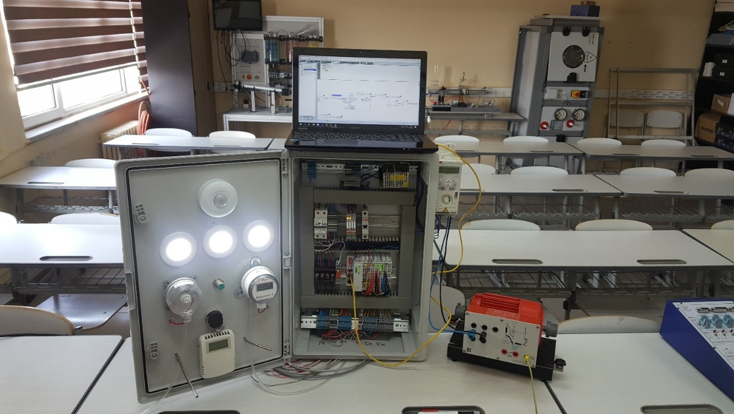

**Figure 1.** Overview of the study.

**3. EXPERIMENTAL**

The Experimental section should provide details of the experimental set-up and the methods used to obtain the results. To make this section interesting, explain the choices you made in your experimental procedure. This section should provide sufficient detail for other scientists to be able to reproduce the experiments presented in this paper. The Methods and Experimental part may be combined.

**3.1. Subtitle 1**

You may organize the body of your paper into subsections or sub-subsections; however, remember to prepare your readers for the structure ahead at all levels.

**3.1.1. Units**

The SI system of units for nomenclature, symbols and abbreviations should be followed closely. Symbols for physical quantities in the text should be written in italics (e.g. v, T, n, etc.). Vectors and matrix should be written in bold. See Eq. (2). Symbols for units that consist of letters should be in plain text (e.g. ms-1, K, min, mm, etc.).

**3.1.2. Tables**

**Table 1.** Table title

|  |  |  |
| --- | --- | --- |
| Title | Title | Title |
| a | a | a |
| b | b | b |
| c | c | c |

**3.1.3. Equations**

Equations should be numbered in consecutive numerical order with the use of brackets in the text and referred in the text as Eq. (1), Eq. (2), etc. The equation editor should be used for composing equations. In addition to the physical quantities, variables such as t should be in italics, matrixes, vectors and tensors, such as one in Eq. (2) in bold, the constants in normal text (c1) and the units (normal text) should be added in square brackets. See Table 1.

|  |  |
| --- | --- |
| $${\left(x+a\right)}^{n}=\sum_{k=0}^{n}{\left({n \atop k}\right)x^{k}a^{n-k}}$$ | (1) |
| $$T=\left[\begin{matrix}18 & 81 \\ 19 & 38\end{matrix}\right]$$ | (2) |

**4. RESULTS**

The Results section should clearly and concisely present the data, using figures and tables where appropriate. State the message of each paragraph upfront: Convey in the first sentence what you want readers to remember from the paragraph as a whole. Focus on what happened. Then develop your message in the remainder of the paragraph, including only that information (figures and tables) you think you need to convince your audience.

**5. DISCUSSION**

The Discussion section that should describe the relationships and generalizations shown by the results and discuss the significance of the results, making comparisons with previously published work. It may be appropriate to combine the Results and Discussion sections into a single section to improve clarity.

**6. CONCLUSIONS**

A Conclusions section should present one or more conclusions drawn from the results and subsequent discussion. It should state the most important outcome of your work. This should not duplicate the Abstract. You may also consider including perspectives - that is, an idea of what could or should still be done in relation to the issue addressed in the paper.

**7. ACKNOWLEDGEMENTS**

Acknowledgement (optional) of collaboration or preparation assistance may be included. Please note the source of funding for the research.

**REFERENCES**

A reference list must be included using the following information as a guide. Only cited text references are to be included. All references must be complete and accurate. Please add DOI code when available. Examples follow.

**Journal Papers:**

[1] Surname 1, Initials, Surname 2, Initials (year). Title. Journal, volume, number, pages, DOI code. Journal titles should not be abbreviated. Note that Journal Title is set in italics.

**Books:**

[2] Surname 1, Initials, Surname 2, Initials (year). Title. Publisher, place of publication. Note that the Title of the Book is italicized.

**Chapters in Books:**

[3] Surname 1, Initials, Surname 2, Initials (year). Chapter title. Editor Surname 1, Initials, Editor Surname 2, Initials (ed(s).), Book title. Publisher, place of publication, pages. Note that the Book title is italicized.

**Proceedings Papers:**

[4] Surname 1, Initials, Surname 2, Initials (year). Paper title. Proceedings title, pages. Note that the Proceedings Title is italicized.

**www pages:**

[5] Surname, Initials or Company name. Title, from http://address, date of access. Note that the www address is italicized.

**APPENDIX**

Appendix(-icies) if any. In some cases detailed information for other scientists is placed in the appendix, primarily because it is not what most readers want to know first.