**The title should be brief and expressive about the work and The first letter of each word must be capitalized.**

**Abstract**

It should be written in a single paragraph with no indentation, no references, and a limit of 200-350 words.

**Key Words:** There should be at least 2 and at most 6 in alphabetical order and should be written in sentence order

**Öz (Abstract in Turkish)**

It should be written in a single paragraph with no indentation, no references, and a limit of 250 words.

**Key Words:** There must be at least 2 and at most 6 in alphabetical order in Turkish and should be written in sentence order.

**INTRODUCTION**

The first paragraph should be left-aligned and the following paragraphs should start with a paragraph indent. There should be a 12 pt space before and after the paragraph. The aim of the study should be clearly stated in the last paragraph.

**MATERIAL AND METHODS**

In this section, the materials and methods used should be stated without going into unnecessary details. It can be divided into sections with subtitles when necessary. Subtitles should first be bold and left-aligned, then italic and at the beginning of the paragraph. Information regarding Ethics Committee approval should be stated in the "**ETHICAL STATEMENT**" section, not in this section.

**Subtitle**

***Secondary subtitle:*** Relevant information should be given in text format.

**RESULTS**

In this section, the data should be briefly described. The findings given in the tables should be avoided from repeating in the text.

**DISCUSSION AND CONCLUSION**

In this section, the obtained findings should be discussed and interpreted in line with literature information. Study results should be clearly stated.

**ACKNOWLEDGEMENT**

People and organizations who contributed to the study in various ways may be thanked in this section as needed.

**FINANCIAL SUPPORT**

This section should provide information on funding support for the research. If there is no funding source, this should be stated as "No support was received from any organization in the conduct of this research.".

**CONFLICT OF INTEREST**

This section should disclose any actual or potential conflicts of interest, including financial, advisory and corporate, that could cause potential bias or conflict of interest. If the authors do not have any conflict of interest to declare, it should be written as "There is no conflict of interest to be declared by the authors.".

**AUTHOR CONTRIBUTIONS**

In this section, the authors' contributions to the article should be stated.

**Sample:** AR, SME, KD and AA took part in the study planning and sample collection. Experimental studies were carried out by AR, MC and KD. The writing of the study and final checks were carried out with the contributions of all authors.

**ETHICAL STATEMENT**

In this section, authors should provide the name of the institution that authorized the relevant ethics committee report, as well as the serial number of the approval. Where necessary, include a sentence explaining that "informed consent" was acquired from the owner..

**REFERENCES**

1. **Surname A, Surname A, Surname A et al. (YEAR OF PUBLICATION)** **.** In studies with more than six authors, the first three names are written followed by “et al.” expression should be used. *Journal Abbreviation*, Volume Number(Issue Number):Page Numbers.
2. **Aksu H, Çolak H, Vural A, Erkan ME (1999).** Diyarbakır bölgesinde üretilen örgü peynirlerinin mikrobiyolojik ve kimyasal özellikleri üzerine bir araştırma. *Yüzüncü Yıl Univ Vet Fak Derg.*, 10(1–2):8–11.
3. **Surname A, Surname A, Surname A (YEAR OF PUBLICATION).** If the source is a book: Author(s) surname(s), first letter of name(s), year of publication, name of the work (first letter of each word capitalized), number of editions (if any), publishing house, place of publication.
4. **Tayar M, Korkmaz NH (2004).** Beslenme ve Sağlıklı Yaşam. I. baskı, Akmat Yayınevi, Bursa.
5. **Surname A (YEAR OF PUBLICATION).** If the reference is a chapter from a book: The surname(s) of the author(s) of the relevant chapter, the first letters of the name(s), the year of publication, the title of the chapter (The first letter is capital, the others are lowercase), "In" in parentheses for foreign books, For Turkish books, a preposition "içinde" meaning in, the name of the book, the initials of the editor's name, the editor's surname and the word "editor(s)" in parentheses, the publishing house, the place of publication, the page numbers of the chapter.
6. **Kaya S (2000).** Antibiyotikler. (İçinde): Veteriner Uygulamalı Farmakoloji. S Kaya S, Pirinççi I, Bilgili A (editörler). Cilt 2. Baskı 2. Medisan Yayınevi, Ankara, Türkiye., 267-420.
7. **Anderson DE (2009)**. Intestinal atresia. In: Current Veterinary Therapy: Food Animal Practice. Anderson DE, Rings DM (eds). 5th ed. Saunders Elsevier, Missouri, USA., 122-124.
8. **Yıldırım Y (2004).** Kuzey Doğu Anadolu Bölgesi’ndeki sığırlarda Mavidil (BT), IBR, PI-3, EBL ve BVD enfeksiyonlarının seroprevalansı. Doctoral Thesis. Ankara University Institute of Health Sciences, Ankara., 42-54.
9. **Köse AM, Koldaş Ürer E (2022).** Investigation of maternal blood progesterone hormone levels in middle and late pregnancy and after parturition in sheep and goats, AGRO, International Conference on Agriculture, June 04-06, Online.
10. **Wild J (2003)** Peritoneal dialysis. Access: http://www.harcourt-international.com/e-books/pdf/374.pdf. Access date: 31.03.2003.

**Table 3.** Some biochemical parameters of control and patient group animals.

|  |  |  |  |
| --- | --- | --- | --- |
| **Parameters** | **Control Group**  **(n: 10)**  **( *x̅* ± *Sx̅* )** | **Patient Group**  **(n: 30)**  **( *x̅* ± *Sx̅* )** | **p value** |
| Cathelicidin (ng/mL) | 8.25±0.53 | 10.41±3.43* | 0.013 |
| PCT (ng/mL) | 0.02 ± 0.00 | 0.04 ± 0.06* | 0.047 |
| Vitamin D (ng/mL) | 25.52 ± 6.41 | 19.26 ± 6.69* | 0.018 |
| Ca (mg/dL) | 6.22 ± 1.44 | 5.34 ± 1.39 | 0.115 |
| P (mg/dL) | 5.74 ± 0.75 | 3.77 ± 1.03*** | 0.000 |
| Mg (mg/dL) | 1.25 ± 0.18 | 1.09 ± 0.32 | 0.081 |
| ALP (IU/mL) | 98.20 ± 39.09 | 71.83 ± 50.41 | 0.103 |
| LDH (U/L) | 454.00 ± 125.30 | 683.20 ± 217.97*** | 0.000 |

*: p<0.05; ***: p<0.001

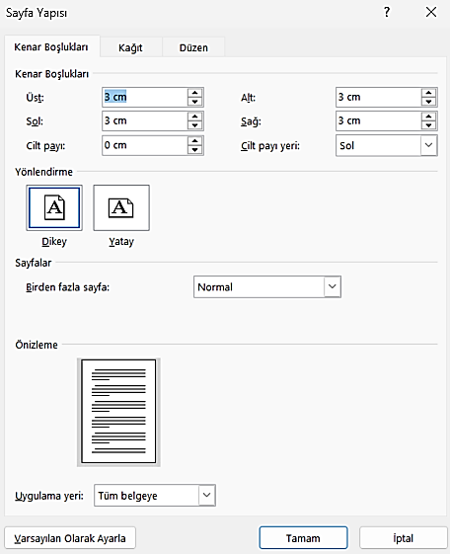

**Figure 1.** Article page structure

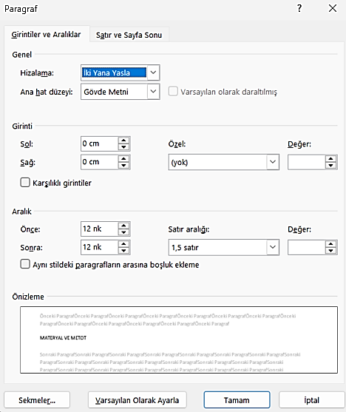

**Figure 2.** Article line spacing