Research Article

**Türkiye Ortadoğu Çalışmaları Dergisi**

**Turkish Journal of Middle Eastern Studies**

ISSN: 2147-7523 E-ISSN: 2630-5631

Publisher: Sakarya University



Vol. x, No. x, xx-xx, 202x

DOI: https://doi.org/10.26513/tocd.xxxxxx

**Cite as (APA 7):** Yılmaz, A. (202x). The first letters in the article title should be written in lower case. *Türkiye Ortadoğu Çalışmaları Dergisi, x*(x), xx-xx. https://doi.org/10.26513/tocd.xxxxxx



This is an open access paper distributed under the terms and conditions of the Creative Commons Attribution-NonCommercial 4.0 International License.

**Please Write the Article Title in English in Cambria 12 Font Size. The First Letter of Each Word Must Be Capitalized.**

**Abstract:** The abstract should be maximum **200 words** and written in **9-point Cambria** font. Research articles written in Turkish must have Turkish and English abstracts. In articles written in Turkish, an **Extended Abstract** of **600-750 words** should be written at the end of the article. At least 3 and at most 5 keywords should be written under Turkish and English abstracts. The first letters of keywords should be written in capital letters.

**Keywords:** Keyword One, Keyword Two, Keyword Three, Keyword Four, Keyword Five

Ayşe Yılmazlogo, grafik, simge, sembol, daire içeren bir resim

Açıklama otomatik olarak oluşturuldu

Sakarya Üniversitesi, Ortadoğu Enstitüsü, Sakarya, Türkiye, ayilmaz@sakarya.edu.tr, [ror.org/04ttnw109](https://ror.org/04ttnw109)



Geliş Tarihi/Received: xx.xx.202x Kabul Tarihi/Accepted: xx.xx.202x Yayımlanma Tarihi/ Available Online: xx.xx.202x

**Introduction**

The article should be written in Cambria and 11 font size.

Articles should be between 6,000-10,000 words, including notes and references. Book reviews should be between 750-1500 words.

**Section Headings:** The section headings should be written in Cambria Bold and 12 font size. Only the first letter of each word in the first heading should be capitalized. The first heading should be left-aligned and written in bold.

**Sub-section headings:** The sub-section headings should be written in Cambria Bold and 11 font size. Only the first letter of first word in the sub-section headings should be capitalized. All other words should be written in lowercase. Sub-section headings should be left-aligned and written in bold.

**Conclusion**

Tables, Figures and Pictures According to APA 7 Format

The following rules must be followed for table formatting according to APA 7 format:

* Table, Figure and Image numbers should be in plain text, bold and placed above the table.
* There should not be a period at the end of the Table, Figure and Picture number.
* Table, Figure and Picture titles should be written in italics and the first letters should be in capital letters.
* All text in Tables, Figures and Pictures should be written in Cambria 10 point font.
* If the Table, Figure and Picture are not original, the source information must be stated immediately below. Source information should start from the left in line with the table, figure and picture and should be given in Cambria 10 point font.
* There should be no vertical lines in the table and as few horizontal lines as possible.
* Notes to the table should be added only if necessary.
* Notes on Tables, Figures and Pictures should be given in 10-point font with the left-aligned "Notes" heading right under the table.

**Table 1**

|  |  |  |
| --- | --- | --- |
| Model policies implemented |  | Model |
| Population exchange |  | German model |
| National integration |  | French model |

*Demographic Characteristics of Participating Students*

**Figure 1**

*Codes and Categories*

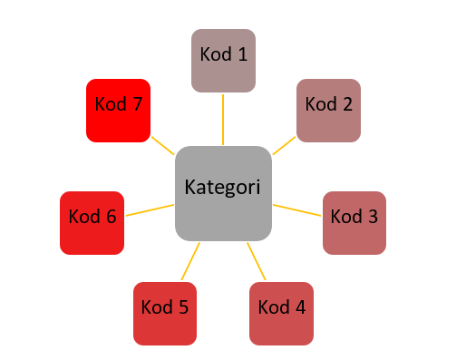

***Note:*** Categories and codes were obtained from research findings.

**References**

For reference, see the sample reference format on the **Writing Rules page**.

References should start from **a new page**.

References should be written alphabetically by **surname**.

**2nd lines** in references should start **1,15 cm** in.

There should be an automatic space between each bibliography by saying “**Add Space After Paragraph**”.

**For example;**

And, M. (2021). *Osmanlı tasvir sanatları 1: Minyatür*. Yapı Kredi Yayınları.

Arseven, C. E. (1993). *Sanat ansiklopedisi*. Milli Eğitim Bakanlığı Basımevi, 5, 76.

Atbaş, Z. (2003). *Topkapı Sarayı Müzesi Kütüphanesi’ndeki H. 2155 numaralı murakka*. [Yayınlanmamış Yüksek Lisans Tezi, Mimar Sinan Üniversitesi]

Atbaş, Z. (2011). Dağılmış bir Safevi murakkasının, 18.yüzyıla ait bir Osmanlı murakkasında değerlendirilişi. *Gelenek Kimlik bileşim: Kültürel kesişimler ve sanat, Günsel Renda’ya armağan*. Z. Y. Yamanlar & S. Bağcı (Haz.). Hacettepe Üniversitesi Basımevi.

Chang, C. (2017). Methodological issues in advertising research: Current status, shifts, and trends. *Journal of Advertising*, *46*(1), 2-20. https://doi.org/10.1080/00913367.2016.1274924

Cho, C. H., & Khang, H. K. (2006). The state of internet-related research in communications, marketing, and advertising: 1994-2003. *Journal of Advertising*, *35*(3), 143-163. https://doi.org/10.2753/JOA0091-3367350309

Article information form should be written after the References. It should **not be started** from a new page.

**Article Information Form**

**Author Note:** **(If you do not want to write any notes, delete this heading.)**

**Conflict of Interest Disclosure:** No potential conflict of interest was declared by the author.

**Artificial Intelligence Statement:** No artificial intelligence tools were used while writing this article. **(If an artificial intelligence tool was used, please write a detailed explanation.)**

**Plagiarism Statement:** This article has been scanned by iThenticate.