**Title of Paper**

**(Times New Roman, Bold, 12pt)**

**First Author1*, Second Author 2**

**(Times New Roman, Bold, 11pt)**

1 Department, Faculty, University, City, Country

2 Department, Faculty, University, City, Country

*Corresponding author e-mail:

**(Times New Roman, 10pt)**

Author 1 ORCID:

Author 2 ORCID:

**(Times New Roman, 10pt)**

**ABSTRACT**

Type your Abstract text here. The font of this single paragraph is Times New Roman 11 pt. Please provide an abstract of 150 to 250 words. The abstract should not contain any undefined abbreviations or unspecified references

Please provide 3 to 5 keywords which can be used for indexing purposes

**KEYWORDS:** Keyword 1, Keyword 2, Keyword 3, Keyword 4, Keyword 5

**1. Introduction**

Manuscripts should be organized as follows: Title page, abstract, keywords, introduction, material-method, results, discussion, conclusion and references. The section titles must be written with bold capital letters at 12 pt font. Units of measurements should all be SI units.

Mediterranean Fisheries and Aquaculture Research, Mediterranean Fisheries and Aquaculture Research Mediterranean Fisheries and Aquaculture Research, Mediterranean Fisheries and Aquaculture Research (Lawrence, 1990; Samuel and Richardson, 2013; Rickshaw et al., 2017)

Samuel and Richardson (2013) Mediterranean Fisheries and Aquaculture Research, Mediterranean Fisheries and Aquaculture Research Mediterranean Fisheries and Aquaculture Research, Mediterranean Fisheries and Aquaculture Research

Rickshaw et al. (2017) Mediterranean Fisheries and Aquaculture Research, Mediterranean Fisheries and Aquaculture Research Mediterranean Fisheries and Aquaculture Research, Mediterranean Fisheries and Aquaculture Research

**2. Material and Methods**

**2.1. Subtitle 1**

These should be referred to in the text as figures using Arabic numbers, e.g. Figure 1, Figure 2, etc., in order of appearance. All tables and figures should not exceed 16x20 cm in size. Figures should be saved in data formats in JPEG or TIFF or PNG and have high resolution with maximum 300 dpi. MSOffice files are also acceptable (Figure 1).

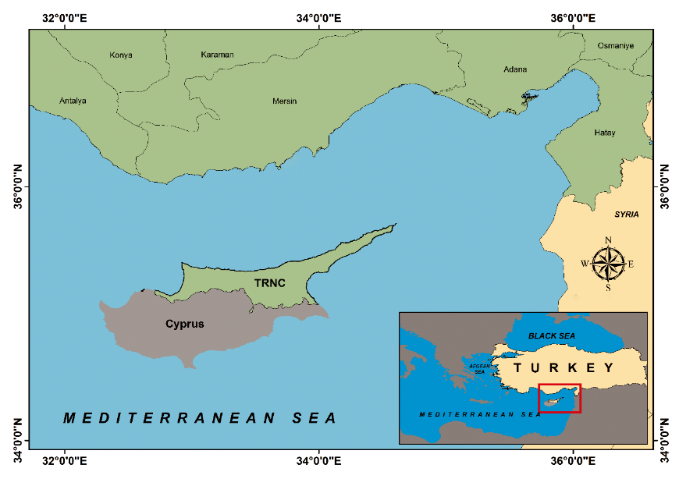

**Figure 1.** Study area

**2.2. Subtitle 2**

Mediterranean Fisheries and Aquaculture Research, Mediterranean Fisheries and Aquaculture Research Mediterranean Fisheries and Aquaculture Research, Mediterranean Fisheries and Aquaculture Research

**3. Results / Result and Discussion**

Tables should be self-explanatory and include only essential data. Each table must be type written on a separate sheet and should be numbered consecutively with Arabic numerals, e.g. Table 1, and given a short caption. The font of the table must be Times New Roman with 10-12 pt.

No vertical rules should be used. Units should appear in parentheses in the column headings and not in the body of the table. All abbreviations should be defined in a footnote (Table 1).

**Table 1.** Growth rate, survival rate, ………..

|  |  |  |  |  |
| --- | --- | --- | --- | --- |
| **Treatment** | **IW (g)** | **FW (g)** | **WG (g)** | **SGR (%)** |
| T₁ | 12.73 ± 0.01 | 38.59 ± 0.95a | 25.87 ± 0.95a | 1.85 ± 0.04a |
| T₂ | 11.07 ± 0.01 | 24.33 ± 0.53b | 13.26 ± 0.53b | 1.31 ± 0.04b |
| T₃ | 12.70 ± 0.01 | 17.26 ± 0.52c | 4.56 ± 0.51c | 0.51 ± 0.05c |

IW: initial weight; FW: final weight; WG: weight gain; SGR: specific growth rate;

Line drawings should be on separate sheets of white paper in black indelible ink (dot matrix illustrations are not permitted); lettering should be on an overlay or photocopy and should be no less than 4 mm high for a 50% reduction. Please note, each figure should have a separate legend; these should be grouped on a separate page at the end of the manuscript. All symbols and abbreviations should be clearly explained.

All tables and figures that are reproduced from a previously published source must be accompanied by a letter of permission from the Publisher or copyright owner if necessary.

**4. Discussion**

Mediterranean Fisheries and Aquaculture Research, Mediterranean Fisheries and Aquaculture Research Mediterranean Fisheries and Aquaculture Research, Mediterranean Fisheries and Aquaculture Research

**5. Conclusion**

Mediterranean Fisheries and Aquaculture Research, Mediterranean Fisheries and Aquaculture Research Mediterranean Fisheries and Aquaculture Research, Mediterranean Fisheries and Aquaculture Research

**Compliance with Ethical Standards**

**Conflict of interest**

The authors declared that for this research article, they have no actual, potential or perceived conflict of interest.

**Author contribution**

The contribution of the authors to the present study is equal.

All the authors read and approved the final manuscript. All the authors verify that the Text, Figures, and Tables are original and that they have not been published before.

**Ethical approval**

Ethics committee approval is not required.

**Funding**

No financial support was received for this study.

**Data availability**

Not applicable.

**Consent for publication**

Not applicable.

**Acknowledgements**

Authors are thankful to

**References**

References to be given in the references section should be listed in "6th Edition of APA Citation" according to following rules;

*Article published in journals:*

Moncada, S., Palmer, R.M.J., Higgs, E.A. (1989) Biosynthesis of nitric oxide from L-arginine: A pathway for the regulation of cell function and communication. Biochemistry and Pharmacology 38: 1709 -1715.

*Books:*

Strunk, W., White, E.B. (2000) The Elements of Style, fourth ed. Longman, New York.

*Chapter in an edited book:*

Mettam, G.R., Adams, L.B. (2009) How to prepare an electronic version of your article, in: Jones, B.S., Smith, R.Z. (Eds.), Introduction to the Electronic Age. E-Publishing Inc., New York, pp. 281–304.

*Conference proceedings:*

Glare, T.R., Barlow, N.D., Walsh, P.J. (1998) Potential agents for eradication or control of gypsy moth in New Zealand. In: Proceeddings of the 51 st New Zealand Plant Protection Conference. New Zealand Plant Protection Society, pp. 224-229.