Title of paper in English

(14 points-6pt space after-All except the first letter should be written in lower case)
First Author ^{1,*} , Second Author ² , Third Author ³ (12 points-6pt space after)
¹ Niğde Ömer Halisdemir University, Computer Engineering Department, 51240, Niğde Türkiye (8 points)
^{2,3} Niğde Ömer Halisdemir University, Mechanical Engineering Department, 51240, Niğde, Türkiye (8 points)
,

In the evaluation version created, all fields marked red in the article template should be removed. Any other statements indicating the identities of the authors should also be removed.
Abstract (10 points)
Abstract should briefly contain the purpose of the study, important findings and results, not exceeding 250 words. Abstract should contain integrity. References should be not given in abstract. If abbreviation will be given in the abstract, it should be defined at its first pass, and then this abbreviation should be used in the article. Abstract should be written in the related table cell. Abstract should be in a single paragraph and shouldn’t overflow to second page. In the abstract, 10 point Times New Roman as font should be used (10 points after 6pt space). Minimum 3 maximum 5 keywords should be defined right after abstract (10 points 6pt space after).
Keywords: Article template, Article, Template, Key, Word

Introduction (10 points – 3pt space after)
The article should include main titles such as Abstract, Introduction, Material and methods, Results and discussion, Conclusions and References.
The main texts of the introduction and other sections should be prepared in 10 points Times New Roman font. The beginning of the paragraph should be started with 0.50 cm indent. Line spacing or paragraph spacing should not be used between paragraphs.
Introduction section is the section where basic information about the study is given, the purpose and importance of the study are explained, the studies in the literature are presented and the results expected to be obtained as a result of the study are expressed. Subheadings should not be used in the introduction. The introduction part can be kept as long as desired. Figures and tables can be used in the introduction to facilitate the explanation. The writing rules for figures and tables are given in detail under the headings of figures and tables.
Introduction section should be supported by literature studies. References to be used in introduction and other sections should be cited sequentially with the numbered spellings as; … [1],… [1, 2, 5],… [1, 2, 4-6],… [3-9] etc. If information will be given about a work done by someone else or others in the introduction and other sections, the references should be cited as; Altun [8]…, Kimour and Meslati [7]…, Nelson et al. [1]…, and the reference numbers should be in blue.
Abbreviations used in the introduction and other sections should be given in parentheses right after the long spelling where they are first used, and these abbreviations should always be used in subsequent uses (10 points).

Material and methods (10 points-6pt space before and 3pt space after)
The materials used in the study and the preferred method should be presented clearly in this section according to the purpose stated in the introduction. Sufficient information should be given to repeat the study. This section can also be presented as subtitles if desired (10 points).

Page layout (10 points-6pt space before and 3pt space after)
Using the template of this document while preparing an article will facilitate to comply with the journal writing format. The page layout of the article should be according to the rules stated below (10 points).

Page basic layout (10 points-6pt space before and 3pt space after)
The article pages prepared must be in A4 (210 x 297 mm) paper size. There should be 1.5 cm margins on the left and right of the page, 3 cm at the top and 2.5 cm at the bottom. Except for the article title section and figures and tables covering both columns, the main text of the article should consist of two columns of 8.5 cm width. There should be 1 cm space between the two columns.

Author and author information (10 points-6pt space before and 3pt space after)
Only the first letters of all names and surnames of the authors should be written in capital, 12 points and bold. 6pt space should be left after the names of the authors. Author order should be given with superscript and this order should be observed in ORCID numbers at the footer and in the affiliation line. The affiliation information of the authors should be written in the order of the authors, with each author's affiliation on a line. The information in the address field should be numbered with superscript and written in 8 points italic font. All necessary information about the authors should be written in the relevant table and the borders of the table should be removed. Corresponding author should be marked with a * superscript, and the e-mail information of the author should be given in the footer at the bottom of the first page. The author's name and surname after the e-mail address should be given in parentheses as shown (10 points).

Headers (10 points-6pt space before and 3pt space after)
The main heading of the article should be written in 14 points and centred. 6 points space should be left after the article title. Of the letters in the title, only the first letter must be capital, all others must be in lowercase. The font color of the article title should be chosen at 50% dark according to the font color.
Times New Roman font should be used in headings. First level section titles should be bold, left aligned and 10 points. Among the letters in the titles, only the first letter should be capital, all other letters should be written in lower case. Second (2.1, 2.2, 3.1 etc.), third (2.1.1, 2.2.2, 3.1.2 etc.) and fourth (2.1.1.1, 2.2.2.1, 3.1.2.3 etc.) level subtitles should be written italic 10 points font size and left aligned. Subheadings should not exceed the fourth level. Avoid using abbreviations in the article title and other titles (10 points).

Font (10 points-6pt space before and 3pt space after)
In the main text of the article, 10 point “Times New Roman” font should be used in the form of plain and justified text. Bold or italic fonts can be used for emphasis (10 points).

Results and discussions (10 points-6pt space before and 3pt space after)
In this section, the findings obtained as a result of the study should be presented clearly. Figures and tables can be used to present the results clearly. Concerning the results obtained, the importance of the results rather than the raw results should be emphasized and interpreted with the support of the literature. This part can be presented as subtitles if desired (10 points).

Equations (10 points-6pt space before and 3pt space after)
Each equation should be written on a separate line. Equations should be numbered. The equations should be given in a 1x2 table and then the borders of the table should be hidden. The equation cell width in the table must be 90%, and the equation number cell width must be 10%. The formula in the equation cell must be left-aligned and the equation number must be right-aligned. The left and right edges of the cells in the table must be zeroed. One-line space should be left before and after the equation. Equation editors of MS-Word® 2007 and later versions or MathType can be used to write equations. Equations should be cited in the text and the equation text and number (for example, Equation (1)) should be blue.

$$y=mx+n$$ | (1)

(2)

If the equation does not fit on a single line, it can be given in more than one line. If necessary, equations can be given in the main text. However, the equation written in the text should be written on a single line.
Care should be taken to keep the numbers and units given in the main text on the same line. Point should be used as the decimal separator in numbers (eg 0.51, 5.51 etc.). Thousands digits can be without spaces or with spaces (1000000 or 1 000 000) (10 points).

Figures (10 points-6pt space before and 3pt space after)
Figures in one column should be centred according to column, figures in two columns should be centred according to page. The titles of the figures should be centred under each figure. It should be in the layouts shown in Figures 1, 2 and 3 and 3pt space should be left before it. Figures in a single column should be given in a 2x1 table with hidden borders as seen in Figure 2. One-line space should be left before and after the figure except at the beginning and end of the page. The figure should be referred to in the main text and the figure text and its number in the text (for example, as seen in Figure 1) should be shown as blue color. If the figures are to be presented in both columns as in Figures 1 and 3, they should be given at the top or the bottom of the page

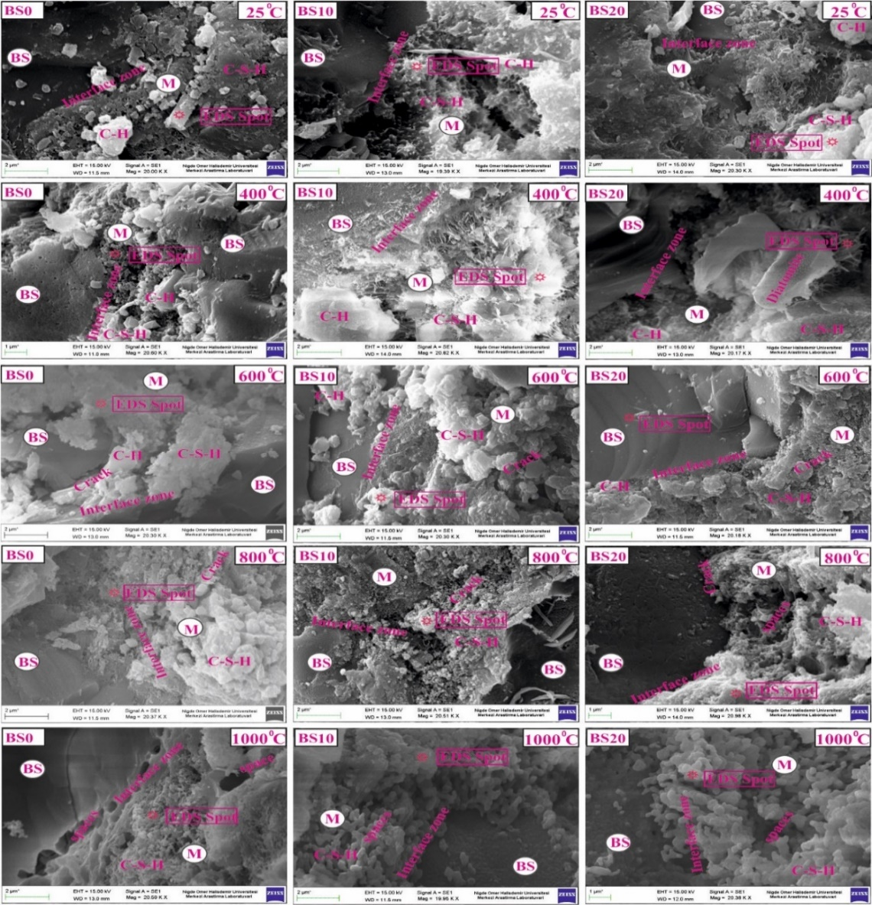
Figure 1. Two column figure at the top of the page (10 points- 3 pt space before)

Figure 2. One column figure (10 points-3 pt space before)

Figures given as pictures should be at least 300 dpi resolution and should be clearly visible. Text in the figure should be clear and legible. The size of the text in the figure should not exceed the text font size. "Times New Roman" font should be used with 8 points font in editable figures. Point should be used as decimal separator in numbers in figures. Reference must be given for quotation or rearranged figures (10 points).

Tables (10 points-6pt space before and 3pt space after)
Tables in one column should be centred according to column, tables in two columns should be centred according to page. Table examples are given in Table 1 and Table 2. Different types of tables can be given according to the purpose of use. Table titles should be at the top of each table and begin with the table line. One blank line should be left before and after the table, except at the beginning and end of the page. 3 pt space should be left after the table title. Any abbreviation to be used in the table can be explained in 8-point font as shown in Table 1 under the table.

Table 1. A table example (10 points 3 pt space after)
1st Column | 2nd Column | 3rd Column
AC* | 0.05 | 10 000
AB | 0.20 | 100 000
BB | 2.80 | 2.5x10⁻⁵
BC | 1000 | 3x10⁴
AC: Alternative Current

(a) | (b)
Figure. 3. Two column figure at the bottom (a) pressure strength and (b) bending strength (10 points- 3pt space before)
Table 2. Two column width table (10 points- 3pt space after)
1st Column | 2nd Column | 3rd Column | 4th Column | 5th Column | 6th Column | 7th Column | 8th Column
A | A | X | X | X | X | X | X
B | B | Y | Y | Y | Y | Y | Y
C | C | Z | Z | Z | Z | Z | Z

If the table covers both columns, it should be given at the top or at the bottom of the page (See Table 2). The spellings in the table should be 8 point "Times New Roman" font. If necessary, the size of the text in the table can be 7 points. Equation editors of MS-Word® 2007 and later versions and MathType should be preferred in writing the equations in the table. The table should be referred to in the main text, and the table text and number in the text (for example, as seen in Table 2) should be shown as be blue color.
If more than one equation, figure or table is to be cited in the same place, “,” and “-” punctuation marks can be used. Here "," means "and", "-" means "range". Each equation, figure and table used in the article should be referred before its place in the main text (10 points).
Hyperlinks (10 points-6pt space before and 3pt space after)
Hyperlinks can be used in the article. The writing style of the hyperlinks should be the same as the text and should be underlined.

Page numbers (10 points-6pt space before and 3pt space after)
Page numbers can be given to the article. Page numbers should be on the right of the page and 1.5 cm above the bottom. Page numbers will be rearranged during the layout process. Title or author names should not be used in the header and footer of the articles.

Other writing rules (10 points-6pt space before and 3pt space after)
The number and % sign must be written adjacent to each other. In texts the percent (%) sign should be after the number (51%).
Abbreviations in the main text of the article should be given in parentheses after being written long in the first place, and only the abbreviation should be used in the following text.
Figures, tables and titles should be in the same column and page. In other words, figures and tables should not be split up.

Conclusions (10 points-6pt space before and 3pt space after)
In the results, important information obtained from the study should be given briefly and the effect of the main results of the study should be clearly expressed (10 points).
You can access the article template from the Article Template link on the Eurasian Journal of Science Engineering and Technology web page (https://dergipark.org.tr/en/pub/ejset/writing-rules).

Acknowledgement (10 points-6pt space before and 3pt space after)
In the articles accepted for publication after the evaluation, if any, the institution, project, person, etc. information should be specified in this section.

Conflict of interest (10 points-6pt space before and 3pt space after)
The authors declare that there is no conflict of interest.

Similarity rate (iThenticate): ....%
The similarity rate of the article should be declared here.

References (10 points-6pt space before and 3pt space after)
Citations given in the text should be given in brackets in order. The references should be listed at the end of the article in order in the text. If more than one publication is to be cited in the text, "," should be used for "and" and "-" for "all publications between". For example, the spelling as [1] refers to the first reference, the spelling as [1, 2, 5] refers to the publications numbered 1, 2 and 5, the spellings as [1, 2, 4-6] refers to the publications numbered 1, 2, 4, 5 and 6, the spelling as [3-9] refers to all publications between 3 and 9, including 3 and 9.
If information about a work done by someone else or others in the text is to be given, the references are expressed as Altun [8]…, Kimour and Meslati [7]…, Nelson et al. [1], (reference numbers must be in blue).
References section should be prepared according to the following examples. For detail; IEEE citation format document should be considered (see. IEEE Citation Guideline). References should be listed in this section according to the citation order given in the text. References should be styled and punctuated according to the following examples.

Journal references
- M. Korkanç, “Deterioration of different stones used in historical buildings within Nigde province, Cappadocia,” Construction and Building Materials, vol. 48, pp. 789-803, 2013. https://doi.org/10.1016/j.conbuildmat .2013.07.033.
- M. Sarıdemir and S. Çelikten, “Investigation of fire and chemical effects on the properties of alkali-activated lightweight concretes produced with basaltic pumice aggregate,” Construction and Building Materials, vol. 260, pp. 1-16, 2020, Art no. 119969. https://doi.org/10.1016/ j.conbuildmat.2020.11996.
- T. Bakharev, J. G. Sanjayan and Y. B. Cheng, “Resistance of alkali-activated slag concrete to acid attack,” Cement and Concrete Research, vol. 33, no. 10, pp. 1607–1611, 2003. https://doi.org/10.1016/S0008-8846(03)00125-X.
- N. P. Mansuroğlu, E. Yazıcı, S. Önder and A. C. Karaça, “Encapsulation of black pepper seed oil in maltodextrin-chickpea protein ısolate matrix with spray drying method,” Nigde Omer Halisdemir University Journal of Engineering Sciences, vol. 9, no 2, pp. 877-882, 2020. https://doi.org/10.28948/ngumuh.649969.

Proceedings/Symposium references
- D. Caratelli, M. C. Viganó, G. Toso, and P. Angeletti, “Analytical placement technique for sparse arrays,” presented at the 32nd ESA Antenna Workshop, Noordwijk, The Netherlands, Oct. 5–8, 2010.
- D. Sarkar and K. V. Srivastava, “SRR-loaded antipodal Vivaldi antenna for UWB applications with tunable notch function,” in Proc. Int. Symp. Electromagn. Theory, Hiroshima, Japan, 2013, pp. 466–469.

Book references
- B. Klaus and P. Horn, Robot Vision. Cambridge, MA, USA: MIT Press, 1986.

Book chapter references
- T. Ogura, “Electronic government and surveillance-oriented society,” in Theorizing Surveillance: The Panopticon and Beyond. Cullompton, U.K.: Willan, 2006, ch. 13, pp. 270–295.
- C. Bennett, “What happens when you book an airline ticket? The collection and processing of passenger data post-9/11,” in Global Surveillance and Policing: Borders, Security, Identity, E. Zureik and M. Salter, Eds., Cullompton, U.K.: Willan, 2005, pp. 113–138.
- A. Taflove, Computational Electrodynamics: The Finite-Difference Time-Domain Method in Computational Electrodynamics II, vol. 3, 2nd ed. Norwood, MA, USA: Artech House, 1996.

Thesis/Dissertation references
- N. Kawasaki, “Parametric study of thermal and chemical nonequilibrium nozzle flow,” M.S. thesis, Dept. Electron. Eng., Osaka Univ., Osaka, Japan, 1993.
- F. Jensen, “Electromagnetic near-field far-field correlations,” Ph.D. dissertation, Dept. Elect. Eng., Tech. Univ. Denmark, Lyngby, Denmark, 1970. [Online]. Available: www.tud.ed/jensen/diss
- D. Schwartz, “Development of a computationally efficient full human body finite element model,” M.S. thesis, Virginia Tech – Wake Forest Univ. School of Biomed. Eng. Sci., Winston-Salem, NC, USA, 2015. [Online]. Available: https://wakespace.lib.wfu.edu/bitstream/handle/10339/57119/Schwartz_wfu_0248M_10697.pdf

Standards/Code references
- Methods of testing cement - Part 1: Determination of strength, TS EN 196 -1, Turkish Standard Institute, Ankara, Turkey, 2016.
- Frequency Response and Bias, NERC Reliability Standard BAL-003-0.1b, May 2009. [Online]. Available: http://www.nerc.com/files/BAL-003-0_1b.pdf

Internet references
- Cancer Research UK, Cancer statistics reports for the UK. http://www.cancerresearchuk.org/aboutcancer/ statistics/cancerstatsreport/, Accessed 13 March 2003.

Project references
- M. Sarıdemir, Uçucu Kül İçeren Beton Özelliklerinin Gen İfadeli Programlama ile Belirlenmesi. Niğde Üniversitesi Bilimsel Araştırma Projeleri Birimi, FEB 2011/21, 2012.
- O. Karahan ve C. D. Atiş, Alkali ve Isı ile Aktifleştirilen Yüksek Dayanımlı F Sınıfı Uçucu Kül Geopolimer Harçların Durabilitesi. TÜBİTAK, 115M171, 2016.

Technical report references
- E. E. Reber, R. L. Michell, and C. J. Carter, “Oxygen absorption in the Earth’s atmosphere,” Aerospace Corp., Los Angeles, CA, USA,Tech. Rep. TR-0200 (4230-46)-3, Nov. 1988.

Patent references
- K. Kimura and A. Lipeles, “Fuzzy Controller Component,” U. S. Patent 14, 860,040, 14 December 2006.

Appendix
The use of appendix is optional. Appendix should be given after the references. Appendix can start on a new page.

