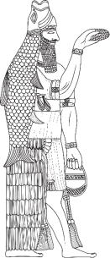 | OANNES  International Journal of Ancient History  e-ISSN: 2667-7059

AUTHOR INFORMATION PAGE
ARTICLE TITLE:

Author 1:
Name:
Surname:
Title:
Institution:
e-mail:
Orcid ID:
Level of contribution to the article:
Does this person is Corresponding author?
Author 2:
Name:
Surname:
Title:
Institution:
e-mail:
Orcid ID:
Level of contribution to the article:
Does this person is Corresponding author?
Author 3:
Name:
Surname:
Title:
Institution:
e-mail:
Orcid ID:
Level of contribution to the article:
Does this person is Corresponding author?

