

e-ISSN: 2792-0178

Makalenin Türü / Article Type : Araştırma Makalesi/ Research Article

Geliş Tarihi / Date Received :

Kabul Tarihi / Date Accepted :

Yayın Tarihi / Date Published :

DOI : <https://doi.org/10.51576/ymd.1234567>

e-ISSN : 2792-0178

İntihal/Plagiarism: Bu makale, en az iki hakem tarafından incelenmiş ve intihal içermediği teyit edilmiştir. / This article has been reviewed by at least two referees and confirmed to include no plagiarism.

**Most Important Note**

Dear authors, we all know that! Academic progress in the music community is just starting to get back on track. Again, we know that! For the academic advancement of all of you, there is a great need for journals indexed in certain directories, and our numbers are still very small. For this reason, you rightly want to rise academically as soon as possible. However, from now on, as a result of TRDizin warning us, if you have sent an article to our journal "***either individually or with more than one author" this year,*** do not send this article to this issue. Because your article will be returned immediately without any questions. In addition, in this guide, it is recommended that you proceed by reading the articles and making them suitable for the guide with the pasting method. Otherwise, your article will be returned to you without being subject to academic review. Thank you very much in advance for your understanding.

**1- TITLES and ABSTRACT**

Except for your footnotes, only "Times New Roman" font should be used in the article.

**THE TITLE WILL CONSIST OF BOLD 14 POINTS AND CAPITAL LETTERS**

SURNAME, First Name[1]

**ABSTRACT (should be bold and 12 points)**

Between 150-250 abstracts should be written in this section. It should be written in right-left justified font size 12 and 1.5 line spacing.

**Keywords:** At least five keywords should be shown, with a comma between each of them. Words other than proper nouns should be written in lowercase.

**THE ENGLISH TITLE SHOULD BE WRITTEN JUST LIKE TURKISH. THE LETTER "I" MUST BE USED IN ENGLISH WORDS THAT CORRESPOND TO THE LETTER I WITH ONLY ONE DIFFERENCE. HOWEVER, THE LETTER "I" CAN BE USED IN NON-ENGLISH WORDS**

**ABSTRACT (the abstract should be written in bold with 12 points as in Turkish).**

The English abstract may not be a complete one-to-one translation, so tolerances around 150-250 (+ - 10) words can be shown.

**Keywords:** It should be written adjacent as here and at least five references should be cited here.

**2- INTRODUCTION**

**INTRODUCTION (14 pt, capital letters and bold)**

INTRODUCTION It will be written in 14 pt bold, simplicity should be preferred in the title and subheadings as seen in the following headings, as in theses, numbers or colons will never be placed on top of each other.

All the following articles should be given as subheadings in the introduction, in bold, 12 font size, Time News Roman and only the initials should be capitalized.

**Before entering the main section of the article, if any of the following titles are to be used, your titles should be named as the following titles in terms of the article title harmony of our journal. If these titles will not be included in the article, the corresponding information should be given in the abstract in order to better understand the subject, even without titles.**

**Purpose and Importance,**

**Problem Situation,**

**Sub-Problems,**

**Problem Statement,**

**Population and Sample / Participants or Working Group** (should be specified as).

**Limitations,**

**Methodology**

**Definitions**

**Data Collection Techniques,**

**Related Research.**

**Note:** Including subheadings other than these headings; The distance between each heading must be 1.5 pt and must be 12nk. Do not leave any spaces after the title or paragraph. After the visuals, an example is presented.

Now we present our example of these intervals. As mentioned above, the rule has been applied in this article, including before or between headings. Do not forget that there should be no spaces after the title and paragraphs.This article is written as an example of the paragraph and it is stated that there should be no spaces.

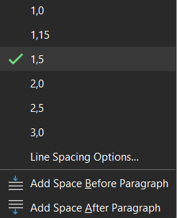 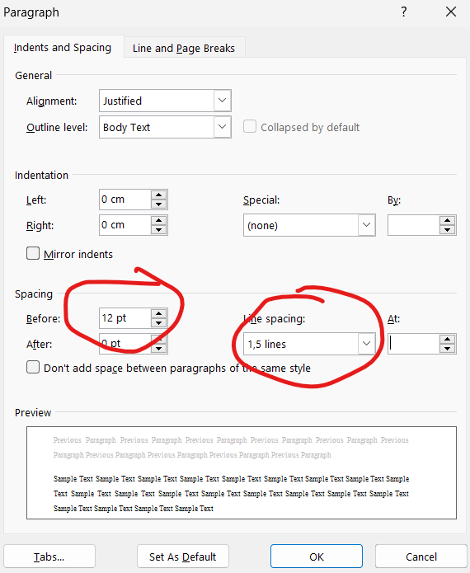

Now we present our example of these intervals. As mentioned above, the rule has been applied in this article, including before or between headings. Do not forget that there should be no spaces after the title and paragraphs.

This article is written as an example of the paragraph and it is stated that there should be no spaces.

**SAMPLE TITLE**

There is no space in the article to be written after the title.

**3- METHOD**

**METHOD** (Before the findings, it should be written in 14 pt bold and capital letters).

**4- FINDINGS, CONCLUSIONS AND RECOMMENDATIONS**

**RESULTS** (14 pt, bold and capitalized).

**CONCLUSION AND SUGGESTIONS** (14 pt, bold and capitalized).

**5- QUOTATIONS**

**It is the spelling of verbatim quotations up to four lines:**

"*If it is quoted verbatim, it should be italicized in quotation marks as seen here and the source must be specified at the end*" (Karaca, 2018: 421). like....

**It is the spelling of verbatim quotations that are more than four lines (**1.25cm indented on both sides and should be in quotation marks**).**

"Such block quotations should be enclosed in quotation marks if they are four lines or more, as in this example. It should be enclosed in quotation marks and  **set to 10 font size**, provided that it is written in **Times New Roman** font . In addition, line spacing **should be reduced to** 1.0 and **1.25** paragraph indents should be made from the left and right. In order for you to better understand this process, this article has been written and at least four lines of sample text are presented. The source you specify at the end of your block quote should still  **be 10 punos**. Let it be easy" (Karaca, 2020: 2). like...

**In the quotations made with your own sentences;**

All of your text will be in 12pt, without quotes, in Times New Roman font. Your citation at the end of your citation is (Karaca, 2005: 55). It should be in the form.

Or, according to APA, Karaca's (2005) research result is "after adding the quoted text here" (p.55).

**When citing the work with two authors:**

(Green and Goodman, 2015: 45).

or

According to Green and Goodman (2015: 45), the Trans-Pacific Treaty should be quoted as one of the largest treaties on a global scale in recent years.

**To Refer to Works with Three or More Authors**; After the surname of the first author, instead of using the surnames of other authors, the expression 'et al.' is used (Walter et al., 1998: 25) or

According to Walter et al. (1998: 25), climate should be the determinant of human character.

**Sequential citations (if multiple citations);**

Multiple references in the same parentheses: Multiple references in the same parentheses should be in alphabetical order according to the surname of the first author and separated by semicolons.

**Example:** (Akbulut and Doğan, 2013; Şencan, 2003; Tonta, 2010).

**Sequential Citations (Multiple References):**

When making multiple references within the same parentheses: Multiple references within the same parentheses should be listed alphabetically by the first author’s surname and separated by semicolons.

**Example:** (Akbulut and Doğan, 2013; Şencan, 2003; Tonta, 2010).

**6- FOOTNOTES**

**To write footnotes:**

Show the sources of the quotations that need to be written inside (e.g., Karaca, 1996:75). Only provide your own comments as footnotes (read the footnote below). Because you will clearly specify your source in the REFERENCES section. Therefore, you will not have repeated it and will have complied with APA rules.

**7- IN-TEXT REMINDERS**

The names of important individuals should be introduced with a footnote the first time they appear in the text.

The first time the names of important individuals appear in the text, their birth and death dates should be provided, if available. If not, only the death date should be given. If neither is available, the century/centuries they lived in must be indicated. Dates should not be repeated when the names are mentioned again.

**8- REFERENCES**

# REFERENCES (14 pt, bold and capitalized). However, when writing the source articles;

1. Do not put numbers on items.

2. Indentations in all references should be 1.25cm.

3. Each reference should be 1.0 line spacing in this section.

4. Line spacing should be 12nk.

***Journal Articles***

**Printed journal article: 1 author  
[Citation in text: (Miller, 2000: 68)]**

1. **(If it is between pages);**

**Miller, M. (2000). The environment where we will share our dreams: Organization. *Journal of Dogus University, 1*(2), 63-75.**

1. **(If it is specific pages);**

**Miller, M. (2000). The environment where we will share our dreams: Organization. *Journal of Dogus University, 1*(2), 22, 28, 86.**

**Printed journal article: 2 authors  
 [Citation in text: (Tonta and Ünal, 2005: 88)]**

1. **Tonta, Y. ve Ünal, Y. (2005). Scatter of journals and literature obsolescence reflected in document delivery requests. *Journal of the American Society for Information Science & Technology, 56*(1), 84-94.**

**Printed journal article: 3-6 authors   
[Citation in text: First citation: (Kernis, Cornell, Sun, Berry, Harlow, & Bach, 1993: 1120); Ensuing citation: (Kernis et al., 1993, p.1130)]**

1. **Kernis, M. H., Cornell, D. P., Sun, C. R., Berry, A., Harlow, T. ve Bach, J. S. (1993). There's more to self-esteem than whether it is high or low: The importance of stability of self-esteem. *Journal of Personality and Social Psychology, 65*, 1190-1204.**

**Printed journal article: with more than 6 authors  
[Citation in text: (Lakic et al., 2012: 3)]**

1. **Lakic, B., Arık, M., Aune, S., Barth, K. L., Belov, A. S., Borghi, S. ...  Zioutas, K. (2012). Status and perspectives of the CAST experiment. *Journal of Physics: Conference Series, 375*(2), 1-4.  http://dx.doi.org/10.1088/1742-6596/375/1/022001**

**Electronic journal article: With DOI number  
[Citation in text: (Koç, 2002: 260)]**

1. **Koç, E. (2002). The impact of gender in marketing communications: The role of cognitive and affective cues. *Journal of Marketing Communications, 8*(4), 257-275. http://dx.doi.org/10.1080/13527260210145993**

**Electronic journal article: Without DOI number (free access from the internet)  
[Citation in the text: First citation: (Aygören, Yeşilyurt, Güloğlu, Küçükkaplan, 2015: 208) ; Follow-up citation: (Aygören et al., 2015: 208)]**

1. **Aygören, H., Yeşilyurt, M., Güloğlu, B. and Küçükkaplan, İ. (2015). The relationship between equity performance and efficiency in the Turkish banking sector. *Journal of Dogus University, 16*(2), 203-215. Access address http://journal.dogus.edu.tr/ojs/index.php/duj/article/view/914**

**Electronic journal article: Preprint  
[Citation in text: (Koç and Altınay, 2007)]**

1. **Koç, E. ve Altınay, G. (2007). An analysis of seasonality in monthly per person tourist spending in Turkish inbound tourism from a market segmentation perspective. *Tourism Management*. Elektronik ön baskı. http://dx.doi.org/10.1016/j.tourman.2006.01.003**

**Electronic journal article: Institutional archive  
[Citation in text: (Muslumov, in press)]**

1. **Müslümov, A. (baskıda). Merger announcements and market efficiency: Do markets predict synergetic gains from mergers properly?. *Doğuş Üniversitesi Dergisi*. (Erişim adresi** [**http://hdl.handle.net/11376/1290**](http://hdl.handle.net/11376/1290)**), (Erişim tarihi: 04.19.2024).**

**Article submitted to the journal for publication  
[Cited in text: Kurt ve Poison, 2016)]**

1. **Kurt, A. and Poison, C. (2016). The relationship between cost leadership strategy, total quality management applications and financial performance. *Journal of Dogus University*. The article has been submitted for publication.**

***Books & eBooks***

**Book: Single author  
 [Citation in text: (Gürsoy, 2009: 175)]**

1. **Gursoy, C. T. (2007). *Principles of financial management*. Istanbul: Dogus University.**

**Book: Two authors  
[Citation in text: (Page and Stritzke, 2015: 88)]**

1. **Page, A. C. ve Stritzke, W. G. K. (2015). *Clinical psychology for trainees: Foundations of science-informed practice* (2nd ed.). Cambridge: Cambridge University Press.**

**Book: 3 authors  
[Citation in text: First citation: (Ranzijn, McConnochie and Nolan, 2009: 66); Follow-up citation: (Ranzijn et al., 2009, p.66)]**

1. **Ranzijn, R., McConnochie, K. ve Nolan, W. (2009). *Psychology and indigenous Australians: Foundations of cultural competence*. South Yarra, Vic: Palgrave Macmillan.**

**Book: 4 or more authors   
[Citation in text: (Wolfe et al., 2015: 120)]**

1. **Wolfe, J. M., Kluender, K. R., Dennis, L. M., Bartoshuk, L. M., Herz, R. S., Lederman, S. J. ve Merfeld, D. M. (2015). *Sensation & perception* (4th ed.). Sunderland, MA: Sinauer Associates.**

**Book: Different editions  
[Citation in text: (Passer and Smith, 2015: 77)]**

1. **Passer, M. W. ve Smith, R. E. (2015). *Psychology: The science of mind and behaviour* (2nd ed.). North Ryde, NSW: McGraw-Hill Education.**

**Book: Without author  
 [Cited in text: (The Australian Oxford dictionary, 1999: 50)]**

1. ***The Australian Oxford dictionary* (3rd ed.). (1999). Melbourne: Oxford University Press.**

**Book: Single Editor[  
Citation in text: (Hallinan, 2006: 36)]**

1. **Hallinan, M. T. (Ed.). (2006). *Handbook of the sociology of education*. New York: Springer.**

**Book: 2 or more editors  
[Citation in text: (Day and Antonakis, 2012: 63)]**

1. **Day, D. V. ve Antonakis, J. (Ed.). (2012). *The nature of leadership* (2nd ed.). Los Angeles, CA: Sage.**

**Book: Author of the institution  
 [Cited in text: (Australian Bureau of Statistics, 2000: 92)]**

1. **Australian Bureau of Statistics. (2000). *Population by age and sex, New South Wales, 30 June 2000* (ABS Cat. no. 3235.1). Canberra, Australian Capital Territory: Yazar.**

**Book: Chapter in the edited book (e.g. article)  
[Cited in text: (Groundwater-Smith, 2007: 135)]**

1. **Groundwater-Smith, S. (2007). As rain is to fields, so good teachers are to students. S. Knipe (Ed.), *Middle years schooling: Reframing adolescence* içinde (151-170. ss.). Frenchs Forest, N.S.W: Pearson Education Australia.**

**Book: Translation  
[Citation in text: (Rowley, 1996: 150)]**

1. **Rowley, J. (1996). *Organization of information: Introduction to access information*. (Trans. S. Karakaş, H. U. Can, A. Yıldızeli, B. Kayıran). Ankara: Turkish Librarians' Association. (Original aired, 1992)**

**eBook: The entire book  
[Citation in text: (Chisum, 2006: 77)]**

1. **Chisum, W. J. (2006). *Crime reconstruction* [Adobe Digital Editions]. Erişim adresi Ebook Library.**

**eBook: Chapter from a database  
[Citation in text: (Mitchell, 1913: 88)]**

1. **Mitchell, H. W. (1913). Alcoholism and the alcoholic psychoses. W. A. White ve S. E. Jelliffe (Ed.), *The modern treatment of nervous and mental diseases* içinde (Cilt 1, 287-330. ss.). Erişim adresi PsycBOOKS.**

**Book: Different work by the same author in the same year   
[Citation in text: (Glenn and Johnson, 1964a: 90); (Glenn and Johnson, 1964b: 90)]**

1. **Glenn, W. H. ve Johnson, D. A. (1964a). *Calculating devices*. London: John Murray.**
2. **Glenn, W. H. ve Johnson, D. A. (1964b). *Graphs*. London: Murray.**

***Book Chapter***

**Published book chapter   
[Cited in text: Onan and Sennaroğlu, 2009: 69)]**

1. **Onan, K., Sennaroğlu, B. (2009). Comparative study of production control systems through simulation. N. Mastorakis, J. Sakellaris (Ed.), *Advances in Numerical Methods* içinde (67-78. ss.). New York; London: Springer. http://dx.doi.org/10.1007/978-0-387-76483-2_6**

***Dictionary / Encyclopedia Articles***

**Reference book article  
[Citation in text: (Keyormarsi, O'Leary, & Pardee, 2007: 200)]**

1. **Keyormarsi, K., O'Leary, N. ve Pardee, A. B. (2007). Cell division. *McGraw-Hill encyclopedia of science & technology* içinde (9. bs., Cilt 3, 618-621. ss.). New York: McGraw-Hill.**

**eReference book article  
[Citation in text: (Keyormarsi, O'Leary & Pardee, 2014: 200)]**

1. **Pegrum, M. (2009). Keyormarsi, K., & Pardee, A. B. (2014). Cell division.*McGraw-Hill in encyclopedia of science & technology*. The access address is AccessScience.**

***Web Resources***

**Web Page  
[Citation in text: ((Journal of Doğuş University, 2016)]**

1. **Journal of Dogus University. (2016). Author's guide. (Access address:** [**http://journal.dogus.edu.tr/ojs/index.php/duj/about/submissions**](http://journal.dogus.edu.tr/ojs/index.php/duj/about/submissions)**), (Access date: 19.12.2024).**

**Web page: Non-author  
[Citation in text: ("All 33 Chile Miners," 2010)]**

1. **All 33 Chile miners freed in flawless rescue. (Erişim adresi:** [**http://www.budapestopenaccessinitiative.org/boai-10-recommendations**](http://www.budapestopenaccessinitiative.org/boai-10-recommendations)**), (Erişim tarihi: 19.12.2024).**

**Web page: Undated  
[Citation in text: (Dinçkol, n.d.)]**

1. **Dinçkol, A. (n.d.). From the Rector. (Access address:** [**http://dogus.edu.tr/tr/dogus/rektor.asp**](http://dogus.edu.tr/tr/dogus/rektor.asp)**), (Access date: 20.11.2023).**

**Web page: Author and undated: With citation  
[Citation in text: ("Heuristic," n.d., par. 1) Count the paragraphs if they are not numbered]**

1. **Heuristic. (t.y.). *Merriam-Webster’s online dictionary* (11th ed.) içinde. (Erişim adresi:** [**http://www.m-w.com/dictionary/heuristic**](http://www.m-w.com/dictionary/heuristic)**), (Erişim tarihi: 09.04.2022).**

**Web page: Media citation: (Youtube, Dailymotion, Instagram, Facebook, etc..) information of those who do not have a date, no author, no author and no date will be made according to the above web pages citations.  
[In-text citation: (Pınarbaşı, E., 2022, 18 March).**

1. **Pınarbaşı, E. (2022, 18 Mart). Saba Saz Semaisi - Ahmet Hakan BAŞ. [video]. Youtube. (Access address:** [**https://www.youtube.com/watch?v=156kFhqCzo8 list=PLU5BqoRxTrJ9KuxbhewnuE_7Sa9jkMKJz**](https://www.youtube.com/watch?v=156kFhqCzo8%20list=PLU5BqoRxTrJ9KuxbhewnuE_7Sa9jkMKJz)**), (Retrieved: 29.11.2024).**

**Press release  
[Citation in text: (Doğuş University, 2012)]**

1. **Dogus University (2012, November 30). *We pay tribute to our martyrs of science* [Press release]. (Access address:** [**https://www.dogus.edu.tr/images/pdf/basin_bulten/11_2012_1.pdf**](https://www.dogus.edu.tr/images/pdf/basin_bulten/11_2012_1.pdf)**), (Access date: 02.02.2024).**

**Discussion forum  
[Cited in text: (Malissa, 2008)]**

1. **Malissa, A. (2008, October 2). Re: Egypt planning DNA test on 3,500 year old mummy [Electronic forum comment]. (Access address: http://www.topix.com/science/anthropology/ 2008/05/egypt-planning-dna-test-for-3-500-year-old-mummy), (Access date: 02.02.2024).**

**Blog  
[Cited in text: (Çelik, 2011)]**

1. **Celik, S. (2011, December 21). Indexing of journals and impact factor. [Weblog post] (Access address:** [**http://sonmezcelik.blogspot.com.tr/2011/12/dergilerin-indekslenmesi-ve-etki.html**](http://sonmezcelik.blogspot.com.tr/2011/12/dergilerin-indekslenmesi-ve-etki.html)**), (Access date: 02.02.2024).**

**Electronic message list  
[In-text citation: (Anderson, 2005)]**

1. **Anderson, O. (2005, June 2). Re: Psychology of terrorism [Electronic mailing list message]. (Erişim adresi:** [**http://archives.econ.utah.edu/archives/theory-frankfurt-school/2005w22/msg00000.htm**](http://archives.econ.utah.edu/archives/theory-frankfurt-school/2005w22/msg00000.htm)**), (Erişim tarihi: 02.02.2024).**

**Wiki  
[Cited in text: (Sports psychology, n.d.)]**

1. **Sports psychology. (n.d.). *In The psychology wiki*. (Access date: Accessed from http://psychology.wikia.com/wiki/ Sports_psychology), (Access date: 02.02.2024).**

***Lecture Notes***

**Lecture note  
[Cited in text: Saito, (2012)]**

1. **Saito, T. (2012). Technology and me: A personal timeline of educational technology[Powerpoint slides]. (Erişim adresi:** [**http://www.slideshare.net/Bclari25/educational-technology-ppt**](http://www.slideshare.net/Bclari25/educational-technology-ppt)**), (Erişim tarihi: 02.02.2024).**

***Theses***

**Unpublished thesis  
[Cited in text: (Çetinkaya, 201: 1885)]**

1. **Çetinkaya, Ş. (2015). *Stochastic mortality using non - life methods.* (Unpublished doctoral dissertation). Doğuş University Institute of Social Sciences, Istanbul.**
2. **Celik, S. (1999). *Personnel management in university libraries and the situation in Turkey*. (Unpublished master's thesis). Istanbul University, Institute of Social Sciences, Department of Librarianship, Istanbul, Turkey.**

**Published thesis   
[Cited in text: (May, 2007: 67)]**

1. **May, B. (2007). *A survey of radial velocities in the zodiacal dust cloud*. Bristol, UK: Canopus Publishing.**

**Electronic thesis: Archived in an electronic database   
[Citation in text: (Rich, 1989: 55)]**

1. **Rich, P. D. (1989). *The rule of ritual in the Arabian Gulf, 1858-1947: The influence of English public schools* (Doktora tezi). Erişim adresi ProQuest Dissertations and Theses - UK & Ireland. (AAT 8918197)**

**Electronic thesis: Archived in the institutional archive  
[Citation in text: (Bilir, 2014: 43)]**

1. **Bilir, C. (2014). *Supply chain network optimization model incorporating competitive facility location problems*. (Ph.D. thesis, Dogus University, Istanbul). (Access address** [**http://hdl.handle.net/11376/1039**](http://hdl.handle.net/11376/1039)**), (Access date: 02.02.2024).**

***Conference Proceedings***

**Paper in the published conference book  
 [Cited in text: (Game, 2001: 350)]**

1. **Game, A. (2001). Creative ways of being. J. R. Morss, N. Stephenson ve J. F. H. V. Rappard (Ed.), *Theoretical issues in psychology: Proceedings of the International Society for Theoretical Psychology 1999 Conference* içinde (3-12. ss.). Sydney: Springer.**

**Paper in the published conference book: Non-editor  
[Cited in the text: (Doğdaş and Akyokuş, 2013: 3)]**

1. **Doğdaş, T. ve Akyokuş, S. (2013). Document clustering using GIS visualizing and EM clustering method. *2013 IEEE International Symposium on Innovations in Intelligent Systems and Applications (INISTA)* içinde (1-4. ss.). Piscataway, NJ: IEEE.  http://dx.doi.org/10.1109/INISTA.2013.6577647**

**Paper in the electronic conference book: Electronics database  
[Citation in text: (Balakrishnan, 2006)]**

1. **Balakrishnan, R. (2006, March). *Why aren't we using 3D user interfaces, and will we ever?* Paper presented at the IEEE Symposium on 3D User Interfaces. http://dx.doi.org/10.1109/vr.2006.148**

**Unpublished conference paper  
[Citation in text: (Santhanam, Martin, Goody, & Hicks, 2001: 259)]**

1. **Santhanam, E., Martin, K., Goody, A. ve Hicks, O. (2001). *Bottom-up steps towards closing the loop in feedback on teaching: A CUTSD project*. Paper presented at Teaching and Learning Forum - Expanding horizons in teaching and learning, Perth, Australia, 7-9 February 2001.**

***Reports***

**Official reports   
[Cited in text: (Akbaytürk et al., 2014: 40)]**

1. **Akbaytürk Çanak, T., Çelik, S., Çetinkaya, İ., Çukadar, S., Güneş, G., Gürdal, G. ... Kaygusuz, A. (2014). *University libraries in Turkey towards 2023: Current situation, problems, standards and solutions*. Ankara: Council of Higher Education. (Access address:** [**http://yok.gov.tr/web/ukr**](http://yok.gov.tr/web/ukr)**), (Access date: 02.02.2024).**

**[Citation in text: (Turkish Statistical Institute [TurkStat], 2012: 67); Cited following: (TurkStat, 2012: 67)]**

1. **Turkish Statistical Institute. (2012). *Annual report: Fiscal year 2011*. (Access address** [**http://www.tuik.gov.tr/jsp/duyuru/upload/FR-2011.pdf**](http://www.tuik.gov.tr/jsp/duyuru/upload/FR-2011.pdf)**), (Access date: 02.02.2024).**

**Unofficial report  
[Cited in text: (Kendall, 2011: 99)]**

1. **Kendall, C. (2011). *Report on psychological distress and depression in the legal profession: Prepared for the Council of the Law Society of Western Australia*. (Erişim adresi:** [**http://www.mhlcwa.org.au/wp-content/uploads/2013/08/Psychological-distress-depression-in-the-legal-profession-16-May-2011.pdf**](http://www.mhlcwa.org.au/wp-content/uploads/2013/08/Psychological-distress-depression-in-the-legal-profession-16-May-2011.pdf)**), (Erişim tarihi: 02.02.2024).**

***Standards & Patents***

**Printed standard  
[Cited in text: (Standards Australia/New Zealand Standard, 1994)]**

1. **Standards Australia. (1994). *Information Processing - Text and office systems - Office Document Architecture (ODA) and Interchange format: Part 10: Formal Specifications* (AS/NZS 3951.10:1994). Homebush, NSW: Standards Australia.**

**Electronic standard: Electronic database  
[Cited in text: (Standards Australia, 2008)]**

1. **Standards Australia. (2008). *Personal flotation devices – General requirements* (AS 4758.1-2008). Erişim adresi Standards Online.**

**Patent  
[Cited in text: (U.S. Patent No. 5,641,424.7, 1996)]**

1. **Hornak, P. (1996). *Resonator for magnetic resonance imaging of the ankle*. U.S. Patent No. 5,641,424.7.**

**Electronic patent: Electronic database  
[Cited in text: (Australian Patent No. AU 2008100919, 2008)]**

1. **Clark, J. M. & McCallum, J. M. (2008). *Method for and composition of excipient suitable for use in herbal formulations and formulations derived therefrom*. Australian Patent AU 2008100919. (Erişim adresi:** [**https://www.Scifinder.com**](https://www.Scifinder.com)**), (Erişim tarihi: 02.02.2024).**

***Official Gazette***

**Official Gazette  
[Cited in text: Seventh Five Years ..., 1999)]**

1. **Seventh Five-Year Development Plan 1996-2000 (1995). *Official Gazette of the Republic of Turkey* (22354, 25 July 1995).**

***Archival Sources*** (This representation is valid for documents given using footnotes in the text)

1. Turkish Diplomatic Archive (TDA)

TDA/502/3764708.

TDA/502/3764813.

2. Prime Ministry Archives of the Republic (BCA)

B.C.A., CHP Extraordinary Grand Congress Meeting Minutes), Box: 218, Shirt: 860, Row: 1, May 10, 1946.

3.Yayınlanmış Arşiv Belgeleri

TBMM Zabıt Ceridesi, Devre VII, İctima 2, Cilt:14, Birinci İnikat, 1 Kasım 1944.

TBMM Zabıt Ceridesi, Devre: VII, Toplantı: 3, Cilt:20, Birinci Birleşim, 1 Kasım 1945.

4. Gazeteler

Cumhuriyet, 12 Temmuz 1946.

Tanin, 13 Temmuz 1946.

Tanin, 18 Temmuz 1946.

Ayın Tarihi, Sayı: 138, 1-31 Mayıs 1945.

**9- WRITING RULES**

The spelling rules in the articles are checked by our language editors. The dictionaries of the Turkish Language Association have been taken into account as a guide. Check the spelling of the words you are hesitating about by clicking on the link below. <https://sozluk.gov.tr/>.

In addition, although the names of the authorities and curtains, which are frequently mentioned in our journal due to our subjects, are written in lowercase letters and with or without hats according to TDK, the responsibility of writing the names of the authorities and curtains is entirely up to the author. The spelling rule requested from you; The words you have written will be the same everywhere in the article. The following are examples of errors:

As it is known, as in every country, some words have different spellings. We ask you to use the same words every time.

Be that as it may, "**paragraph spacing must be 0nk"** . We felt the need to remind this rule again.

**10- ATTACHMENT OF ATTACHMENTS OR OBJECTS**

**USE OF FIGURES, PICTURES, PHOTOGRAPHS, TABLES OR PICTURES:**

The common way in which they are all added is shown below.

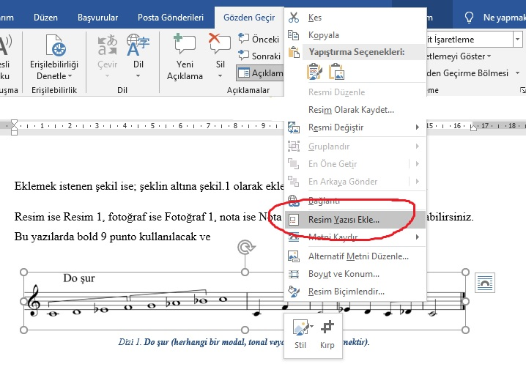

Table 1. Table texts should be like this. There should be no vertical lines. Horizontal lines, on the other hand, must be under the title and at the end**, if there**  is total data at the end, there must also be a line in the intermediate section.

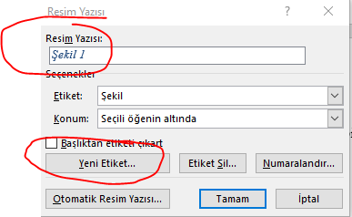

Then you choose the citation you will put **by specifying the type from the "Caption:"** section. If there is no text you want, click Create a new tag and complete the process by writing notes, photos or series, etc. In this way, the system will continue the series itself while you do your next operations. All that is left for you is to right-click on your citation and select the correct caption throughout your article.

**Now, a few examples of this topic are shown below for you.**

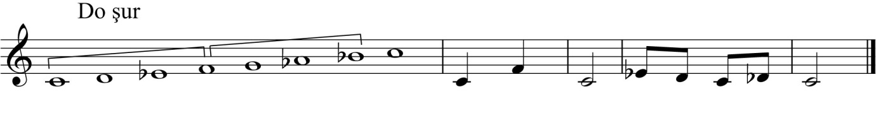

Scale 1. Any scale, quartet, fifth, octave-length scale, or jazz scales are called "**Scale**".

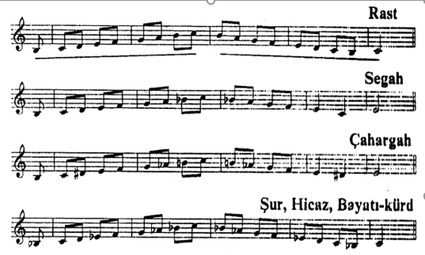

Score 1. If a passage or a few measure examples from any work are to be given,name it **"Score".**

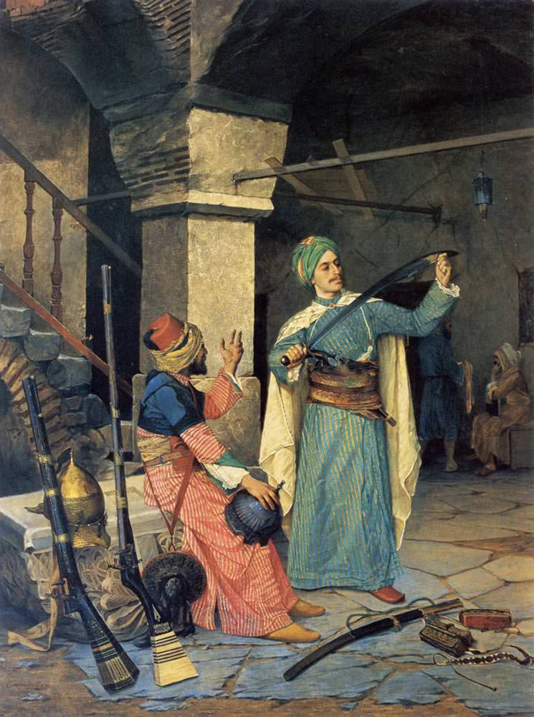

Picture 2. When adding such oil paintings or paintings, select the "Image" option from the caption.

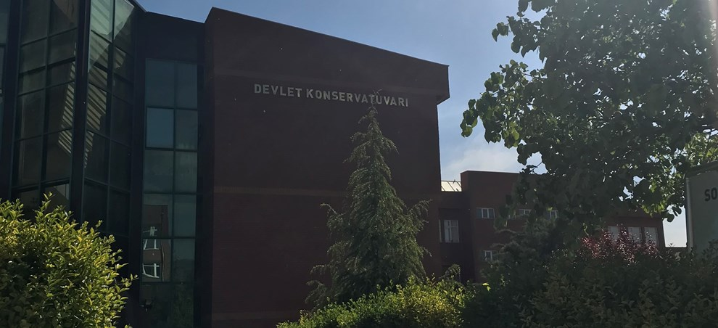

Photo 1. If it's a photo you've added, it must have been taken by a media device. "Photo" should also be selected in the caption or created if it is not available.

|  |  |  |  |
| --- | --- | --- | --- |
| Railway | New students | Graduate students | Change |
|  | Undergraduate Student |  |  |
| Cedar University | 110 | 103 | +7 |
| Karaağaç College | 223 | 214 | +9 |
| Maple Academy | 197 | 120 | +77 |
| Pine College | 134 | 121 | +13 |
| Oak Institute | 202 | 210 | -8 |
|  |  |  |  |

Table 1. Table texts should be in this way and vertical lines should never be used between items.

When submitting the first version of your article, do not forget to add the table below at the bottom of the page.

**11- ETHICS COMMITTEE APPROVAL DOCUMENT**

Check out the template given below. If you answer "yes" to any question in the diagram, you must "ATTACH IT TO YOUR ARTICLE" if there is no situation that requires Ethics Committee Permission, the pdf document should be restored exactly.

In the study carried out; If personal data sharing, surveys, interviews have been made with people, they should be added to the end of the article by obtaining an officially approved permission letter from the institutions of those people or themselves, if the subject is related to animals, and if experimental activities have been carried out on these animals, from the owner of the animals. If this is not noticed, all legal responsibilities of the submitted articles belong to the authors. Our journal is not responsible for any legal sanctions that may arise from this.

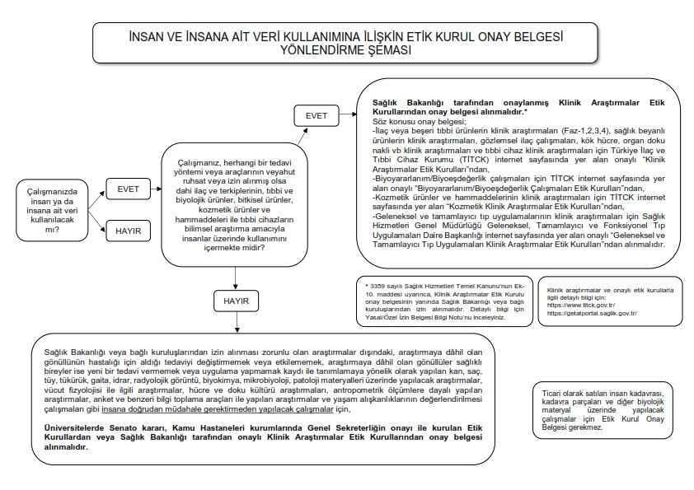

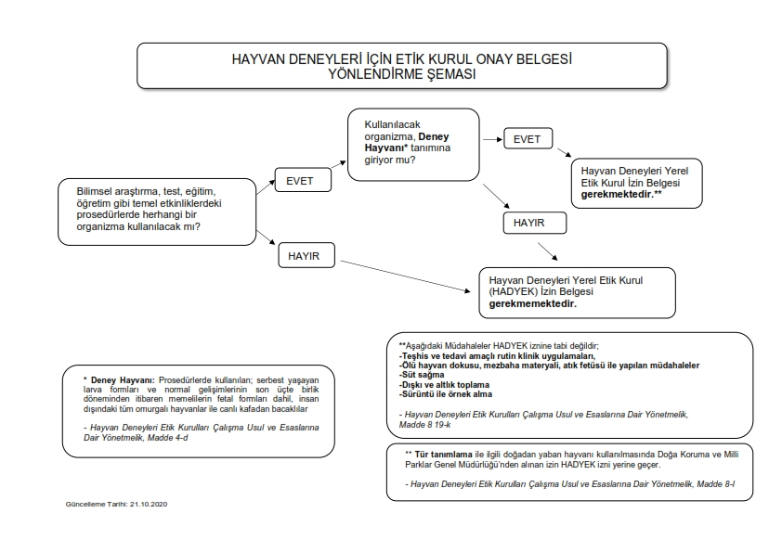

**12- PERSONAL INFORMATION**

|  |  |
| --- | --- |
| Name Surname |  |
| The Institution You Work For |  |
| Your last graduated position |  |
| The year you took up your graduated position |  |
| Your Mobile Phone number for emergencies |  |
| E-mail address |  |

Be sure to fill in this table and add it to the end of your article.

**13- NUMBER OF WORDS IN THE ARTICLE**

"If the length of the text, including the extended abstract and references, exceeds 9,000 words or 40 pages, the author is required to pay an additional layout fee, amounting to 10% of the editorial fee. Please make sure to calculate the page count and word count of your manuscript before submission."

1. Appellation......... University ..............., Department of Turkish Music, Turkish Classical Music ASD, [yegaheditor@gmail.com](mailto:yegaheditor@gmail.com), <https://orcid.org/0000-0003-0939-0087> .