**The Name of the Manuscript**

**Author’s Name LASTNAME**

Organization

e-mail

orcid.org/0000-……

***Example***

**Duty Free Shops in Turkish Law And**

**Comparative Law**

**Altan Fahri GÜLERCİ**

Assoc. Prof. Dr., Afyon Kocatepe University, Faculty of Law

Afyonkarahisar/Türkiye

[afgulerci@aku.edu.tr](mailto:afgulerci@aku.edu.tr)

<https://orcid.org/0000-0001-8731-4181>

**Abstract**

In the abstract, the basic methodological framework of the research, including its subject, scope, significance, objective, and method, should be specified. It should also include findings and observations related to the topic, as well as highlight the main conclusions reached.Articles must be sent with an English abstract of at least 100 and at most 150 words, with the article name and max. five keywords added to the beginning of the article.

**Keywords:** At least 5 keywords should be provided, separated by commas and ending with a period. (The first term should be the discipline, and other terms should be arranged from general to specific.)

**Introduction**

Under the introduction heading, the following points must be addressed:

1. A general overview of the topic should be provided, including the rationale for the research.
2. The subject/concept/person, etc., should be discussed in terms of its historical background.
3. Relevant literature should be reviewed, and the original aspects of the study should be highlighted.
4. The research method and its contribution to the field should be specified, but a summary of the results should not be included.

The introduction and subsequent headings should only have the first letter capitalized. On the first line after the headings, paragraph indent is not used, the paragraph is started left-justified. Paragraph indent should be used for subsequent paragraphs.

**1. Main Title**

Only the first letter of main titles should be capitalized. Articles must be prepared in “Microsoft Word” program. Main text, 16x24 size, 3 cm margins from the top of the page, 2.5 cm margins from the bottom, right and left sides of the page, 10.5 point "Palatino Linotype" font, footnotes[1] 9 point "Palatino Linotype" character, It should be written with a 5 mm indent in the spacing and paragraphs. Articles; should not be more than 5000 words, including footnotes but except abstract and bibliography.

* 1. **Subtitle**

Subtitles should be numbered and written with only the first letters capitalized. No heading style should be applied.

* 1. **Subtitle**

Xxxxxx xxxxxx xxxxxx xxxxxx xxxxxx xxxxxx xxxxxx xxxxxx xxxxxx xxxxxx xxxxxx xxxxxx xxxxxx xxxxxx xxxxxx xxxxxx xxxxxx xxxxxx xxxxxx xxxxxx xxxxxx xxxxxx xxxxxx xxxxxx xxxxxx xxxxxx xxxxxx xxxxxx xxxxxx

Xxxxxx xxxxxx xxxxxx xxxxxx xxxxxx xxxxxx xxxxxx xxxxxx xxxxxx xxxxxx xxxxxx xxxxxx xxxxxx xxxxxx xxxxxx xxxxxx xxxxxx xxxxxx xxxxxx xxxxxx xxxxxx xxxxxx xxxxxx xxxxxx xxxxxx xxxxxx xxxxxx xxxxxx xxxxxx

1. **Main Title**

Xxxxxx xxxxxx xxxxxx xxxxxx xxxxxx xxxxxx xxxxxx xxxxxx xxxxxx xxxxxx xxxxxx xxxxxx xxxxxx xxxxxx xxxxxx xxxxxx xxxxxx xxxxxx xxxxxx xxxxxx xxxxxx xxxxxx xxxxxx xxxxxx xxxxxx xxxxxx xxxxxx xxxxxx xxxxxx

Xxxxxx xxxxxx xxxxxx xxxxxx xxxxxx xxxxxx xxxxxx xxxxxx xxxxxx xxxxxx xxxxxx xxxxxx xxxxxx xxxxxx xxxxxx xxxxxx xxxxxx xxxxxx xxxxxx xxxxxx xxxxxx xxxxxx xxxxxx xxxxxx xxxxxx xxxxxx xxxxxx xxxxxx xxxxxx

* 1. **Subtitle**

Xxxxxx xxxxxx xxxxxx xxxxxx xxxxxx xxxxxx xxxxxx xxxxxx xxxxxx xxxxxx xxxxxx xxxxxx xxxxxx xxxxxx xxxxxx xxxxxx xxxxxx xxxxxx xxxxxx xxxxxx xxxxxx xxxxxx xxxxxx xxxxxx xxxxxx xxxxxx xxxxxx xxxxxx xxxxxx

***Example***

**Introduction**

**1.** General Information on Duty-Free Shops and Their Regulation in Comparative Law

**1.1.** Concept, Operational Logic, and Emergence of Duty-Free Shops

**1.2.** Regulations on Duty-Free Shops in Comparative Law

**1.2.1.** Regulations in Swiss Law

**1.2.2.** Regulations in Taiwanese Law

**2.** Regulations on Duty-Free Shops in Turkish Law

**2.1.** General Overview

**2.2.** Definition and Types of Duty-Free Shops

**Conclusion**

**References**

***Table Example***

Table 1. Table Title, "Palatino Linotype," 10.5 pt, justified alignment, no indentation, with the first letter of each word capitalized.

|  |  |  |  |
| --- | --- | --- | --- |
|  | 1 | 2 | 3 |
| A | Xxx | Xxx | Xxx |
| B | Xxx | Xxx | Xxx |

Tables should be created from the Table menu in the Word program. The table number, title, and content should be in "Palatino Linotype," 10.5 pt. A space should be left before the table title, and no space should be left after the table. The criteria and metrics within the table should be bold and capitalized, while the information inside the table should be in normal text with the first letter capitalized.

***Figure Example***

Figure 1. Figure Title, "Palatino Linotype," 10.5 pt, no indentation, centered, with the first letters of the title capitalized.

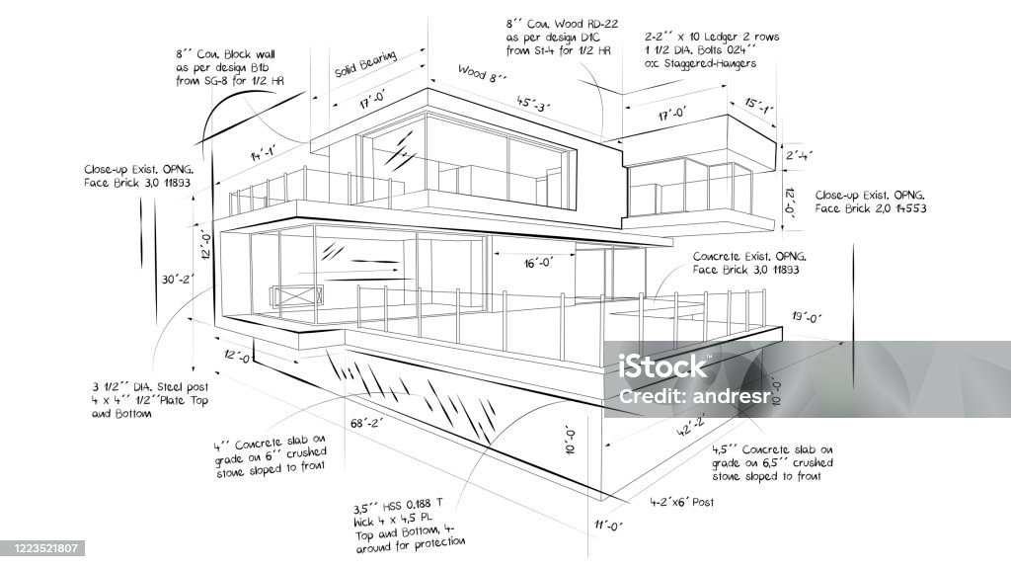

Figures should be centered, with figure titles placed above the figures. The aspect ratio of the figures should not be altered during resizing. Figures should be numbered sequentially, with one line of space left after the text before inserting the figures.

If there are any sources of information taken from other works in tables and figures, the source of this information should be indicated, and any explanatory details should be provided below the tables and figures.

**Quotation**

Quotations should be "Palatino Linotype," 10.5 pt. Also quotations must be italicized and placed within quotation marks.

***Quotation Example***

*“xxxxxx xxxxxx xxxxxx xxxxxx xxxxxx xxxxxx xxxxxx xxxxxx xxxxxx xxxxxx xxxxxx xxxxxx xxxxxx xxxxxx xxxxxx xxxxxx xxxxxx xxxxxx xxxxxx xxxxxx xxxxxx xxxxxx xxxxxx xxxxxx xxxxxx xxxxxx xxxxxx xxxxxx xxxxxx xxxxxx xxxxxx xxxxxx xxxxxx xxxxxx xxxxxx xxxxxx xxxxxx xxxxxx xxxxxx xxxxxx xxxxxx xxxxxx xxxxxx”*

**Conclusion**

The results obtained in the study are discussed with support from the relevant literature. Recommendations are provided for individuals within the target audience of the study, as well as for researchers. The conclusion does not summarize the topic; instead, the findings can be presented in bullet points.

**Bibliography**

The references must begin on a new page. A page break should be added at the end of the conclusion. At the end of the works, there must be a bibliography arranged alphabetically according to the Chicago reference system.

***Example***

Binder, Amy J., and Jeffrey L. Kidder. The Channels of Student Activism: How the Left and Right Are Winning (and Losing) in Campus Politics Today. University of Chicago Press, 2022.

Yu, Charles. Interior Chinatown. Pantheon Books, 2020.

**Please Note That**

1. The written language of the journal is English. Articles must be sent with an English abstract of at least 100 and at most 150 words, with the article name and max. five keywords added to the beginning of the article.

2. Articles; It must be prepared in “Microsoft Word” program. Main text, 16x24 size, 3 cm margins from the top of the page, 2.5 cm margins from the bottom, right and left sides of the page, 10.5 point "Palatino Linotype" font, footnotes 9 point "Palatino Linotype" character, It should be written with a 5 mm indent in the spacing and paragraphs.

3. Articles; should not be more than 5000 words, including footnotes but except abstract and bibliography,

4. Articles requested for publication should be sent to article@eajcl.org.

5. The first page of the works to be sent must contain the following information about the author(s): Name-surname, title, institution, e-mail and ORCID ID information.

6. The titles of the submitted articles are appropriate to the text; It should be short and clearly expressed.

7. All references, tables and figures to be used in the works should be arranged using the The Chicago Manual of Style. For more information about The Chicago Manual of Style, please visit https://www.law.ox.ac.uk/sites/default/files/migrated/oscola_4th_edn_hart_2012.pdf

8. On the first line after the headings, paragraph indent is not used, the paragraph is started left-justified. Paragraph indent should be used for subsequent paragraphs.

9. Parts that are not directly related to the subject examined in the work, but require explanation or detailed information, should be added to the work using the footnote method.

10. At the end of the works, there must be a bibliography arranged alphabetically according to the Chicago reference system.

1. 9 point "Palatino Linotype" character.