Click Here, Type the Title of Your Paper, Capitalize First Letter
First Author¹, Second Author ¹, Third Author ²
¹Address, Postal Code and City, COUNTRY
²Address, Postal Code and City, COUNTRY
Received: ../../.... Accepted: ../../.... Published Online: ../../....
Final Version: ../../....

Abstract
Write your abstract here. It will be in 10-point Times New Roman format and will not exceed 200 words

.
Keywords
In separate columns, write a maximum of 6 words here, using a comma as a separator.

(Since our journal conducts evaluations according to the double-blind peer review procedures, the initial version of the document submitted for evaluation must not contain any author information; however, all authors must be entered into the system with their complete information during the upload to Dergipark. Please delete this warning before uploading.)

- Introduction

This is the title page, and if necessary, it is the page with the section on symbols and abbreviations, in a box with the same type and size as the rest of the text. Paragraphs will continue from here and will only be separated by headings, subheadings, images, and formulas. Paragraphs should not have indentation at the beginning; there should be a line space at the end of paragraphs.

Symbols and Abbreviations
D | Diameter
L | Length
ρ | Density
θ | Angle
μ | Dynamic Viscosity
σ | Surface Tension
P | Pressure

The Symbols and Abbreviations section is mandatory and can be provided at the end of the introduction section in accordance with the above example. It should be in table format, left-aligned, and a single table border should be used between the symbol and the explanations. The text should be in italics, Times New Roman, 10-point font.

  - Titles

Main Titles

Section headings should be bold, with the first letter of each word capitalized and in 10-point font, while the texts should be in 10-point Times New Roman font. There should be a line space between section headings and texts.

Primary subheadings

Primary subheadings should have the same formatting characteristics as the main heading; however, there should be a line space between section headings and texts. Only the first word of this title should start with a capital letter, while the other words should start with lowercase letters.

Secondary and subsequent subheadings

Secondary and subsequent subheadings should be written in Times New Roman font, size 10 and italic. Only the first word of the title should start with a capital letter, and the other words should start with lowercase letters. This title should not have bold text. there should be a line space between section headings and texts. Punctuation marks should not be placed at the end of the title, and it should not be written in bold.

  - Structure

The files will only be in MS Word format and must be in a ready-to-print format with tables and figures embedded within the text.

Please make sure to use the required font in your documents as much as possible. It is important to follow the order: Title, Authors, Institution, Abstract, Keywords, Main Text (Introduction, Materials and Methods, Results, Discussion and Conclusion, etc. with figures and tables), Acknowledgments, References. Acknowledgments should be in a separate section at the end of the article and should not be added as a footnote on the title page.

Please do not change the style created in this template. As specified in the template, the article should be prepared in a single column format, suitable for direct printing, with page dimensions of 192 x 262 mm. Leave a line spacing between paragraphs.

  - Tables

All tables should be numbered with Latin numerals. It should be numbered as "Table X. text" and only this part should be in bold. The table description/title should not be in bold and should be in Times New Roman 10-point font. A dot should be used between the table number and the description. Each table should have a title. Headings should be above the tables and centered. Only horizontal lines should be used in the table, and these are for defining the table body and distinguishing the column headings in the table. Tables will not be distinguished within the text. When the table needs to continue on a different page, it should be split, and the number of the continuation table should be formatted as "Table X (continued)" and the same description/title should be used. Below is a useful example for authors. When naming the table, the first letter of each word should be capitalized.

Table 1. Example of Tables
Column header example | Column A (t) | Column B (t)
One input | 1 | 2
Another input | 3 | 4
Other input | 5 | 6
  - Figures

All figures should be numbered with Latin numerals (1,2,3,…). Each figure should be provided with a title. Each word of the title should be written in uppercase letters. All photographs, charts, graphs, and diagrams should be shown as figures. Drawings should be high-quality scans or actual electronic outputs. (en az 300 dpi). Low-quality scans are not acceptable. Figures must be embedded within the text and will not be accepted separately. Shapes must be properly coded within MS Word. The preferred shape formats are PNG, JPEG, GIF, etc. Text and symbols should be clearly defined in the title or as part of the figure's description.

Figures should be positioned as close as possible to the paragraph in the text. The figure option for shapes should be aligned with the text. The figure number should be bold, written in 10-point font below the image, and centered; the figure caption/title should be written next to the number and should not be bold; a period should be placed to separate the figure number and the caption/title. There should line space before and after the figure caption. There will be no shape at the edge of the text. If two shapes fit together, they can be placed side by side to save space. If the figures consist of multiple images such as a, b, etc., a table should be created as in the example and the images should be placed inside it. For example, it should be done as shown in Figure 1.

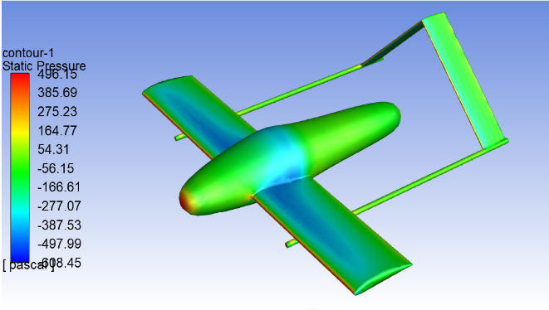 | 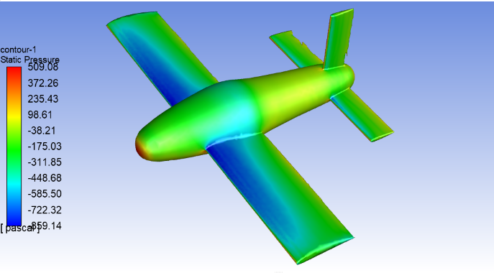
a) | b)

Figure 1. (a) First Figure; (b) Second Figure.

  - Equations

Equations and formulas should be written using the Word program's own equation editor and numbered in parentheses with Latin numerals on the right side of the page. (All equations must be referenced within the text). There should be a 6nk space before and after the equations. If necessary, the font size of the equations can be at least 8 points. [Note: If the equation editor in the Word program is insufficient and a third-party equation editor needs to be used, this situation should be reported to the editor during the article submission phase, and a copy of the article in PDF format without author information should also be uploaded to the system alongside the Word format.]

- General Rules for Preparing the Text

Use single line spacing in the text, prepare it in a single column, and justify the text on both sides. Paragraphs should not have indentations at the beginning. There should be a line space between paragraphs. Page margins should be top 1.6 cm / bottom 1.5 cm / left 1.3 cm / right 1.4 cm. The top and bottom margins should be 1 cm. Since the information in the header and footer will be arranged by us, it should not be interfered with.

Avoid separating syllables at the end of the sentence. Symbols representing vectors and matrices should be indicated in bold letters. Scalar variable names should be expressed in italics. Weights and measures should be expressed in SI units. All non-standard abbreviations and symbols should be as defined the first time they are mentioned, or a glossary should be provided.

  - File Naming and Submission

Please name the file as shown: 'IJERAD_day_month_year_first_word_of_title'. Please upload the Word format to the Dergipark system along with the other requested documents.

  - Acknowledgments / Information

Thank you and reference headings should be aligned to both sides, bold, and with the first letters capitalized. However, numbering will not be done. The text will continue normally below. [Note: Since our journal follows a double-blind peer review process, this section will not be included in the first version submitted for review. ]

  - References

References should be listed at the end of the text. Unless necessary, do not start references on a new page. Authors must ensure that the references they use in the text are included in the reference list, and vice versa. You can cite references in the text as Clark et al. (1962) or Deal and Grove (2009) or Fachinger (2006). The reference section should be arranged alphabetically by the last name of the first author. There should be a single line space between references. Detailed format explanations regarding references have been provided in the writing rules file. Please make your adjustments accordingly.

