Research Article

**Turkish Journal of African Studies**

ISSN : 1306-7885 E-ISSN : 2602-3016

Publisher : Sakarya University

Vol. x, No. x, xx-xx, 202x

DOI: https://doi.org/10.17550/tujas/xxxx

**Cite as(APA 7):** İzgi, M.C., & Bodur, Y. (2024). The first letters in the article title should be written in lower case, *Turkish Journal of African Studies*, x(x), xx-xx. https://doi.org/10.17550/tujas/xxxx



This is an open Access paper distributed under the terms of Conditidions of the Creative Commons Attribution-NonCommercial 4.0 International License.

**Manuscript Title, Write in Cambria 12 Point Size, with the First Letter of Each Word Capitalized**

Mahmut Cihat İzgi1* 

Yasir Bodur2 

1 Sakarya University, The Middle East Institute, Sakarya, Türkiye,

[cizgi@sakarya.edu.tr](mailto:cizgi@sakarya.edu.tr)

2 Sakarya University, The Middle East Institute, Sakarya, Türkiye

[yasirbodur@sakarya.edu.tr](mailto:yasirbodur@sakarya.edu.tr)

*Corresponding Author

**Abstract:** The abstract should express the subject concisely and clearly. The word count of the abstract in the language it is written **should not exceed 250 words**, and it should be written in **9-point Cambria** font. Research articles written in Turkish must include both Turkish and English abstracts. Since the English abstract is translated from Turkish, it is not subject to a word limit. For research articles written in English, an English abstract is mandatory, and the inclusion of a Turkish abstract is recommended. In such cases, no word limit applies either. For Turkish articles, **750-1000 words** **extended abstract** must be provided following the abstracts. Both Turkish and English abstracts should include 3 to 5 keywords summarizing the content. The first letters of the keywords must be capitalized.

**Keywords:** Keyword One, Keyword Two, Keyword Three, Keyword Four, Keyword Five

Received: xx.xx.202x

Accepted: xx.xx.202x

Available Online: xx.xx.202x



**Introduction**

The article should be written in Cambria font and 11-point font. Text should be justified.

**1. Section Headings**

Only first letter of each word in the section heading should be capitalized. The first heading should be left-aligned and written in **bold**.

**1.1. Sub-section headings**

Only the first letter of first word in the sub-section headings should be capitalized. All other words should be written in lowercase. Sub-section headings should be left-aligned and written in **bold**.

**Tables, Figures and Pictures (According to APA 7 Format):**

The following rules must be followed for table formatting according to APA 7 format:

* Table, Figure and Image numbers should be in plain text, **bold** and placed above the table.
* There should not be a period at the end of the Table, Figure and Picture number.
* Table, Figure and Picture titles should be written in *italics* and the first letters should be in capital letters.
* All text in Tables, Figures and Pictures should be written in Cambria 10-point font.
* If the Table, Figure and Picture are not original, the source information must be stated immediately below. Source information should start from the left in line with the table, figure and picture and should be given in Cambria 10-point font.
* Notes to the table should be added only if necessary.
* Notes on Tables, Figures and Pictures should be given in 10-point font with the left-aligned "Notes" heading right under the table.

**For Example:**

**Table 1**

|  |  |
| --- | --- |
| Model policies implemented | Model |
| Population exchange | German model |
| National integration | French model |

*Demographic Characteristics of Participating Students*

Note: Data was obtained from research findings.

**For Example:**

**Figure 1**

*Codes and Categories*

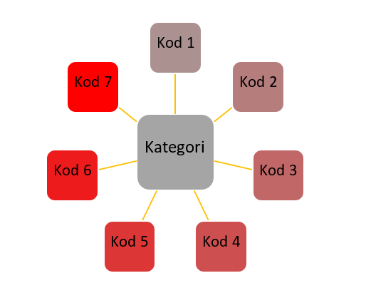

Note: Categories and codes were obtained from research findings.

**References**

For reference, see the sample reference format on the Writing Rules page.

References should start from a new page.

References should be written alphabetically by surname.

2nd lines in references should start 1,15 cm in.

There should be an automatic space between each bibliography by saying “Add Space After Paragraph”.

**For Example:**

And, M. (2021). *Osmanlı tasvir sanatları 1: Minyatür*. Yapı Kredi Yayınları.

Arseven, C. E. (1993). *Sanat ansiklopedisi*. Milli Eğitim Bakanlığı Basımevi, 5, 76.

Atbaş, Z. (2003). *Topkapı Sarayı Müzesi Kütüphanesi’ndeki H. 2155 numaralı murakka*. [Yayınlanmamış

Yüksek Lisans Tezi, Mimar Sinan Üniversitesi]

Atbaş, Z. (2011). Dağılmış bir Safevi murakkasının, 18.yüzyıla ait bir Osmanlı murakkasında değerlendirilişi. *Gelenek Kimlik bileşim: Kültürel kesişimler ve sanat, Günsel Renda’ya armağan*. Z. Y. Yamanlar & S. Bağcı (Haz.). Hacettepe Üniversitesi Basımevi.

Chang, C. (2017). Methodological ıssues in advertising research: Current status, shifts, and trends. *Journal of Advertising*, 46(1), 2-20. https://doi.org/10.1080/00913367.2016.1274924

Cho, C. H., & Khang, H. K. (2006). The state of internet-related research in communications, marketing, and advertising: 1994-2003. *Journal of Advertising*, 35(3), 143-163.

https://doi.org/10.2753/JOA0091-3367350309

Article information form should be written after the References. It should not be started from a new page.

**Article Information Form**

**Authors Notes:** If you do not want to write any notes, delete this heading.

**Authors Contributions:** All authors contributed equally to the writing of this paper. All authors read and approved the final manuscript.

**Conflict of Interest Disclosure:** No potential conflict of interest was declared by the authors.

**Copyright Statement:** Authors own the copyright of their work published in the journal and their work is published under the CC BY-NC 4.0 license.

**Supporting/Supporting Organizations:** No grants were received from any public, private or non-profit organizations for this research.

**Ethical Approval and Participant Consent**: It is declared that during the preparation process of this study, scientific and ethical principles were followed and all the studies benefited from are stated in the bibliography.

**Plagiarism Statement:** This article has been scanned by iThenticate.