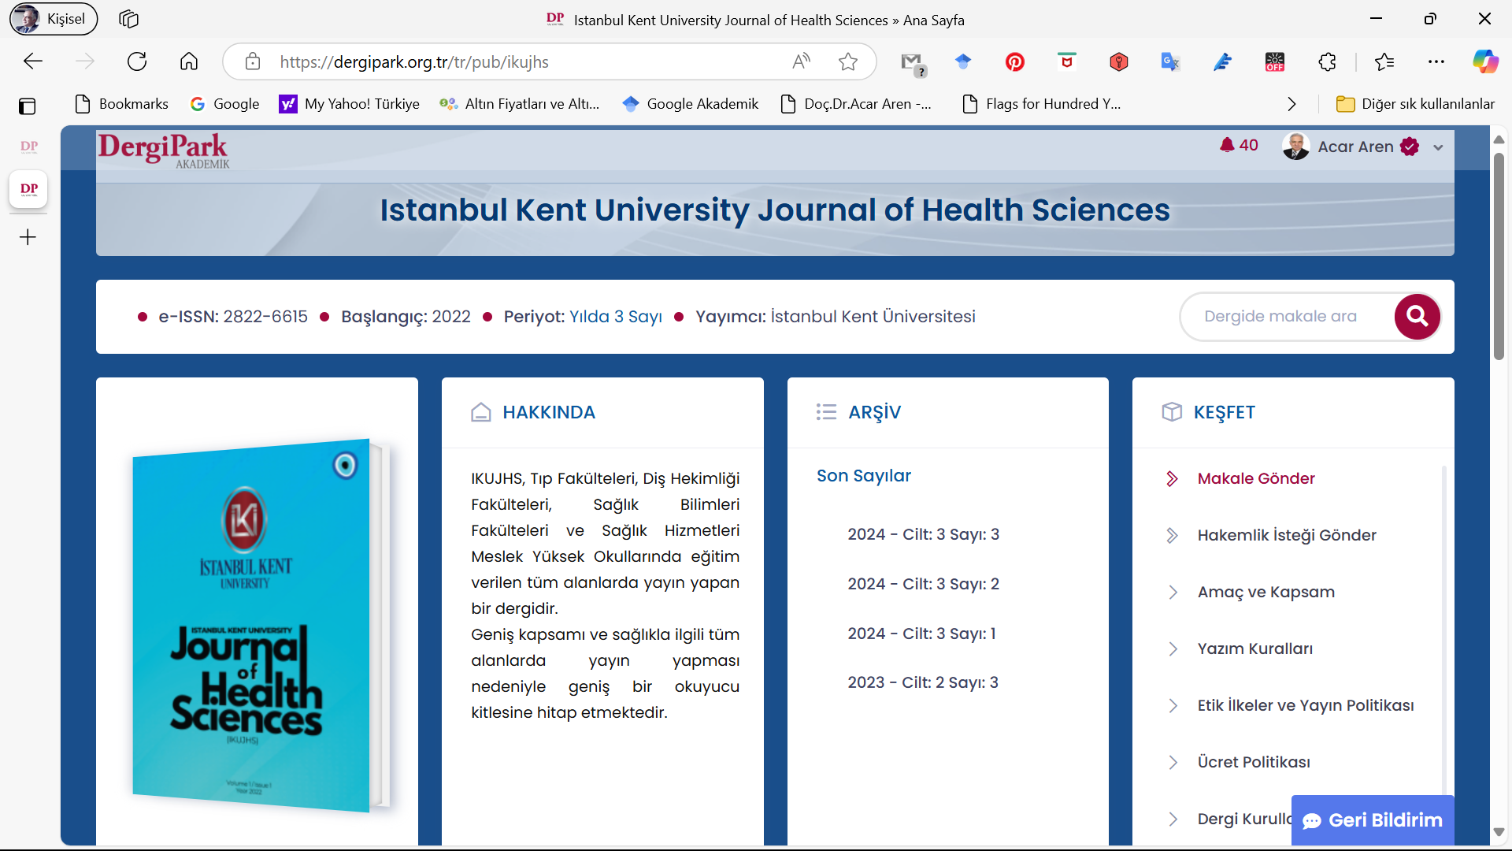

**Copyright Transfer Agreement Form**

To the Editor-in-Chief of the **Journal of Istanbul Kent University Journal of Health Sciences**

As the author(s) of the manuscriptentitled**............................................................................... ................................................................................................................................................................** I (we) hereby assign, convey, and otherwise transfer all rights, title, interest, and copyright ownership of said work for publication. Work includes the material submitted for publication and any other related material submitted to the Journal of **Istanbul Kent University Journal of Health Sciences**. The assignment of rights includes, but not limited to, editing, publishing, reproducing, distributing copies, signing in indexes or search databases in print, electronic, or other media, whether or not in use at the time of execution of this agreement, and claim copyright in said work throughout the world for the full duration of the copyright and any renewals or extensions thereof. All accepted works become the property of the Journal of **Journal of Istanbul Kent University Health Sciences** and its publisher of the Journal of Istanbul Kent University Journal of Health Sciences and may not be published elsewhere without having prior written permission from the journal.The author(s) hereby represents and warrants that they are sole author(s) of the work, that all authors have participated in and agree with the content and conclusions of the work, that the work is original, and does not infringe upon any copyright, propriety, or personal right of any third party, and that no part of it nor any work based on substantially similar data has been submitted to another publication.

Author name: ........................... Date: .../../.......

Author name: ........................... Date: .../../......

Author name: ........................... Date: .../../....

# Signature..............

**Please scan and upload this document to the journal’s online manuscript tracking system at https://dergipark.org.tr/tr/pub/ikujhs or send it back as an e-mail attachment. Please be sure to include this form in the original submission.**

**E-mail:** acar.aren@kent.edu.tr **GSM:** +90 5425421068