Article Title

**Abstract**

There should be 12 nk spaces before the title of the abstract and 6 nk spaces after the title. The title should be written in 10 pt, bold, plain, and left-aligned. There should be no space before the text (paragraph) and 6 nk spaces after the text (paragraph). The text should be written in 10 pt, plain, justified and “single-spaced”. In this section, an English abstract of at least 350 and at most 500 words should be written in a single paragraph. In the abstract, the purpose, scope and research questions of the research should be included, and the method, findings and results should be briefly mentioned. Words of Arabic/Persian origin in this section should be written in accordance with the transcription rules.

*Keywords*: At least 5 keywords should be given, the first keyword should be in a way to indicate the field of the article (e.g. Kalam, Hadith, etc.), the initials of all words should be capitalised.

*Article Title in Turkish*

**Öz**

There should be 12 nk spaces before the title of the abstract and 6 nk spaces after the title. The title should be written in 10 pt, bold, plain, and left-aligned. There should be no space before the text (paragraph) and 6 nk spaces after the text (paragraph). The text should be written in 10 pt, plain, justified and “single-spaced”. In this section, a Turkish abstract of at least 350 and at most 500 words should be written in a single paragraph. In the abstract, the purpose, scope and research questions of the research should be included, and the method, findings and results should be briefly mentioned.

*Anahtar Kelimeler*: At least 5 keywords should be given, the first keyword should be in a way to indicate the field of the article (e.g. Kalam, Hadith, etc.), the initials of all words should be capitalised.

Introduction

In this section, the purpose of the research should be stated, then the method, processes and tools used should be detailed.

There should be no space before the text (paragraphs) and 6 nk spaces after the text (paragraphs). The text should be written in Times New Roman font, 12 pt, plain and justified. Headings and paragraphs should be indented 1 cm in the whole article. Line spacing in all article fields should be “1,15”. Footnotes must comply with the ISNAD Citation System 2nd Edition as in the examples given.[1]

1. Title

First level titles should be written in 12 pt, plain, bold and left aligned. The first letter of each word should be capitalised. There should be 12 nk spaces before the first level title and 6 nk spaces after the title. In the article, except for the Introduction, titles should be numbered. Subtitles should be numbered hierarchically. First level titles can be used as many times as necessary.

1. 1. Subtitle

Second level titles should be in 12 pt, bold and left aligned. The first letter of each word should be capitalised. There should be 12 nk spaces before the second level title and 6 nk spaces after the title. Second level titles can be used as many times as necessary.

**1.1.1. Subtitle**

Third level titles should be in 12 pt, bold and left aligned. The first letter of each word should be capitalised. There should be 12 nk spaces before the third level title and 6 nk spaces after the title. Third level titles can be used as many times as necessary.

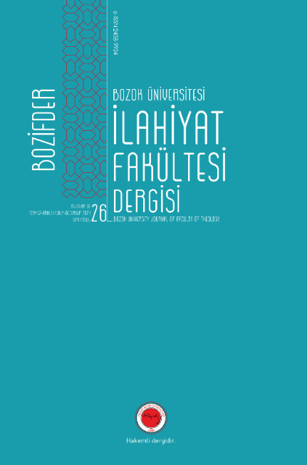

**Image 1**: Image Title[2]

The images and tables to be used in the article should be included in the text as shown in the example. All tables and figures should be numbered separately. Image and table captions should be placed under the image, aligned to the centre. Images and tables should be cited according to ISNAD Citation System 2nd Edition.

Conclusion

In the conclusion section, the findings, evaluation, and recommendations of the research should be included. If deemed necessary, appendices can be included at the end of the article.

There should be no space before the text (paragraphs) and 6 nk spaces should be left after the text (paragraphs). The text should be written in Times New Roman font, 12 pt, plain and justified.

Bibliography

ISNAD Citation System 2nd Edition must be taken into consideration in in-text referencing and bibliography writing as in the examples. References cited in the text have to be listed alphabetically at the end of the study.

In order to minimise errors in citation, it is recommended to use citation software such as Endnote, Zotero, Mendeley.

BOZIFDER, Bozok University Journal of Theology Facult. “Volume: 26 Issue: 26”. Access 20 January 2025. <https://dergipark.org.tr/en/pub/bozifder/issue/89650>

James, E. O. - Litt, D. *The Old Testament in The Light of Anthropology*. London: The Macmillan Company, 1935.

Taylor, Glen J. “A Response to Steve A Wiggins, ‘Yahweh, The God of Sun?’”. *Journal for the Study of the Old Testament* 71 (1996), 107-119.

1. E. O. James - D. Litt, *The Old Testament in The Light of Anthropology* (London: The Macmillan Company, 1935), 14–16; Glen J. Taylor, “A Response to Steve A Wiggins, ‘Yahweh, The God of Sun?’”, *Journal for the Study of the Old Testament* 71 (1996), 117.
2. Bozok University Journal of Theology Faculty (BOZIFDER), “Volume: 26 Issue: 26” (Access 20 January 2025).