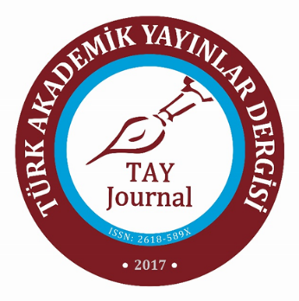
TAY JOURNAL
FIELD EDITOR EVALUATION CHECKLIST
Title and content are compatible.  ☐Good  ☐Average  ☐Poor | It contributes to the field.  ☐Good  ☐Average  ☐Poor
Summary and content are compatible.  ☐Good  ☐Average  ☐Poor | The method used is appropriate.  ☐Good  ☐Average  ☐Poor
The purpose and problem of the research were revealed.  ☐Good  ☐Average  ☐Poor | The results fulfil the research purpose/problem.  ☐Good  ☐Average  ☐Poor
The importance of the research and the gap it will fill in the literature are explained.  ☐Good  ☐Average  ☐Poor | The results are discussed together with the theoretical framework and literature.  ☐Good  ☐Average  ☐Poor
The theoretical and conceptual framework of the research is appropriate.  ☐Good  ☐Average  ☐Poor | The recommendations are in line with the research results.  ☐Good  ☐Average  ☐Poor
Current scientific studies and sources were used.  ☐Good  ☐Average  ☐Poor | The references in the text and the works in the bibliography are compatible.  ☐Good  ☐Average  ☐Poor
The research is organised in accordance with the field terminology.  ☐Good  ☐Average  ☐Poor | Language, style, intelligibility and fluency are appropriate.  ☐Good  ☐Average  ☐Poor
Suggestions for Authors:

Suggestion to the Editor:

