|  |
| --- |
| **Alman Dili ve Kültürü Araştırmaları Dergisi**  **Zeitschrift für Forschungen zur deutschen Sprache und Kultur The Journal of German Language and Culture Research**  **Cilt** xxx **Sayı** xxx **Haziran 2023/ Volume** xxx **Issue** xxx **June 2023**  Geliş Tarihi: xx.xx. 2023- Kabul Tarihi: xx.xx. 2023 /Submitted: xx.xx.2023- Accepted: xx.xx. 2023  Doi: xxxxxxxxxxxxxxxxxxxxxxxxxxxxxxx |

**Insert the Title Here Without Changing the Formatting**

Insert the Title in a Foreign Language Here

**(Do not write anything here)**

Name SURNAME[1]*

Name SURNAME [2]**

**Abstract**

Insert your abstract here without changing the formatting. The abstract should be between 150-200 words. Xxxxxxxxxxxxxxxxxxxxxxxxxxxxxxxx xxxxxxxxxxxxxxxxxxxxxxxxxxxxx xxxxxxxxxxxxxxxxxxxxxxxxx xxxxxxxxxxxxxxxxxxxxxxxxxxxxxxxxxxxxx xxxxxxxxxxxxxxxxxxxxxxxxxxxxxxxx xxxxxxxxxxxxxxxxxxxxxxxxxxxxx xxxxxxxxxxxxxxxxxxxxxxxxxxxxxxx xxxxxxxxxxxxxxxxxxxxxxxx.

***Keywords:*** *at least three, at most five words (the first letters of the keywords should be capitalized)*

**Abstract/Zusammenfassung**

Insert your abstract here without changing the formatting. Xxxxxxxxxxxxxxxxxxxxxxxxxxxxx xxxxxxxxxxxx xxxxxxxxxxxxx xxxxxxx xxxxxxxxxxxxxx xxxxxxxxxxxx xxxxxxx xxxxxxx xxxxxxx xxxxxxxxxxxxxxxxxxxxxxxxxx xxxxxxxxxxx xxxxxxxx xxxxxxxxxxxx xxxxxxxxxxxxxxx.

***Keywords:*** Keyword1, Keyword2, Keyword3

**Introduction (Level 1 Heading, Centered)**

Insert your text here without changing the formatting. Xxxxxxxxxxxxxxxxxxxxxxxxxxxxxxxxxxxxxxxxxxxxxxxxxxxxxxxxxxxxxxxxxxxxxxxxxxxxxxxxxxxxxxxxxxxxxxxxxxxxxxxxxxxxxxxxxx.

Xxxxxxxxxxxxxxxxxxxxxxxxxxxxxxxxxxxxxxxxxxxxxxxxxxxxxxxxxxxxxxxxxxxxxxxxxxxxxxxxxxxxxxxxxxxxxxxxxxxxxxxxxxxxxxxxxxxxxxxx.

**Level 2 Heading (Bold and Straight)**

Insert your text here without changing the formatting.Xxxxxxxxxxxxxxxxxxxxxxxxxxxxxxxxxxxxxxxxxxxxxxxxxxxxxxxxxxxxxxxxxxxxxxxxxxxxxxxxxxxxxxxxxxxxxxxxxxxxxxxxxxxxxxxxxx.

Xxxxxxxxxxxxxxxxxxxxxxxxxxxxxxxxxxxxxxxxxxxxxxxxxxxxxxxxxxxxxxxxxxxxxxxxxxxxxxxxxxxxxxxxxxxxxxxxxxxxxxxxxxxxxxxxxxxxxxxx.

***Level 3 Heading (Bold and Italicized)***

Xxxxxxxxxxxxxxxxxxxxxxxxxxxxxxxxxxxxxxxxxxxxxxxxxxxxxxxxxxxxxxxxxxxxxxxxxxxxxxxxxxxxxxxxxxxxxxxxxxxxxxxxxxxxxxxxxx.

Xxxxxxxxxxxxxxxxxxxxxxxxxxxxxxxxxxxxxxxxxxxxxxxxxxxxxxxxxxxxxxxxxxxxxxxxxxxxxxxxxxxxxxxxxxxxxxxxxxxxxxxxxxxxxxxxxxxxxxxx.

**Tables and Figures**

Tables and figures should be prepared according to the examples shown below. Figures and tables should be placed as close to the text as possible but should not be pasted into the text. Vertical lines should not be used in tables. Horizontal lines should be used as little as possible. For detailed information, please review the writing guidelines.

**Figure 1**

*Wright Map of Items (Title should be italicized, and the first letters of words should be capitalized)*

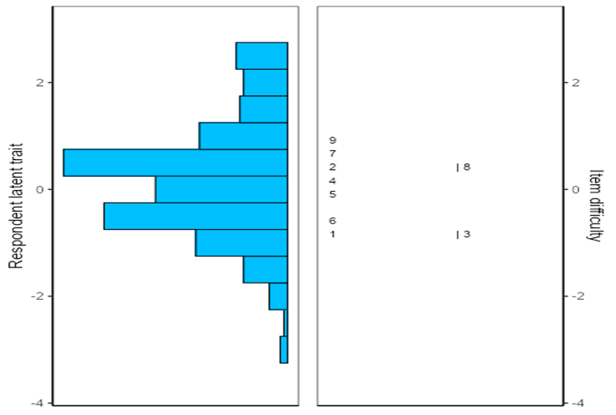

**Table 1**

*Convergent and Discriminant Validity of Scale (Title should be italicized, and the first letters of words should be capitalized)*

|  |  |  |  |  |  |  |  |
| --- | --- | --- | --- | --- | --- | --- | --- |
|  | CR | AVE | MSV | MaxR(H) | Personal enjoyment | Teacher appreciation | Social enjoyment |
| PE  TA  SE | 0.737  0.819  0.801 | 0.495  0.606  0.576 | 0.425  0.425  0.297 | 0.797  0.857  0.832 | 0.703  0.652  0.539 | 0.778  0.545 | 0.759 |

**Conclusion**

Insert your text here without changing the formatting.Xxxxxxxxxxxxxxxxxxxxxxxxxxxxxxxxxxxxxxxxxxxxxxxxxxxxxxxxxxxxxxxxxxxxxxxxxxxxxxxxxxxxxxxxxxxxxxxxxxxxxxxxxxxxxxxxxx.

Xxxxxxxxxxxxxxxxxxxxxxxxxxxxxxxxxxxxxxxxxxxxxxxxxxxxxxxxxxxxxxxxxxxxxxxxxxxxxxxxxxxxxxxxxxxxxxxxxxxxxxxxxxxxxxxxxxxxxxxx.

**References**

Aktay, S. (2010, 10 Temmuz). *İnternet nasıl çalışır? İnternet nedir?* <http://www.internetnedir.net/internet-nasil-calisir.html>

Aktay, S. (2015). Teknoloji destekli fen bilimleri öğretimi. İçinde Ş. S. Anagün & N. Duban (Eds.), *Fen Bilimleri Öğretimi* (ss. 425-454). Anı Yayıncılık.

Koçak, M. & Çobanoğulları, F. (2017). Dünyada ikinci yabancı dil olarak Almanca öğretiminde Danimarka örneği. *Maarif Mektepleri Uluslararası Eğitim Bilimleri Dergisi*,*1*(1), 1-12.

Shorey, R. C. (2015). Trait mindfulness and early maladaptive schemas in women seeking residential substance use treatment: A preliminary investigation. *Addiction Research & Theory*, *23*(4), 280-286. <http://doi.org/10.3109/16066359.2014.981810>

Yıldırım, A. & Şimşek, H. (2003). *Sosyal bilimlerde nitel araştırma yöntemleri*. Seçkin Yayıncılık.

1. * Author1 Title, Institution Name, Faculty Name, Department Name. Email: ….@........, ORCID: **(Do not write, will be added later)**
2. ** Author2 Title, Institution Name, Faculty Name, Department Name. Email: ….@......., ORCID: **(Do not write, will be added later)**