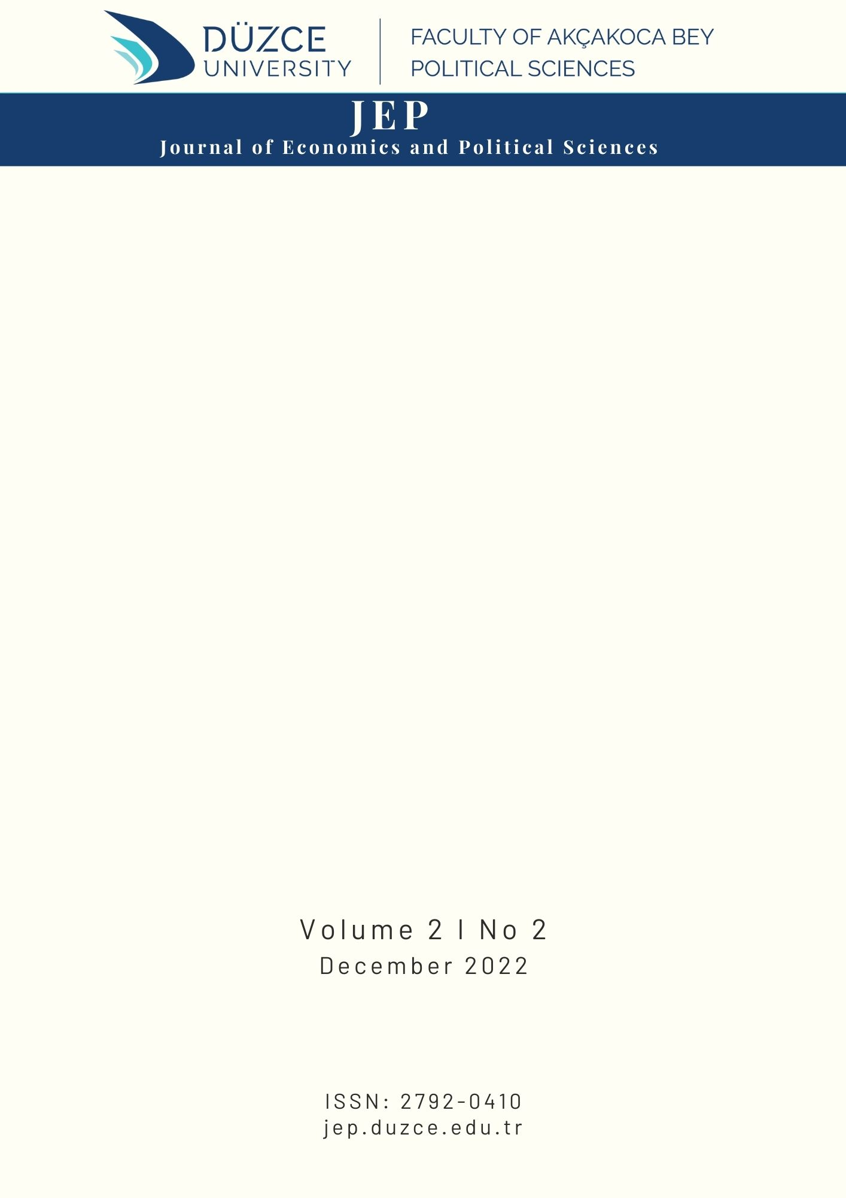
Makale Türü (Araştırma, Derleme, İnceleme vb.) ● Review Article
Please Write the Title of the Article Here (14 point, bold)
Author*
Title, Institution, Faculty/School, Department/Program, City/Country, ORCID number.
ARTICLE INFO |  |  |  | ABSTRACT
Article History:  Received: Please leave blank  Accepted: Please leave blank |  |  |  | Please write the abstract here. Make sure that the abstract is between 150-250 words. Please write in Bookman Old Style font, 9 points and italics.
Keywords: Please write the keywords here (3-5 words)

1. Introduction (12 point, bold)
Please write the main text here. The main text should be written in Bookman Old Style font and 11 points. Please write the main text here. The main text should be written in Bookman Old Style font and 11 points. Please write the main text here. The main text should be written in Bookman Old Style font and 11 points. Please write the main text here. The main text should be written in Bookman Old Style font and 11 points. Please write the main text here. The main text should be written in Bookman Old Style font and 11 points. Please write the main text here. The main text should be written in Bookman Old Style font and 11 points. Please write the main text here. The main text should be written in Bookman Old Style font and 11 points. Please write the main text here. The main text should be written in Bookman Old Style font and 11 points. Please write the main text here. The main text should be written in Bookman Old Style font and 11 points. Please write the main text here. The main text should be written in Bookman Old Style font and 11 points. Please write the main text here. The main text should be written in Bookman Old Style font and 11 points. Please write the main text here. The main text should be written in Bookman Old Style font and 11 points. Please write the main text here. The main text should be written in Bookman Old Style font and 11 points. Please write the main text here. The main text should be written in Bookman Old Style font and 11 points.
2. Theoretical Framework
Please write the main text here. The main text should be written in Bookman Old Style font and 11 points. Please write the main text here. The main text should be written in Bookman Old Style font and 11 points. Please write the main text here. The main text should be written in Bookman Old Style font and 11 points. Please write the main text here. The main text should be written in Bookman Old Style font and 11 points. Please write the main text here. The main text should be written in Bookman Old Style font and 11 points. Please write the main text here. The main text should be written in Bookman Old Style font and 11 points. Please write the main text here. The main text should be written in Bookman Old Style font and 11 points. Please write the main text here. The main text should be written in Bookman Old Style font and 11 points. Please write the main text here. The main text should be written in Bookman Old Style font and 11 points. Please write the main text here. The main text should be written in Bookman Old Style font and 11 points.
Please write the main text here. The main text should be written in Bookman Old Style font and 11 points. Please write the main text here. The main text should be written in Bookman Old Style font and 11 points. Please write the main text here. The main text should be written in Bookman Old Style font and 11 points. Please write the main text here. The main text should be written in Bookman Old Style font and 11 points. Please write the main text here. The main text should be written in Bookman Old Style font and 11 points. Please write the main text here. The main text should be written in Bookman Old Style font and 11 points. Please write the main text here. The main text should be written in Bookman Old Style font and 11 points. Please write the main text here. The main text should be written in Bookman Old Style font and 11 points. Please write the main text here. The main text should be written in Bookman Old Style font and 11 points. Please write the main text here. The main text should be written in Bookman Old Style font and 11 points.
Please write the main text here. The main text should be written in Bookman Old Style font and 11 points. Please write the main text here. The main text should be written in Bookman Old Style font and 11 points. Please write the main text here. The main text should be written in Bookman Old Style font and 11 points. Please write the main text here. The main text should be written in Bookman Old Style font and 11 points. Please write the main text here. The main text should be written in Bookman Old Style font and 11 points. Please write the main text here. The main text should be written in Bookman Old Style font and 11 points. Please write the main text here. The main text should be written in Bookman Old Style font and 11 points. Please write the main text here. The main text should be written in Bookman Old Style font and 11 points. Please write the main text here. The main text should be written in Bookman Old Style font and 11 points. Please write the main text here. The main text should be written in Bookman Old Style font and 11 points.
Figure 1. Please Write the Title of the Figure Here. (10 point, italic)

Source: Please write the source of the figure here. (10 point, italic)
3. Literature Review
Please write the main text here. The main text should be written in Bookman Old Style font and 11 points. Please write the main text here. The main text should be written in Bookman Old Style font and 11 points. Please write the main text here. The main text should be written in Bookman Old Style font and 11 points. Please write the main text here. The main text should be written in Bookman Old Style font and 11 points. Please write the main text here. The main text should be
written in Bookman Old Style font and 11 points. Please write the main text here. The main text should be written in Bookman Old Style font and 11 points. Please write the main text here. The main text should be written in Bookman Old Style font and 11 points. Please write the main text here. The main text should be written in Bookman Old Style font and 11 points. Please write the main text here. The main text should be written in Bookman Old Style font and 11 points. Please write the main text here. The main text should be written in Bookman Old Style font and 11 points.

Table 1. Please Write the Title of the Table Here. (10 point, italic)
(Avoid using vertical lines in tables. Variables should have a “bold” font. Units, if any, should be “italicized” and shown in parentheses one line below.)

Bank Type | Number of Banks | Share in the Sector  (%)
Deposit Banks | 34 | 65
Development and Investment Banks | 13 | 25
Participation Banks | 5 | 10
Total | 52 | 100
Source: Please write the source of the table here. (10 point, italic)

4. Data, Methodology and Analysis
Please write the main text here. The main text should be written in Bookman Old Style font and 11 points. Please write the main text here. The main text should be written in Bookman Old Style font and 11 points. Please write the main text here. The main text should be written in Bookman Old Style font and 11 points. Please write the main text here. The main text should be written in Bookman Old Style font and 11 points. Please write the main text here. The main text should be written in Bookman Old Style font and 11 points. Please write the main text here. The main text should be written in Bookman Old Style font and 11 points. Please write the main text here. The main text should be written in Bookman Old Style font and 11 points. Please write the main text here. The main text should be written in Bookman Old Style font and 11 points. Please write the main text here. The main text should be written in Bookman Old Style font and 11 points. Please write the main text here. The main text should be written in Bookman Old Style font and 11 points.
4.1. Data and Methodology
Please write the main text here. The main text should be written in Bookman Old Style font and 11 points. Please write the main text here. The main text should be written in Bookman Old Style font and 11 points. Please write the main text here. The main text should be written in Bookman Old Style font and 11 points. Please write the main text here. The main text should be written in Bookman Old Style font and 11 points. Please write the main text here. The main text should be written in Bookman Old Style font and 11 points. Please write the main text here. The main text should be written in Bookman Old Style font and 11 points. Please write the main text here. The main text should be written in Bookman Old Style font and 11 points. Please write the main text here. The main text should be written in Bookman Old Style font and 11 points. Please write the main text here. The main text should be written in Bookman Old Style font and 11 points. Please write the main text here. The main text should be written in Bookman Old Style font and 11 points.
4.2. Analysis
Please write the main text here. The main text should be written in Bookman Old Style font and 11 points. Please write the main text here. The main text should be written in Bookman Old Style font and 11 points. Please write the main text here. The main text should be written in Bookman Old Style font and 11 points. Please write the main text here. The main text should be written in Bookman Old Style font and 11 points. Please write the main text here. The main text should be written in Bookman Old Style font and 11 points. Please write the main text here. The main text should be written in Bookman Old Style font and 11 points. Please write the main text here. The main text should be written in Bookman Old Style font and 11 points. Please write the main text here. The main text should be written in Bookman Old Style font and 11 points.

4.2.2. Third Level Title
Please write the main text here. The main text should be written in Bookman Old Style font and 11 points. Please write the main text here. The main text should be written in Bookman Old Style font and 11 points. Please write the main text here. The main text should be written in Bookman Old Style font and 11 points. Please write the main text here. The main text should be written in Bookman Old Style font and 11 points.

Table 2. Please Write the Title of the Table Here. (10 point, italic)
Null Hypotheses | F statistic | p – value
INR does not Granger cause EXR | 0.12714 | 0.8807
EXR does not Granger cause INR | 3.14090 | 0.0461
Note: According to AIC proper lag length is 2.
Source: Please write the source of the table here. (10 point, italic)

Please write the main text here. The main text should be written in Bookman Old Style font and 11 points. Please write the main text here. The main text should be written in Bookman Old Style font and 11 points. Please write the main text here. The main text should be written in Bookman Old Style font and 11 points. Please write the main text here. The main text should be written in Bookman Old Style font and 11 points.
5. Findings
Please write the main text here. The main text should be written in Bookman Old Style font and 11 points. Please write the main text here. The main text should be written in Bookman Old Style font and 11 points. Please write the main text here. The main text should be written in Bookman Old Style font and 11 points. Please write the main text here. The main text should be written in Bookman Old Style font and 11 points.
6. Conclusion and Evaluation
Please write the main text here. The main text should be written in Bookman Old Style font and 11 points. Please write the main text here. The main text should be written in Bookman Old Style font and 11 points. Please write the main text here. The main text should be written in Bookman Old Style font and 11 points. Please write the main text here. The main text should be written in Bookman Old Style font and 11 points.
Please write the main text here. The main text should be written in Bookman Old Style font and 11 points. Please write the main text here. The main text should be written in Bookman Old Style font and 11 points. Please write the main text here. The main text should be written in Bookman Old Style font and 11 points. Please write the main text here. The main text should be written in Bookman Old Style font and 11 points.
Please write the main text here. The main text should be written in Bookman Old Style font and 11 points. Please write the main text here. The main text should be written in Bookman Old Style font and 11 points. Please write the main text here. The main text should be written in Bookman Old Style font and 11 points. Please write the main text here. The main text should be written in Bookman Old Style font and 11 points.

References
Campbell, J. L. (2002). Ideas, politics, and public policy. Annual review of sociology, 28(1), 21-38.
Dixit, A. K. (2011). Lawlessness and economics. İçinde Lawlessness and Economics. Princeton University Press.
Djankov, S., Glaeser, E., La Porta, R., Lopez-de-Silanes, F., & Shleifer, A. (2003). The new comparative economics. Journal of comparative economics, 31(4), 595-619.
Gibson-Graham, J. K. (2006). A postcapitalist politics. University of Minnesota Press.
Greif, A. (2006). Institutions and the path to the modern economy: Lessons from medieval trade. Cambridge University Press.
Henrich, J., Ensminger, J., McElreath, R., Barr, A., Barrett, C., Bolyanatz, A., ... & Ziker, J. (2010). Markets, religion, community size, and the evolution of fairness and punishment. Science, 327(5972), 1480-1484.
Heywood, A. (2013). The Palgrave Macmillan Politics. New York: Palgrave Macmillan.
Rodrik, D. (2008). One economics, many recipes. İçinde One Economics, Many Recipes. Princeton University press.

* Sorumlu yazar / Corresponding Author. e-posta:

