Article Title
First AUTHOR^{1*}, Second AUTHOR², Third AUTHOR³
¹Yozgat Bozok University, Hemp Research Institute, Department of Agriculture and Food, 66100, Yozgat, Türkiye
²Yozgat Bozok University, Hemp Research Institute, Department of Materials and Energy, 66100, Yozgat, Türkiye
³Yozgat Bozok University, Hemp Research Institute, Department of Basic Sciences and Health, 66100, Yozgat, Türkiye

Abstract
(Times New Roman, 10 point, single spaced): This document is a template prepared for use by authors submitting articles to the Journal of Hemp and Biotechnology Research. The title of the article should be written in lower case letters except for the first word and proper nouns. The title page should include the full title in sentence form, the full names of all authors and their institutions. Information about the corresponding author should be written at the end of the first page. Please include all necessary notifications or disclaimers. Clear information about the research and the results obtained should be provided immediately below the abstract title and should not exceed 250 words. The abstract should not contain quotations. The title and abstract of the article should not contain mathematical formulas. Please provide a maximum of 5 keywords or phrases that will be useful for access and indexing. Keywords should not contain abbreviations.
Keyword: Keyword 1, Keyword 2, Keyword 3, Keyword 4, Keyword 5
Özet
(New Roman, 10 punto, tek satır aralıklı,): Bu belge, Kenevir ve Biyoteknoloji Araştırmaları Dergisi’ne makale gönderen yazarların kullanması için hazırlanmış bir şablondur. Makalenin başlığı, ilk kelime ve özel isimler dışında küçük harflerle yazılmalıdır. Başlık sayfası, cümle halinde tam başlığı, tüm yazarların tam adlarını ve kurumları içermelidir. Sorumlu yazara ait bilgiler ilk sayfanın sonuna yazılmalıdır. Lütfen gerekli tüm bildirimleri veya sorumluluk reddi beyanlarını da ekleyiniz. Özet başlığının hemen altında, araştırma ve elde edilen sonuçlar hakkında net bilgi verilmeli ve 250 kelimeyi geçmemelidir. Özet alıntı içermemelidir. Makalenin başlığı ve özeti matematiksel formüller içermemelidir. Lütfen erişim ve indeksleme için faydalı olacak en fazla 5 anahtar kelime veya kelime öbeği veriniz. Anahtar kelimeler kısaltmalar içermemelidir.
Anahtar kelime: Anahtar kelime 1, Anahtar kelime 2, Anahtar kelime 3, Anahtar kelime 4, Anahtar kelime 5

- INTRODUCTION (Title Times New Roman, 12 point, 1.15 line spacing)
Main topics are Times New Roman 12 point, 1.15 line spacing. Text content is Times New Roman 11 point, 1.15 line spacing. The first letter of each word in subheadings should be capitalized.
The study should discuss the status of the study, only outline the basic background, and should not include findings or conclusions. It should not be a review of the subject area and should end with a clear statement of the problem addressed. Abbreviations should be defined in parentheses first and then used as abbreviations.

  - Article Content
Authors should use this template when preparing an article to be submitted to the Journal of Hemp and Biotechnology Research. The article should be written in Microsoft Word. The texts in the relevant sections of the template can be changed by typing or copying and pasting, and the styles provided in the template can be used.
The order of the studies submitted for publication in the journal should consist of; Title, Abstract, Keywords and then Introduction, Materials and Methods, Findings and Discussion or Findings, Discussion, Conclusion, References and Appendix sections. Grammar rules should be taken into account in the articles. Articles should be written in Times New Roman 11 point font with 1.15 line spacing, leaving 1.27 cm margins on all sides of the page. Extensive quotations and discussions from published literature should be avoided. Research articles should not exceed 30 pages and should have a limit of 40 sources.
1.2 Symbols, Units and Abbreviations
If symbols such as ×, µ, η, ν are used, they should be added using Word's Symbol menu. Microsoft Word equations should be used to write mathematical equations and formulas. Equations should not be in the form of pictures.
Degree symbols (°) should be used from the Symbol menu, superscript o or number 0 should not be used. Multiplication symbols (×) should be used, the letter x should not be used. Spaces should be placed between numbers and units (e.g. 3 km) and numbers and mathematical symbols (+, –, ×, =, <, >), but not between numbers and percentage symbols (e.g. 45%). Please use SI unit system.
  - In-text Citation
References in the text should be written according to the author-year principle and year order. Literature from the same year but by different authors should be listed alphabetically (Aras et al., 2021; Türkan and Atalar, 2021; Xu, 2021). If more than one source published by the same author in the same year is used, the source should be indicated with letters such as a, b, c after the publication year. It is recommended not to use sources with web addresses whenever possible. Authors should not cite unpublished results and personal interviews as sources. Footnotes should be avoided, and if absolutely necessary (not including important sections of the study) they should be written briefly by separating them with a line and placing an asterisk on the page where they are used. If the article sent to our journal is written in Turkish; for a single author (Surname, year), for two authors (Surname and Surname, year), for three or more authors (Surname et al., year); If the article sent to our journal is written in English; For a single author, it should be written as (Surname, Year), for two authors, it should be written as (Surname and Surname, Year), for three or more authors, it should be written as (Surname et al., Year). If more than one source is cited, the references should be separated with (;) and should be listed from oldest to newest (Surname, 1977; Soyadı et al., 2013). If the source is an unknown author, it should be given as (Anonymous, Year) in articles written.
  - Author Names
Author names should be in 11 point font, and addresses should be in 10 point font. There should be no line spacing between author names and addresses.
  - Footnotes
Footnotes should be avoided as much as possible, but if necessary, they should be written at the bottom of the page, separated by a line.
- MATERIAL AND METHODS
The findings obtained from the study should be included. The same data or information given in a table should not be repeated in any way and vice versa. It is unacceptable to repeat the numbers in the tables too much in the text, as well as to give long explanations of the tables or figures.
- FINDINGS AND DISCUSSION
The findings obtained from the study should be included. The same data or information given in a table should not be repeated in any way and vice versa. It is unacceptable to repeat the numbers in the tables too much in the text, as well as to give long explanations of the tables or figures.
  - Tables and Figures
First, simple findings can be given directly in the text without the need for tables or figures. All illustrations (photographs, drawings, graphs, etc.) except tables should be labeled as "Figure". All tables and figures should have a title and/or description and should be numbered (Table 1, Figure 2), in case of a single table or figure, the table or figure should be labeled as "Table" or "Figure". Subtitles should be written in sentences (Artificial Bee Colony Algorithm). The font used in figures should be Times New Roman. If symbols such as ×, μ, η or ν are used, they should be added using Word's Symbol menu.
Table 1. (Short Title) (Times New Roman, 10 point, single spaced)
Positive Experiences
Classification | Embodied Metaphors
Abstract | jungle, driving force, game-changer, underprivileged
Concrete | stones, heart, fumes
Non-living | technology, browser
All tables and figures should be numbered consecutively as referred to in the text. When the width is set to 16 cm, the resolution of the images should not be less than 118 pixels/cm. Images should be scanned at 1200 dpi and should be in jpeg or tiff format. Graphs and diagrams should be drawn with a line thickness between 0.5 and 1 point. Graphs and diagrams with a line thickness of less than 0.5 points or more than 1 point are not accepted. Scanned or photocopied charts and diagrams are not accepted. Figures that are graphs, diagrams or drawings should be presented in an editable format, i.e. the graphics team should be able to modify them. Also, all tables should be presented as editable text, not as images, excel or pdf. It should not be pasted as an image file (tiff, jpeg or eps) unless it is a photograph. Tables and figures, including titles, section headings, and footnotes, should not exceed 16 × 20 cm and should not be less than 8 cm wide. Please use the Table feature of Microsoft Word for all tables
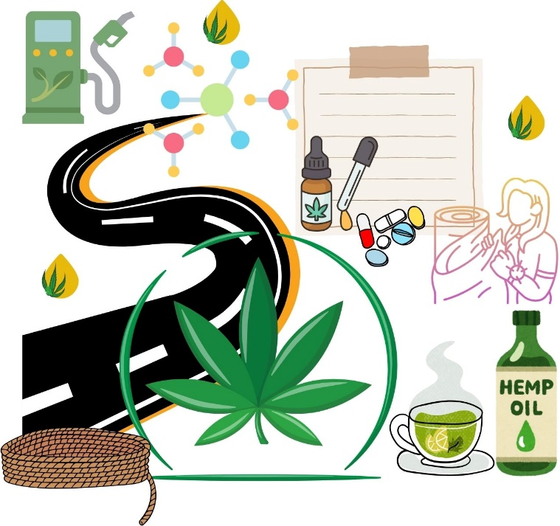
Figure 1. (Short Title) (Times New Roman, 10 point, single-spaced)

4. CONCLUSION
Statements from the Results and Discussion sections should not be repeated here. The final paragraph should highlight the main conclusions of the study.
ACKNOWLEDGEMENTS
Authors should state technical assistance, the source of specific materials, and financial support. The names of funding organizations should be written in full.
AUTHORS' CONTRİBUTİONS
Authors should acknowledge technical assistance, sources of special materials, and financial support. The names of funding organizations should be written in full.
CONFLICTS OF INTEREST
Conflicts of interest must be declared.

RESEARCH AND PUBLICATION ETHICS

If your article is outside the scope of ethics, please include the statement “The author declares that this study complies with Research and Publication Ethics.” If it is a study that requires an ethics committee decision, information regarding approval (board name, date and issue number) should be stated.
REFERENCES
References should be arranged according to APA (6.0) style. All articles cited in the text should be included in the references list. The references list should be arranged alphabetically by taking into account the author surnames. The references in the text should be written according to the author-year basis and year order. Literatures from the same year but different authors should be listed alphabetically (Aras et al., 2021; Türkan and Atalar, 2021; Xu, 2021). If more than one reference published by the same author in the same year is used, the reference should be indicated with letters such as a, b, c after the publication year. It is recommended not to use sources with web addresses as much as possible. Authors should not cite unpublished results and personal interviews as references. The references in text should be written as (Surname, year), (Surname and Surname, year), and (Surname et al., year) for a single, two and three or more authors, respectively. If more than one reference is cited, should be separated with (;) and should be listed from oldest to newest (Surname, 1977; Surname et al., 2013). If the reference is unknown, it should be given as (Anonymous, Year). The references section should be in 11 point font size and a 0.5 cm hanging indent should be left on the second line and the following lines of each source. Journal names should not be abbreviated. All references should be given in alphabetical order.
Journal Articles
Surname, A. A., Surname, B. B., Surname, C. C. (Year). Title of the article. Title of the Periodical, Volume(Issue), s-s. doi:xx.xxxxxxxxxx
Surname, N. N., Surname, N. (Year). The full title of the article. Journal Name, Volume(Issue), first and last page.
Books and Book Chapters
Surname, N., Surname, N. (Year). Title of the book or proceeding. City: Publisher.
Book
Surname, A. A. (Year). Title of the work. Place: Publisher.
Surname, A. A. (Year). Title of the work. URL: http://www.xxxxxxxxxx
Surname, A. A. (Year). Title of the work. doi:xxxxxxxxxxx
Editor, A. A. (Ed.). (Year). Title of the work. Location: Publisher.
Book Chapter
Surname, A. A., Surname, B. B. (Year). Chapter or Introduction Title. A. Editor, B. Editor and C. Editor (Ed.), Book Title (pp. xxx-xxx). Location: Publisher.
Surname, A. A., Surname, B. B. (Year). Chapter or Introduction Title. A. Editor and B. Editor (Ed.), Book Title (pp. xxx-xxx). URL: http://www.xxxxxxxxxxx
Surname, A. A., Surname, B. B. (Year). Chapter or Introduction Title. A. Editor, B. Editor and C. Editor (Ed.), Book Title (pp. xxx-xxx). doi:xxxxxxxxxxxx
Congress or Symposium Proceedings
Surname, A. A. (Year). Paper or Poster Title. In: Title of Book in Which It Was Published. A. Surname, A. A. Surname, A. Surname (Ed.), Congress/Symposium title, (pp. xxx-xxx). City, Country. Access address: XXXXXX
Surname, N. and Surname, N. (Year). The full title of the conference paper. In: Title of proceeding book. N., Surname, N., Surname, (Ed.), Congress/Symposium title, (pp. xxx-xxx). City, Country. Access address: XXXXXX
Thesis
Surname, A. A. (Year). Title of doctoral or master's thesis (Master's thesis/PhD thesis). Retrieved from database (Access or Order No.).
Surname, A. A. (Year). Title of doctoral or master's thesis (Unpublished doctoral thesis/master's thesis). Institution name, Location information.
Articles or Reports with Internet Address
Surname N. (Year). The full title of internet addressed article. Access address: http://www.xxxxxxxxxxxx (Access address: day month, year).
Surname N. (Year). The full title of internet addressed article. Access address:: http://www.xxxxxxxxxxxx (Accessed date: month day, year).

