Research Article

**Sakarya Tıp Dergisi**

**Sakarya Med J**

e-ISSN: 2146-409X

Publisher: Sakarya University

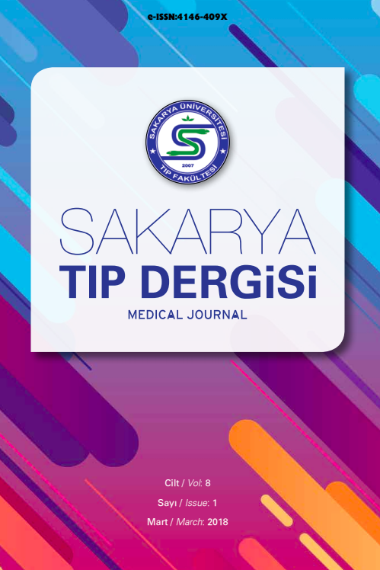

Vol. xx, No. x, xx-xx, 202x

DOI: http://doi.org/10.31832/smj.xxxx

**Cite as:** Surname N, Surname N. Manuscript title, write in cambria 11 point size, with the first letter of each word capitalized. *Sakarya Med J.* 202x;x(x):xx-xx. doi:10.31832/smj.xxxx



This is an open access paper distributed under the terms and conditions of the Creative Commons Attribution-NonCommercial 4.0 International License.

**Manuscript Title, Write in Cambria 12 Point Size, with the First Letter of Each Word Capitalized**

Name Surname1*[](https://orcid.org/), Name Surname2[](https://orcid.org/)

1 Sakarya University, Sakarya, Türkiye

xxxxx@sakarya.edu.tr, [ror.org/04ttnw109](https://ror.org/04ttnw109)

2 xxx University, xxx, Türkiye

xxxxx@xxxx.xx.xx,

ror.org/xxxxx

* Corresponding Author

**Abstract:** The abstract should express the subject briefly and concisely. The number of words in the language in which the abstract is written should be a maximum of 250 words and written in **9-point Cambria** font. Research articles written in Turkish must have Turkish and English abstracts (the number of words is not required in the English abstract since it is a translation from Turkish). Research articles written in English must include an English abstract (It is recommended to include a Turkish abstract. Word count is not required.) The word count is not required in the translated abstract. In articles written in Turkish, an extended summary of **750-1000 words** should be written immediately after the abstracts. At least 3 and at most 6 keywords should be written under Turkish and English abstracts. The first letters of keywords should be written in capital letters. The abstract should express the subject briefly and concisely. The number of words in the language in which the abstract is written should be a maximum of 250 words and written in **9-point Cambria** font. Research articles written in Turkish must have Turkish and English abstracts (the number of words is not required in the English abstract since it is a translation from Turkish). Research articles written in English must include an English abstract (It is re commended to include a Turkish abstract. Word count is not required.) The word count is not required in the translated abstract. In articles written in Turkish, an extended summary of 750-1000 words should be written immediately after the abstracts. **At least 3 and at most 6 keywords** should be written under Turkish and English abstracts. The first letters of keywords should be written in capital letters.

**Keywords:** Keyword one, Keyword two, Keyword three, Keyword four, Keyword five



Received: xx.xx.202x

Accepted: xx.xx.202x

Available Online: xx.xx.202x

**1. INTRODUCTION**

The article should be written in Cambria font and 11 pt.

In the body text, 1.15 line spacing should be used and 6 nk space should be left between paragraphs by clicking ‘Add Space After Paragraph’.

Section headings: The first title should be capitalised. The first title should be left justified and bold.

In the second title, only the first letter of the first word should be capitalised. All other words should be written in lower case. The second title should be left justified and bold.

In the third title, only the first letter of the first word should be capitalised. All other words should be lowercase. The third title should be left justified and bold.

**Figure 1.**

*The words used in writing a caption written in lowercase except for the first letter*

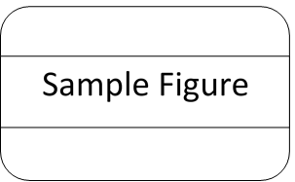

* 1. **Figures and tables**

For figure and table captions, 11-point Cambria font should be used. Figures and tables should be placed immediately after the first citation in the text and should be placed so that they can be easily referred to while reading the text.

Figure captions should be written below the figure, centred, and no full stops should be left at the end of the lines.

Table captions should be placed at the top of the table, left-justified and without a full stop at the end of the line.

**Table 1.**

*Table 1 title*

|  |  |  |
| --- | --- | --- |
| Heating Rate (β)  °C/dak | **Level 1** | **Level 2** |
| Peak Temperature, K | Peak Temperature, K |
| 5 | 797.0 | 974.2 |
| 10 | 821.7 | 993.3 |
| 15 | 829.4 | 1008.4 |
| 20 | 833.2 | 1023.6 |

**Table 2.**

*Table 2 title*

|  |  |  |
| --- | --- | --- |
| Heating Rate (β)  °C/dak | **Level 1** | **Level 2** |
| Peak Temperature, K | Peak Temperature, K |
| 5 | 797.0 | 974.2 |
| 10 | 821.7 | 993.3 |
| 15 | 829.4 | 1008.4 |
| 20 | 833.2 | 1023.6 |
| 5 | 797.0 | 974.2 |
| 10 | 821.7 | 993.3 |
| 15 | 829.4 | 1008.4 |
| 20 | 833.2 | 1023.6 |
| 5 | 797.0 | 974.2 |
| 20 | 833.2 | 1023.6 |

**Figure 2.**

*Figure 2 title*

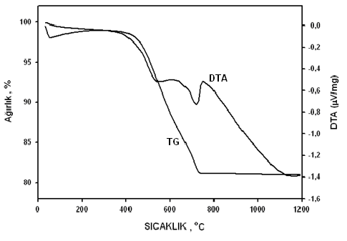

Article information form should be written after the Conclusion section.

**Article Information Form**

***Acknowledgments***

Authors would like to thank Dr. Xxxx Xxxxx. for his/her contributions.

Publications produced from theses can be listed in this section.

***Funding***

Authors has no received any financial support for the research, authorship or publication of this study.

***Authors' Contribution***

Please write the author contributions in detail as specified in the copyright agreement.

***The Declaration of Conflict of Interest/ Common Interest***

No conflict of interest or common interest has been declared by authors.

***The Declaration of Ethics Committee Approval***

This study does not require ethics committee permission or any special permission.

***The Declaration of Research and Publication Ethics***

Authors of the paper declare that they comply with the scientific, ethical and quotation rules of Sakarya Medical Journal in all processes of the paper and that they do not make any falsification on the data collected. In addition, they declare that Sakarya Medical Journal and its editorial board have no responsibility for any ethical violations that may be encountered, and that this study has not been evaluated in any academic publication environment other than Sakarya Medical Journal.

***Artificial Intelligence Statement***

No artificial intelligence tools were used while writing this article. (If an artificial intelligence tool was used, please write a detailed explanation.)

***Copyright Statement***

Authors own the copyright of their work published in the journal and their work is published under the CC BY-NC 4.0 license.

# REFERENCES

1. Baki S, Piyal B. Work-family conflict as regard to healthcare workers in extraordinary situations such as COVID-19 pandemic. *Health and Community*. 2020;July(Suppl):119-123.

2. Pala SÇ, Metintaş S. Healthcare workers in the COVID-19 pandemic. *ESTUDAM Journal of Public Health*. 2020;5(COVID-19 Suppl.):156-168.

3. Saatçı E. COVID-19 pandemic and healthcare workers: To survive or to live? *Turkish Journal of Family Practice*. 2020;24(3):153-166.

4. Lumley SF, O’Donnell D, Stoesser NE, Matthews PC, Howarth A, Eyre DW, et al. For the Oxford University Hospitals Staff Testing Group. Antibody status and incidence of SARS-CoV-2 infection in health care workers. *N Engl J Med*. 2020;December. doi:10.1056/NEJMoa2034545

5. Elvis AM, Ekta JS. Ozone therapy: A clinical review. *J Nat Sci Biol Med*. 2011;2(1):66-70. doi:10.4103/0976-9668.82319