**English Title**

**ABSTRACT**

“Abstract” should not exceed 300 words and abbreviations should be avoided as much as possible in both abstracts. In accordance with the English spelling rules, it should be written in "Times New Roman" font with 10 font size and one and a half line spacing.

**Keywords:** Keywords1, keywords2, keywords3, keywords4

**Türkçe Başlık**

**ÖZET**

Türkçe “Özet” 300 kelimeyi geçmemeli ve her iki özette kısaltmalardan mümkün olduğunca kaçınılmalıdır. Türkçe yazım kurallarına uygun olarak “Times New Roman” yazı karakterinde 10 punto olarak ve bir buçuk satır aralıkla yazılmalıdır.

**Anahtar Kelimeler:** Anahtar kelime1, anahtar kelime2, anahtar kelime3, anahtar kelime4

**GRAPHICAL ABSTRACT**

A graphıcal abstractis recommended for our journal.

Examp:

**1. INTRODUCTION**

When citing references in the text, references should be specified according to the "(surname, date)" system. When citing references in the text according to the surname date system, the surname of the author should be written in parentheses with the first letter of the reference capitalized and the others lowercase, then the publication date of the work should be written by placing a comma (Tanriverdi, 2020). If more than one author is to be named, a semicolon should be placed after the dates (Tanriverdi, 2021; Yildiko, 2022). If the reference is to a work with two authors, if it is published in English, the conjunctions “and” (Halliwell and Gutteridge, 1990; Akdeniz and Cakmak, 2007) should be added between the surnames of the authors. While citing the reference according to the surname of the author in the text, if the number of authors is three or more, if the article was published in English after the surname of the first author, the expressions "et al.," (Adiguzel et al., 2022; Yildiko et al., 2021) should be used. While citing the reference in the text according to the surname of the author, if there are publications by the same author and authors in the same year, the letters a, b, c should be used after the publication year. (Tanriverdi, 2021a; 2021b).

**2. MATERIAL AND METHOD**

SI (Systeme International d'Units) measurement units should be used in all articles. In numbers and units, only a period (.) should be used as a decimal separator (20.23), “/” sign should not be used when writing units, it should be exponentiated by leaving a space (g L-1) in writing very large numbers, the numbers should be separated by triples (such as 100 000). ).

**3. RESULTS AND DISCUSSIONS**

**3.1. Second Level Title**

**3.1.1. third level title**

For Figures and Tables, the expressions “Figure” and “Table” should be used in the English article. (Table 1., Figure 1.). Explanations and footnotes of tables and figures should be written in 10 points at the bottom of the table or table, and there should not be a dot (.) at the end. The title of the table should be 12 points and above the table, and the content should be given in 10 points. Figures, graphics, photographs and the like should be written with the title "Figure" at the bottom and in 12 points. Figures and Tables should be given in the text and should not be added to the end of the text.

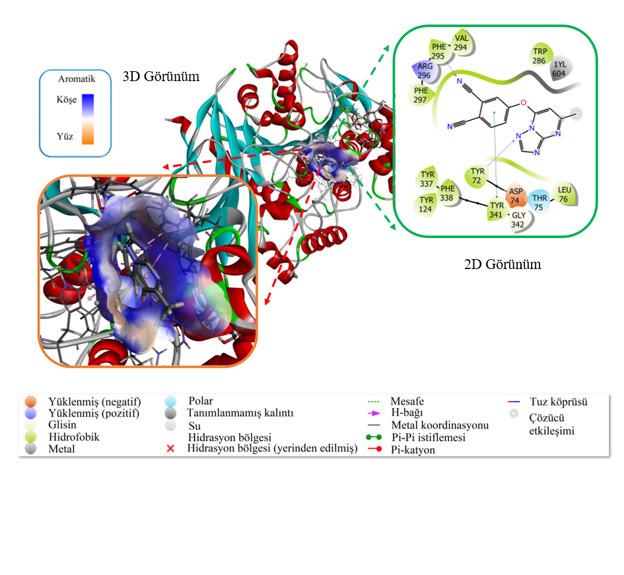

**Figure 1.** 3D view of the aromatic surface on the receptor and 2D view of PN2 - AChE enzyme interactions

**Table 1.** Physicochemical and lipophilicity of the most active organism

| **Code** | **Lipophilicity consensus**  **log P** | **Physico-chemical properties** | | | | | | | | |
| --- | --- | --- | --- | --- | --- | --- | --- | --- | --- | --- |
| **MAa**  **g/mol** | **Heavy atoms** | **aromatic heavy atoms** | **Rot. bond** | **H‐bond acc.** | **H‐bond don.** | **MRb** | **TPYAc  (A2)** | **% ABSd** |
| 1 | 4.99 | 416.47 | 32 | 24 | 5 | 4 | 1 | 123.04 | 77.04 | 82.42 |
| 2 | 1.54 | 276.25 | 21 | 15 | 2 | 6 | 0 | 71.69 | 99.89 | 74.54 |

a**MA**, molecular weight; b**MR**, molar refractivity; c**TPYA**, topological polar surface area; d**%ABS:** absorption percentage (ABS %= 109 − [0.345 × TPYA]; **e**Quinic acid; **f**Quercitrin; gMiquelianin.

Formulas should be numbered and the formula number should be shown in parentheses, aligned to the right next to the formula. Formulas should be in 12 points, main characters and variables should be in italics, numbers and mathematical expressions should be plain.

**4. CONCLUSION**

“It should be noted that the conclusion part is not the same as the abstract.”

**ACKNOWLEDGMENTS (IF AVAILABLE)**

**REFERENCES**

References section should be in 11 font size and should be as follows;

Yildiko U., Turkan F., Tanriverdi A.A., Ata A.C., Atalar M.N., Cakmak I. (2021). Synthesis, enzymes inhibitory properties and characterization of 2- (bis (4-aminophenyl) methyl) butan-1-ol compound: Quantum simulations, and in-silico molecular docking studies. Journal of the Indian Chemical Society, 98(11), 100206.

Tanriverdi A.A., Yildiko U., Cakmak I. (2020). New Type Sulfonated Polyimide Membrane Fuel Cells and Applications. Journal of the Institute of Science and Technology, 10(4), 2714-2729.

Fessenden R.J., Fessenden, J.S. (1986). Organic Chemistry. Third Edition, Brooks, Cole Publishing Company, California, 892.

Castillo E., Marty A., Condoret J.S., Combes, D. (1996). Enzymatic Catalysis in Nonconventional Media Using High Polar Molecules as Substrates. In: Annals of the New York Academy of Science.

Dordick, J. S. ve Russell, A.J. (eds), The NewYork Academy of Science, New York, 206-211. Bildiri, Sempozyum; Soyadı-ilk ad(lar)ının baş harf(ler)i-nokta-virgül-(yılı)-nokta-bildirinin başlığı-noktakongre, sempozyum vb’nin adı-virgül-tarihi-virgül-yapıldığı yer-virgül-başlangıç ve bitiş sayfası-nokta

Atalay Y., Arıoğlu Ç., Tamer Ö., Avcı D., Başoğlu, A., Atalay A.S. (2015). LMetiyoniyum Nitrat (LMN) Bileşiğinin, Geometrik, Optik ve Spektroskopik Özelliklerinin Teorik İncelenmesi. 2. Ulusal Hesaplamalı Kimya Kongresi. 2-5 Haziran, Kars, 9.

Tanriverdi A.A. (2022). Synthesis, Characterization, DFT Studies and AIM Analysis of Some Sulfonated Polyimides. Master Thesis, Kafkas University, Institute of Science and Technology, Kars.

Elmacı C., Öner Y., Yeşilbağ K., Tuncel E. (2009). Prion Protein Gene (PRP) Polymorphism in Turkish Sheep Breeds. TÜBİTAK-TOKVAG-106 O 718 Final Project Report, Bursa.

http://www.aku.edu.tr/akademik/enstitüler/fenbil.html, (21.03.2003).

Warrence N.J., Bauder J.W., Pearson K.E. (2004). Basics of Salinity and Sodicity Effects on Soil Physical Properties. Land Resources and Environmental Sciences Department, Montana State University, http://waterquality.montana.edu/docs/methane/basics.pdf, (15.12.2004).