**Title (Times New Roman, 14 Font Size with Only the Initial Letters Capitalized, Centered, and Bold)**

**TYPE OF ARTICLE (TIMES NEW ROMAN, 9 PT, UPPERCASE, CENTERED, AND BOLD)**

**Name SURNAME1, Name SURNAME2**  
1 Title, Institution, Department, Email Address, ORCID Number  
2 Title, Institution, Department, Email Address, ORCID Number

**NOTE:** In the anonymous file, this information about the author(s) **must not be included**.

**Submission Date:** dd.mm.yyyy **Acceptance Date:** dd.mm.yyyy **DOI:** 10.37669/milliegitim.articleID

**Citation:** “Surname, A., & Surname, A. (2024). Article title in sentence case. *Milli Eğitim, volume(issue),* pages X-X. DOI: 10.37669/milliegitim.articleID” **NOTE:** Author-related information should not be included in the anonymous file.

***Abstract***

*This section must not exceed 250 words. It should concisely and comprehensively reflect the entirety of the article. The abstract must clearly include essential elements such as the purpose of the study, research methods, and findings. It should be written as a single paragraph and justified on both sides. The abstract must not include references, figures, or tables. After leaving a single line space under the abstract, keywords reflecting the entirety and content of the study should be added.*

***Keywords:*** *All keywords should be written in lowercase (except proper nouns and uppercase abbreviations), ordered from general to specific concepts. The number of keywords should be between 4 and 8. A comma should separate each keyword, and the keywords should not be finished with a full stop.*

**Makale Başlığı (Times New Roman, 14 Punto, İlk Harfleri Büyük Olacak Şekilde, Ortalı ve Koyu)**

**MAKALENİN TÜRÜ (TİMES NEW ROMAN, 9 PUNTO, BÜYÜK HARFLERLE, ORTALI VE KOYU)**

***Öz (Times New Roman, 10 punto, italik, koyu, tek satır aralığı)***

*Bu bölüm 250 kelimeyi geçmemelidir. Makalenin tamamını en kısa ve öz şekilde yansıtacak nitelikte olmalıdır. Öz*, çalışmanın amacı, araştırma yöntemi ve sonuçları gibi temel unsurları açıkça içermelidir. *Tek paragraf hâlinde yazılmalı ve iki yana yaslı biçimde düzenlenmelidir. Öz içerisinde; yararlanılan kaynaklar, şekil ve çizelgeler yer almamalıdır. İngilizce öz (abstract) bölümü de aynı özellikleri taşımalıdır. Özün altında bir satır boşluk bırakılarak çalışmanın bütünlüğünü ve içeriğini yansıtan anahtar kelimeler eklenmelidir.*

***Anahtar Kelimeler:*** *Anahtar kelimelerin tamamı küçük harfle yazılmalı (özel isimler ve büyük harfli kısaltmalar hariç), kavramlar genelden özele doğru sıralanmalıdır. Anahtar kelime sayısı 4–8 arasında olmalı, kelimeleri birbirinden ayırmak için virgül kullanılmalı ve listenin sonunda nokta kullanılmamalıdır.*

*If this study is a part of a thesis, project, or a conference paper that has not been previously published, it should be indicated in a footnote. **NOTE:** In the anonymous file, the name of the thesis, project, or paper should be replaced with "xxxx" (e.g., "This study is derived from the author's xxxx master's thesis.").

**Introduction (Times New Roman, 12 pt, bold, centered)**

The text should be formatted in Times New Roman, 11 pt, with 1.5 line spacing, a 1.25 cm paragraph indentation, and a 6 pt paragraph spacing. There should be a single space after punctuation marks.

The introduction section should comprehensively address the foundation and conceptual framework of the research topic. It should summarize the study's sections, its place in the academic literature, its relationship with previous studies, its unique and distinctive aspects, its significance, its contributions to the literature, and details regarding the research problem and objectives.

The writing should be clear, concise, and easy to understand. Repetitions, unsupported statements, and explanations not directly related to the topic should be avoided. General statements should not be used. Assertions or definite claims must be supported by data and references.

In-text citations should adhere to APA 7 guidelines. When the article is in Turkish, the conjunction "ve" should be used in citations; when the article is in English, "and" should be used.

**Method (Times New Roman, 12 pt, bold, centered)**

This section should detail the type of research, research group, data collection tools, data collection techniques, validity and reliability, data analysis, and limitations. If the article is a review study, the method used to conduct the study should be explained under the "Method" section.

**Subheading (Times New Roman, 11 pt, bold, left-aligned, first letter of each word capitalized)**

The relationship between the research problem and the chosen research method should be explicitly stated. The theoretical framework of the problem, the research model, the fundamental characteristics of the study group/sample, the selection process, and the justification for the measurement tools used should be explained. The development, adaptation, implementation, validity, and reliability stages of all data collection tools, as well as scoring and results, should be detailed. Additionally, the methods used in data analysis should be clearly stated. If subheadings are used, they should follow the order and format below:

**Research Model**

**Study Group/Population and Sample**

**Data Collection**

**Validity and Reliability Studies**

**Data Analysis**

**Findings (Times New Roman, 12 pt, bold, centered)**

The findings obtained in the study should be presented clearly, systematically, and objectively, without interpretation, using relevant tables, figures, graphs, or images that support the research problem. Significant findings should be highlighted. Tables included in the article should be formatted as shown in the following example. The table number should be bold, while the table title should be italicized and written with capitalized first letters on the line below the table number. The table's font should match the font used in the article, with a size of 10 pt. There should be a 6 pt space before and after the table title. Paragraph spacing within the table should be single-spaced and 0 pt. The same format applies to figures and images.

**Table 1**

***ANOVA Test Results for the Sub-Dimension of Science in Daily Life in the Study Group***

|  |  |  |  |  |  |  |
| --- | --- | --- | --- | --- | --- | --- |
| **Source of Variance** | **Sum of Squares** | **df** | **Mean Square** | **F** | **p** | **Significant Difference** |
| Between Groups | 91.386 | 3 | 30.462 | 2.395 | .069 | - |
| Within Groups | 2862.159 | 225 | 12.721 |  |  |  |
| Total | 2953.546 | 228 |  |  |  |  |

\**p* < .05

**Figure 1**

***Participants' Mean Scores on the Professional Development Activities Scale by School/Institution Type***

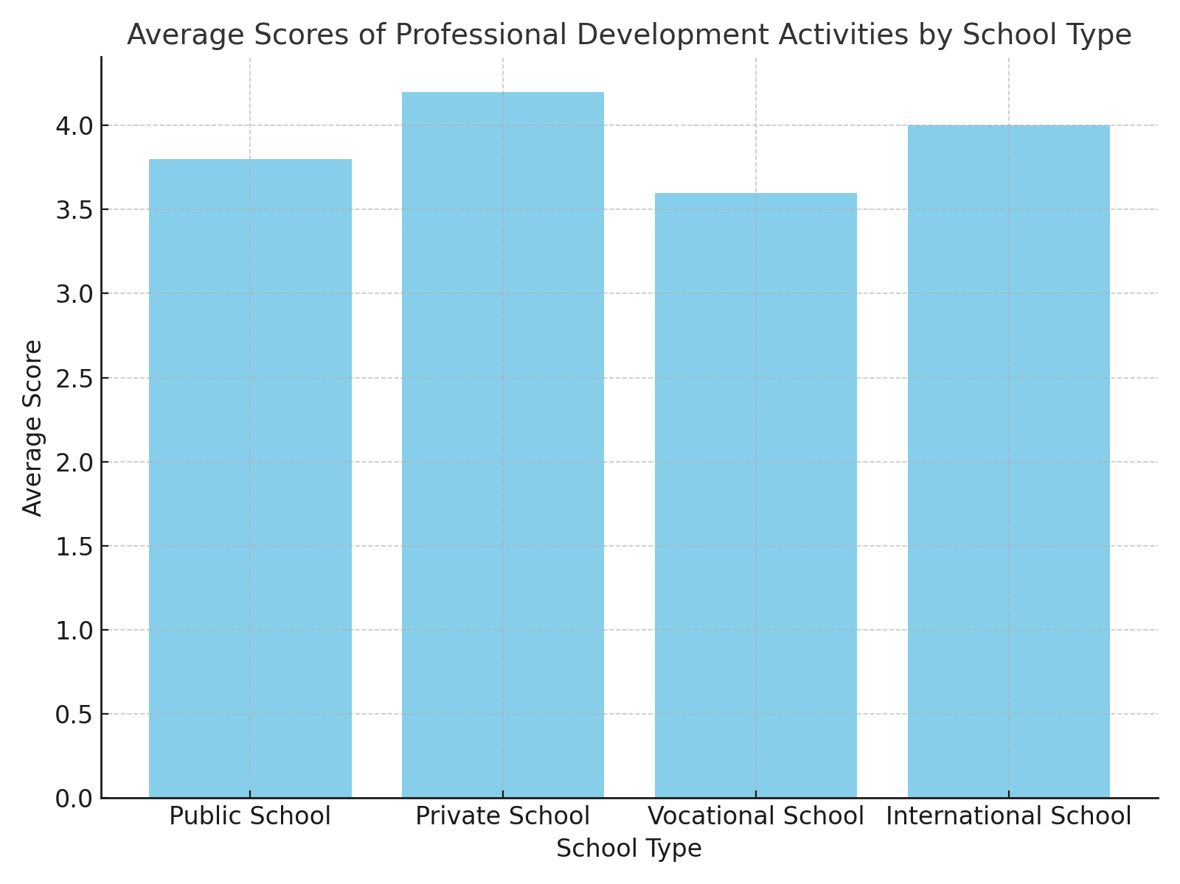

**Photo 1**

***Some Applications from the Study***

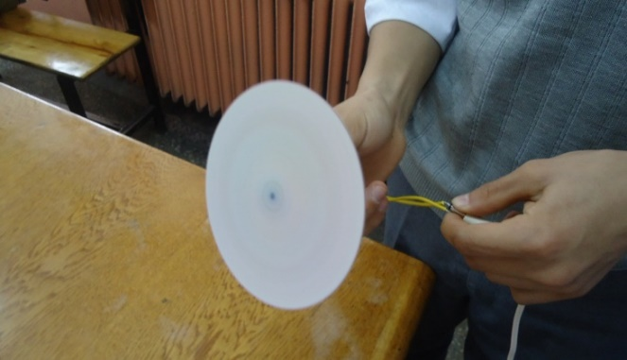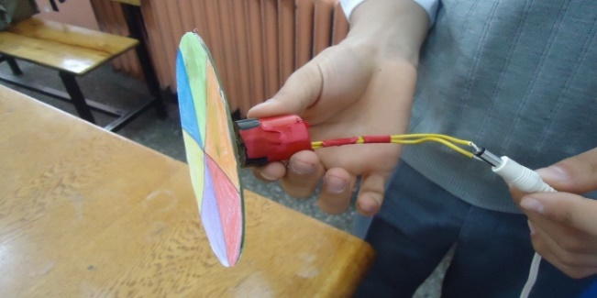

**Discussion (Times New Roman, 12 points, bold, centered)**

**In the discussion section, the findings obtained in the study should be explained clearly and systematically, considering the study's purpose, problems, and hypotheses. Findings should be discussed with relevant literature. The relationship between the findings and the research questions or hypotheses should be presented, with this relationship evaluated through the authors' comments. A comparison of the findings with existing studies in the literature should be made, highlighting both similarities and differences with previous research. Any contradictions in the literature should also be addressed.**

**Additionally, the contribution of the findings to the literature and their role in advancing existing knowledge should be emphasized. The obtained data should be presented holistically, and understood as complementary and meaningful when combined. The reliability and validity of the data should be assessed, and any limitations or methodological constraints should be discussed. Authors should also address unexpected results, provide explanations for them, and consider alternative explanations.**

**Conclusion (Times New Roman, 12 points, bold, centered)**

**This section should present the conclusions based on the study's findings. The conclusions should focus solely on the results obtained within the scope of the research and their meaning. Key ideas from the discussion section should be explained based on the findings, and the significance of these findings should be emphasized. The answers to the research questions should be presented, and the importance and contributions of the study results should be summarized. The relationship of the obtained findings with existing studies in the literature should be briefly mentioned, and the theoretical and practical contributions of the research should be discussed. In addition, the research's limitations should be presented in light of the findings. This section should include an overall evaluation of the study.**

**Recommendations (12 points, bold, centered)**

**Recommendations should be based on the obtained data, discussion, and conclusion. These recommendations should be valuable contributions to the field of literature and should guide future studies and practical applications. The "Discussion, Conclusion, and Recommendations" section can be presented under a single heading or as separate sections.**

**Extended Summary (1000-1500 words)**

**The extended summary should be provided in the language opposite of the article's original language (if the article is in Turkish, the extended summary should be in English, and if the article is in English, the extended summary should be in Turkish). An extended summary should include the following structure:**

**Introduction**

**Methodology**

**Findings**

**Discussions, Conclusions, and Recommendations**

**Acknowledgments: This section is optional.**

**Author Contributions: If the article is written by multiple authors, the contribution of each author should be specified. (Author names should not be included in the anonymized file.)**

**Conflict of Interest: Authors must declare that there is no conflict of interest among them.**

**Ethical Declaration: We declare that the rules specified in the Higher Education Institutions Scientific Research and Publication Ethics Guidelines have been followed and that no actions contrary to scientific research and publication ethics have been taken. We also declare that all authors contributed to the work, there is no conflict of interest among the authors, and all responsibility for any ethical violations lies with the authors.**

**Ethics Committee Approval: If the research requires ethics approval, the name of the ethics committee, the approval date, and the document number should be provided. (Institution name and document number should not be included in the anonymized file.)**

**Funding: If this research is funded, the name of the funding source should be specified. If not, the statement “This research has not received any funding” should be included.**

**Copyright: Works published in the Millî Eğitim journal are licensed under the Creative Commons Attribution-NonCommercial 4.0 International License.**

**Data Availability Statement: The data created or analyzed during this study can be obtained from the authors upon request.**

**Use of Artificial Intelligence in Writing Assistance: Authors must declare the use of artificial intelligence, if applicable.**

**References**

**The references should be prepared according to the APA 7 citation style.**

**Appendices**

**If there is additional information, plans, tables, figures, graphs, and images in the study, they should be placed on a new page after the references section. Each appendix should be titled separately (Appendix A, Appendix B, etc.). Titles should be formatted in the same style as the main headings, and the information should be formatted in the same style as the main text.**

**References**

Azer, H. (2017). *Millî Eğitim Bakanlığı arşiv kütüphanesindeki Osmanlı Türkçesi ile basılı eserler bibliyografyası* [Yayımlanmamış yüksek lisans tezi]. Kırıkkale Üniversitesi.

Beyatlı, Y. K. (1985). Kendi gök kubbemiz. Millî Eğitim Bakanlığı Yayınları.

Bozan, M. (2004, 1 Şubat). Bölge yönetimi ve eğitim bölgeleri kavramı. MEB. [http://www.yayim.meb.gov.tr](http://www.yayim.meb.gov.tr/)

Brown, A. L., & Campione, J. C. (1996). Guided discovery in a community of learners. In K. McGilly (Ed.), *Classroom lessons: Integrating cognitive theory and classroom practice* (pp. 229–270). The MIT Press.

Cüceloğlu, D. (2010, 29 Ekim). *Güzel insan olmak.* Xxxxx Gazetesi. <https://www.xxxxx.com/yazarlar/dogan-cuceloglu/566361-guzel-insan-olmak>

Demiral, Ü., ve Güneş Koç, R. S. (2023). İdeal fen öğretimi. B. Gülbahar, ve S.Y. Sıvacı, (Ed.ler), *Cumhuriyet’in 100. yılında eğitimde idealler üzerine* içinde (s 273-293). Xxx Yayınevi.

Güneş Koç, R. S., ve Sarıkaya, M. (2018, 6-8 Eylül). *7. sınıf öğrencilerinin ışık konusundaki başarılarına 5E ile desteklenmiş bağlam temelli öğretim yönteminin etkisinin incelenmesi* [Sözlü bildiri]. I. ILTER Uluslararası Öğrenme, Öğretim ve Eğitim Araştırmaları Kongresi, Amasya Üniversitesi, Amasya.

Maier, U., Wolf, N., & Randler, C. (2016). Effects of a computer-assisted formative assessment intervention based on multiple-tier diagnostic items and different feedback types. *Computers and Education,* 95, 85-98. [https://doi.org/10.1016/j.compedu.2015.12.002](https://psycnet.apa.org/doi/10.1016/j.compedu.2015.12.002)

Miles, M. B., & Huberman, A. M. (1994). *Qualitative data analysis: An expanded sourcebook.* Sage Publications.

Öztürk, N., Bozkurt Altan, E., ve Tan, S. (2020). Ortaokul öğrencilerinin geleceğe hazırlanıyorum problemlere çözüm arıyorum projesinin kendilerine katkılarına yönelik değerlendirmelerinin incelenmesi. *Milli Eğitim, 49*(225), 153–179. <https://dx.doi.org/10.37669/milliegitim.644986>

Rayner, A. (2005, September). *Reflections on context based science teaching: A case study of physics students for physiotherapy* [Poster presentation]. Annual UniServe Science Blended Learning Symposium Proceedings, Sydney.

Safran, M. (Ed.) (2019). *Dünya eğitimine yön verenler* (Cilt 1-2). Millî Eğitim Bakanlığı Yayınları.