Araştırma Makalesi / Research Article

**Sakarya Üniversitesi İlahiyat Fakültesi Dergisi**

**Journal of Sakarya University Faculty of Theology**

e-ISSN: 1304-6535

Yayıncı/Publisher: Sakarya University

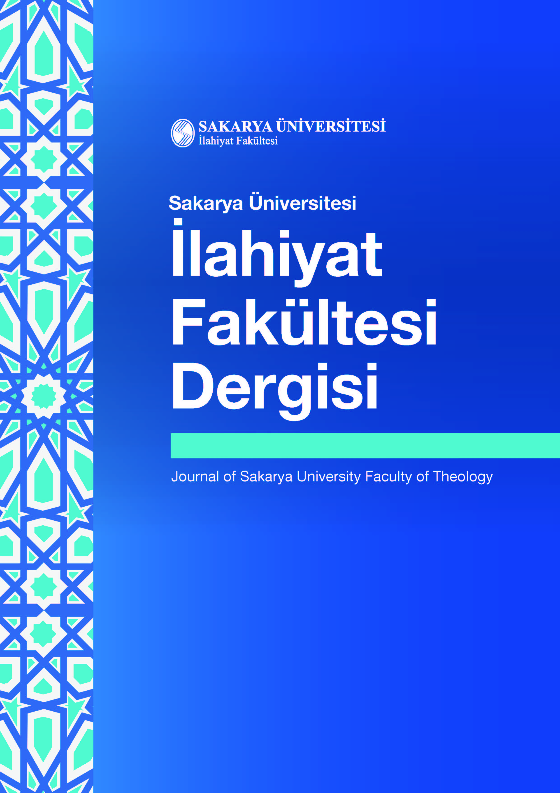

Cilt/Vol.: 27, Sayı/No.: 2, xx-xx, 2025

DOI: https://doi.org/10.17335/sakaifd.xxxxxxx‎‎

**Cite as (ISNAD 2):** First Author’s Surname, Name – Second Author’s Surname, Name. “Manuscript Title‎”. *Sakarya Üniversitesi İlahiyat Fakültesi Dergisi* 27/2 (2025), xx-xx. https://doi.org/‎10.17335/sakaifd.xxxxxxx‎



This is an open access paper distributed under the terms and conditions of the Creative Commons Attribution-NonCommercial 4.0 International License.

**Manuscript Title, Write in Cambria 12 Point Size, with the First Letter of Each Word ‎Capitalized**

*Manuscript Title in Turkish, Write in Cambria 12 Point Size, with the First Letter of Each Word Capitalized*

First Author1*

Second Author2

1 Title, First Author's Institution, Faculty, Department, Main Field of Study, City, Country,

First Autor's email address (institutional email address must be used)

https://ror.org/xxxxxxxxx

2 Title, Second Author's Institution, Faculty, Department, Main Field of Study, City, Country,

Second Autor's email address (institutional email address must be used)

https://ror.org/xxxxxxxxx

*(If there is no second author, it should be deleted.)*

*Sorumlu Yazar/Corresponding Author *(If there is no second author, it should be deleted.)*

**Abstract:** The abstract should include the subject, context, significance, purpose, and methods of the research, as well as the main findings. The abstract should be between 200 and 250 words and should not exceed 250 words. The abstract should consist of a single paragraph and be written in 9-point Cambria font. An 8nk space should be left after the abstract paragraph. At least 3 and at most 5 keywords should be written below the abstract. The first keyword must be related to the relevant field of research, and the subsequent keywords should be listed from general to specific. The first letter of each keyword should be capitalized, and a period should be placed at the end.

**Keywords:** Keyword One, Keyword Two, Keyword Three, Keyword Four, Keyword Five.



**Öz:** Authors are encouraged to provide a Turkish title, abstract (200–250 words), and keywords; however, these may be added after the article has been accepted for publication.Turkish abstract should be a direct translation of the English abstract, between 200 and 250 words long, and should not exceed 250 words. The Turkish keywords should be the same as the Turkish keywords.

**Anahtar Kelimeler:** Anahtar Kelime 1,Anahtar Kelime 2,Anahtar Kelime 3,Anahtar Kelime 4,Anahtar Kelime 5.

Geliş Tarihi/Received: xx.xx.2025

Kabul Tarihi/Accepted: xx.xx.2025

Yayımlanma Tarihi/ Available Online: xx.xx.2025

Introduction

The introduction section title should not be numbered. There should be no indentation in the first paragraph after titles, tables, and block quotations. The first paragraphs should be written with 1.15 line spacing, Cambria font, 11 points.

The second and subsequent paragraphs should be justified. They should be indented by 0.5 cm, with 1.15 line spacing and Cambria font size 11.

The introduction section of the article should provide a comprehensive overview of the topic addressed in the study. This section should provide the reader with information about the subject, scope, importance, purpose, and methodology of the research in greater detail than the abstract. If the study is based on field research, the methodology section should be presented under a separate heading.

The introduction section should also include current literature. In this context, studies published in the last three years indexed in Web of Science (WoS) and Scopus should be taken into consideration. Thus, the current academic literature in the relevant field should be revealed, and the gap that the study fills in the literature should be explained.

1. First Level Headings

Section headings: Only the first letter of each word in the first heading should be capitalized. The first heading should be left-aligned and bold. A 6nk space should be left before it.

The ISNAD 2nd Edition citation system should be used for citations and references in articles. Authors may choose to use the ISNAD 2nd Edition [footnote](https://www.isnadsistemi.org/en/guide/isnad2-2/isnad-author-title-system/) or [in-text](https://www.isnadsistemi.org/en/guide/isnad2-2/isnad-author-date-system/) citation system.[1] Articles should not exceed 9,000 words, including footnotes, references, and abstracts.

Authors are encouraged to use a program such as Zotero, Mendeley, or Endnote for citations and references. The ISNAD 2nd Edition citation system has [templates](https://www.isnadsistemi.org/en/downloads/) for Zotero, Mendeley, and EndNote.

“If a section quoted directly in the article is longer than three lines or forty words, it should be shown as a separate paragraph. Such block quotations are indented 1 cm from the beginning and end of the paragraph, justified on both sides, with 1.15 line spacing, Cambria font, 10 point size, and enclosed in quotation marks. The source must be indicated at the end of block quotations (after the quotation marks).”

There should be no indentation in the first paragraph following headings, tables, and block quotations.

1.1. Second Level Headings

Only the first letter of each word in a second level heading should be capitalized. They should be left-aligned and bold. There should be a 4 nk space before them.

1.1.1. Third Level Headings

Only the first letter of each word in a third-level heading should be capitalized. It should be left-aligned and bold. No space should be left before it.

Tables, Figures, and Images should be prepared in accordance with the ISNAD 2nd Edition Footnote Citation System.

<https://www.isnadsistemi.org/en/guide/isnad2-2/academic-writing/21-tables-and-figures/>

Table example:

**Table 1:** A Title Explaining the Table with the First Letter of Each Word Capitalized, Cambria 10 Point

|  |  |  |
| --- | --- | --- |
| **First Value** | **Second Value** | **Third Value** |
| A | X | 1 |
| B | Y | 2 |
| C | Z | 3 |

**Reference:** If the table was not prepared by the author and was taken from another source, the reference should be cited here.

**Table 2:** Transcription Alphabet Table for Writers Using Transcription

|  |  |  |  |
| --- | --- | --- | --- |
| **Letters** | **English** | **Letters** | **English** |
| ء | ʾ | ش | Sh, sh |
| آ | Ā, ā | ص | Ṣ, ṣ |
| ا | A, a, E, e, Ā, ā | ض | Ḍ, ḍ |
| ب | B, b | ط | Ṭ, ṭ |
| پ | P, p | ظ | Ẓ, ẓ |
| ت | T, t | ع | ʿ |
| ث | Th, th | غ | Gh, gh |
| ج | J, j | ف | F, f |
| چ | Ç, ç | ق | Q, q |
| ح | Ḥ, ḥ | ك | K, k, G, g, Ñ, ñ |
| خ | Kh, kh | ل | L, l |
| د | D, d | م | M, m |
| ذ | Dh, dh | ن | N, n |
| ر | R, r | و | V, v, W, w, O, o, U, u, Ū, ū |
| ز | Z, z | ه | H, h, A, a |
| ژ | Zh, zh | ى | Y, y, İ, i, Ī, ī, Ā, ā |
| س | S, s | Renounced w (…خوا) | Khwā…, khwā… |

Image example:

metin, kitap, ekran görüntüsü, grafik tasarım içeren bir resim

Yapay zeka tarafından oluşturulmuş içerik yanlış olabilir.

**Image 1:** Cover of Sakarya University Faculty of Theology Journal

For detailed information on spelling rules, see <https://www.isnadsistemi.org/en/guide/isnad2-2/academic-writing/>

Conclusion

The conclusion title should not be numbered.

References

The reference list should be written with 1.15 line spacing and hanging indentation, excluding the first lines. The indentation should be set to 1.25 cm (hanging).

The references should start on the page following the “Conclusion” section. The article information form should be written right after the references. It should not start on a new page.

**Article Information Form**

**Authors’ Notes:** *(If you have no notes, delete this heading.)*

**Authors’ Contributions:** If there is more than one author, contributions should be indicated as percentages: “First Author contributed 60%, Second Author contributed 40%; First Author contributed 70%, Second Author contributed 30%.” Percentage values should not be selected as 50%–50%. *(If the article has a single author, the heading should be deleted.)*

**Conflict of Interest Statement:** No potential conflict of interest has been reported by the author. *(If there is a conflict of interest, it should be reported here.)*

**Artificial Intelligence Statement:** No artificial intelligence tools were used in writing this article. *(If artificial intelligence tools were used, a detailed explanation must be provided.)*

**Support/Supporting Organizations:** This research was funded by a grant from a non-profit organization called ... or from the private sector. (or)

This research was prepared based on project no. xxxxxxx, titled “…,” which was supported by the public institution named … under the xxxx Projects. *(If not supported by any institution or project, the title should be deleted.)*

**Ethics Committee Approval:** The ethics committee application titled “...” was reviewed at the meeting of the Scientific Research and Publication Ethics Committee of xxx University on xx/xx/xxxx, and it was decided that the project complies with the applicable legislation. Number: xxxxxx-xxxxx *(If no ethics committee approval was sought, the title should be deleted.)*

**Plagiarism Statement:** This article has been scanned by *iThenticate.‎*

1. If the ISNAD 2nd Edition footnote citation system is preferred, footnotes should be written in Cambria 8 point font. There should be no space before or after the footnote paragraph, the line spacing should be single, and the paragraph indentation should be 0.5 hanging.