ENGLISH TITLE (CAMBRIA BOLD, 16 PT.)[1] , [2]

Author Title Abbreviation **Author Name Surname**Author Place of Duty- University Faculty Department  
City / Country  
email address  
**ORCID ID:** 0000-0000-0000-0000

**Articles should be uploaded to the system in two copies, one named and one unnamed.**

**Use this section if your article has two authors**

|  |  |
| --- | --- |
| Author Title Abbreviation **Author Name  SURNAME** Author Place of Duty- University Faculty Department City / Country email address **ORCID ID:** 0000-0000-0000-0000 | Second Author Title Abbreviation **Author Name Surname** Author Place of Duty- University Faculty Department City / Country email address **ORCID ID:** 0000-0000-0000-0000 |

**Abstract:** At the beginning of the article, there should be a short English abstract. The abstract should be written in Calibri Light font, 9 pt and 1.0 line spacing.

**Keywords:** Keyword 1, Keyword 2, Keyword 3, Keyword 4, Keyword 5.

TURKISH TITLE (CAMBRIA BOLD, 12 PT.)

***Öz:*** *Makalenin başında en çok 150 sözcükten oluşan kısa bir Türkçe ve İngilizce özet bulunmalıdır. Özet yerine Öz ifadesi kullanılmalıdır. Öz, Calibri Light yazı karakterinde, 9 punto ve 1,0 satır aralıklı olacak şekilde iki yana yaslı yazılmalıdır. Özün Türkçesi italik olmalıdır.*

***Anahtar Sözcükler:*** *Anahtar Sözcük 1, Anahtar Sözcük 2, Anahtar Sözcük 3, Anahtar Sözcük 4, Anahtar Sözcük 5.*

GENİŞLETİLMİŞ ÖZET (CAMBRIA BOLD, 12 PT)

The extended Turkish abstract of the article should be included in this section. This section should be written in Turkish between 500-800 words. The body text of the extended abstract section should be written in Calibri Light font, 9-point font and 1.0 line spacing in the same way as the abstract. It is recommended that there should be no quotation sentences in the text.

This section;

* This section should be written in Calibri Light font, 9 pt. and 1.0 line spacing, leaving 6 pt. paragraph spacing.
* It should be written in Turkish between 500-800 words.
* It should not exceed 1 page.
* It should include aim-subject-methods-results and findings.

# 1. Introduction (Calibri Bold, 12 Punto)

In the introduction section, include an extended version of the abstract and information about the problem, purpose, method and importance of the research.

First level main headings should be written in Calibri Bold font, 12 pt, and the first letter of each word should be capitalized. Body text should be written in Calibri Light 10-point font and 1.15 line spacing, justified. **The number of words in the whole article** is limited to between **3500-7000**.

# 2. Main Title (Calibri Bold, 12 Punto)

The article should be prepared using this template, and the settings (paragraphs, spacing, etc.) in the template should not be changed. Header and footer should not be interfered with. Headings are headings that can be collapsed and expanded, when adding a new heading, it should be added in this format.

**\*Maximum 15 images** should be included in the article. All images should be referred to in the text. Images (visuals, tables, figures, etc.) should be numbered in bold as **Image 1, Image 2, Image 3.** Below the image, the information about that image should be written in Calibri Light 9-point font, center aligned, and the source from which it is taken should be indicated (Example 1, Example 2, Example 3).

*If the sources such as images, photographs, applications, etc. used in the images belong to the author, Personal Archive should be written at the end of the image footer.

*If the quotation used **in the** image **information** is taken from a printed source, it should be given as in Image 1 and if it is taken from the internet, it should be given as in Image 2 (In the source indication in the colophon, the internet address should be written as URL1, URL2, URL3, ... respectively by giving the URL token with a hyperlink). After the hyperlinking process, the token should be converted to a black text style without underlining by removing changes such as color change and underlining. The process of giving a URL to the token can be done in Microsoft Word software by right-clicking on the word after selecting it and accessing the menu that comes up.**In the Image Bibliography**, it should be stated as an open network address without using abbreviations.

**EXAMPLE 1:** IMAGES TAKEN FROM A BOOK

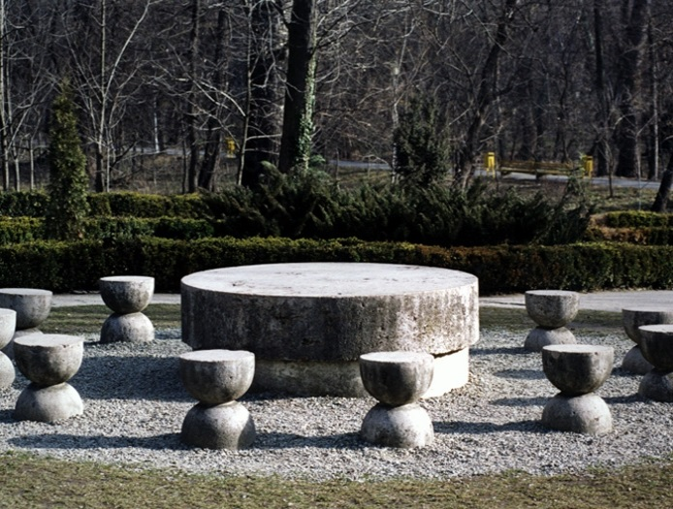

**Image 1.** Name and Surname of the Artist, Year of the Work, English Name of the Work / Original Name of the Work.

Author's Surname, A. (Year of Publication). Book title. Publisher, p. page number where the image is located.

**Image 1.** Constantin Brancusi, 1937, Table of Silence.

Tucker, W. (1996). The language of sculpture. Thames and Hudson, p. 132.

**EXAMPLE 2:** IMAGES FROM AN ELECTRONIC SOURCE

**Image 2.** Artist's Name and Surname, Year of the Work,English Name of the Work / Original Name of the Work.

Name of the Source. URL Indicator

**Image 2.** Christian Boltanski, 1988, Canada / Canada. The Japan Times. [URL1](https://qph.cf2.quoracdn.net/main-qimg-5da55c34d3bf11b0ac638dfe0e14c261)

**EXAMPLE 3:** USE OF MULTIPLE IMAGES

**Image 3.** (Left) Image Imprint. (Right) Image Imprint   
(When using double or triple images, the image tags should be listed in order from left to right.   
"Left, Right" or "Left, Center, Right").

# 3. Conclusion

In the conclusion section, the findings, diagnoses and ideas reached in line with the data obtained in the research should be included.

# Bibliography

*Each source cited in the text should be included in the bibliography, and each source cited in the bibliography should be cited in the text. The bibliography should appear at the end of the article. The bibliography text should be written in Calibri Light font, 1.15 line spacing, 10 pt and aligned to the left.

*The access extensions of the Internet Resources used in the article should be included in the bibliography without using the URL shortening program, **there should not be a separate internet bibliography**.

*For referencing and in-text citations, please click on **SANAT YAZILARI PUBLICATION PRINCIPLES AND ARTICLE WRITING RULES**.

# Image Bibliography

*After the bibliography, the Image Bibliography should be included, and the sources of all images used in the article should be written here. The text of the Image Bibliography should be written in Calibri Light font, 1.15 line spacing, 10 pt and aligned to the left.

*If the images are taken from electronic sources, the internet address should be clearly included in the source without using the URL abbreviation program and the access date information must be written. The sources of all images in the article should be included in this section. If the images are taken from an electronic source, the access date information must be included.

In cases not covered in this document, the Principles of Citation in Hacettepe University Scientific Publications and **APA 7** (American Psychological Association) publication guidelines should be consulted.

1. Research and Publication Ethics have been followed in the article.
2. If the article is derived from a thesis or any publication (paper, panel, conference, etc.), it should be indicated here.