Ekonomi-tek, Volume ??, Issue ??, 20??, ??-??

*Received:* *??, 20?? Accepted:* *??, 20?? Research/Review Paper*

Abstract Title (18 Point, Capitalize the First Letters)[1]*

**Author1 (16 Point)**\*\*

**Author2 (16 Point)**\*\*\*

## Abstract

Manuscripts must include 100-150 words abstract in English. Manuscripts must include 100-150 words abstract in English. Manuscripts must include 100-150 words abstract in English. Manuscripts must include 100-150 words abstract in English. Manuscripts must include 100-150 words abstract in English. Manuscripts must include 100-150 words abstract in English. Manuscripts must include 100-150 words abstract in English. Manuscripts must include 100-150 words abstract in English. Manuscripts must include 100-150 words abstract in English. Manuscripts must include 100-150 words abstract in English. Manuscripts must include 100-150 words abstract in English. Manuscripts must include 100-150 words abstract in English. Manuscripts must include 100-150 words abstract in English. Manuscripts must include 100-150 words abstract in English. Manuscripts must include 100-150 words abstract in English.

**JEL Codes:** At least 3 JEL codes should be added.

**Keywords:** 3-5 keywords should be added.

## Makale Başlığı (18 Punto, İlk Harfleri Büyük)

## Öz

Makaleler 100-150 sözcük Türkçe öz içermelidir. Makaleler 100-150 sözcük Türkçe öz içermelidir. Makaleler 100-150 sözcük Türkçe öz içermelidir. Makaleler 100-150 sözcük Türkçe öz içermelidir. Makaleler 100-150 sözcük Türkçe öz içermelidir. Makaleler 100-150 sözcük Türkçe öz içermelidir. Makaleler 100-150 sözcük Türkçe öz içermelidir. Makaleler 100-150 sözcük Türkçe öz içermelidir. Makaleler 100-150 sözcük Türkçe öz içermelidir. Makaleler 100-150 sözcük Türkçe öz içermelidir. Makaleler 100-150 sözcük Türkçe öz içermelidir. Makaleler 100-150 sözcük Türkçe öz içermelidir. Makaleler 100-150 sözcük Türkçe öz içermelidir. Makaleler 100-150 sözcük Türkçe öz içermelidir. Makaleler 100-150 sözcük Türkçe öz içermelidir. Makaleler 100-150 sözcük Türkçe öz içermelidir. Makaleler 100-150 sözcük Türkçe öz içermelidir.

**JEL Kodları:** En az 3 adet JEL kodu eklenmelidir.

**Anahtar Kelimeler:** 3-5 anahtar kelime eklenmelidir.

## 1. Introduction

The introduction should be placed at the top of the third page. Therefore, it should be sure that the abstract and information on the first two pages do not exceed the third page. Section headings should be written in bold, and the first letters should be capitalized.

As is shown here, the text should be written in Times New Roman font, and 12 punto with 1.15 line spacing (the text should be right justified). Please keep the template format unchanged. The main text (including references and appendices) should comprise at least 5000 words but not more than 12000 words.

## 2. Section Title

**2.1. Subsection Title Should Be Written in Lower Case**

Subsections may be used. Subsection titles should be written in lower case, bold, and in accordance with the format above.

Footnotes should appear at the bottom of the page. Please do not use endnotes at the end of the text.

Direct quotation under forty words could be quoted in the text by citing the source. It should be a block quotation, when the quote exceeds 40 words as shown below.

It should be a block quotation, when the quote exceeds 40 words as shown below. It should be a block quotation, when the quote exceeds 40 words as shown below. It should be a block quotation, when the quote exceeds 40 words as shown below. It should be a block quotation, when the quote exceeds 40 words as shown below. It should be a block quotation, when the quote exceeds 40 words as shown below. (Source, 20??, s. ???)

**3. Tables, Figures and Equations**

Equations, tables, figures, and appendices should be numbered consecutively. Equations should be placed on a separate line and place the equation number in the bracket right of (the first line of) the equation with no indent. Tables and figures should be titled appropriately and be placed on the top of the figure or table. Notes, references, and data sources should be placed under the table or figure. Notes and references should be in Times New Roman font and 10 points.

**3.1. Tables**

Please consider the following example for tables and place them vertically and in an appropriate place in the text.

**Table 1. Some indicators of the basic structure of an economy**



Source: World Development Report (2024)

Notes:

**3.2. Figures**

Please consider the following example for figures and place them in an appropriate place in the text.

**Figure 1. Inflation rate, average consumer prices (Annual percent change)**

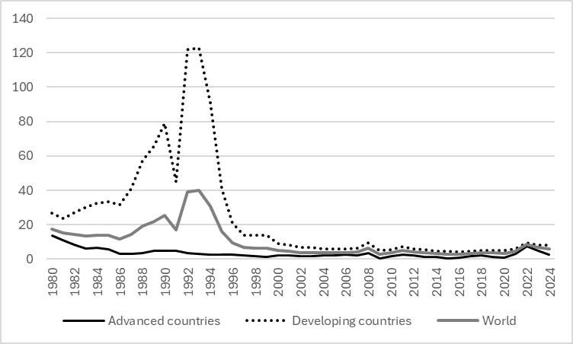

Source: IMF (2024)

Notes:

**3.3. Equations**

## $f\left(x\right)=a_{0}+\sum_{n=1}^{∞}{\left(a_{n}\cos{\frac{nπx}{L}}+b_{n}\sin{\frac{nπx}{L}}\right)}$ (1)

${\left(x+a\right)}^{n}=\sum_{k=0}^{n}{\left({n \atop k}\right)x^{k}a^{n-k}}$ (2)

## 4. Conclusion

## References

**DISCLOSURE STATEMENTS:**

**Research and Publication Ethics Statement:** This study has been prepared in accordance with the rules of scientific research and publication ethics.

**Contribution rates of the authors:** First author (??%), Second author (??%).

**Conflicts of Interest:** Author states that there is no conflict of interest.

**Research Support and Acknowledgements:** This research was not supported by any institution.

**Ethics Committee Approval:** Ethics committee approval was not obtained because human subjects were not used in the research described in the paper.

**Appendices**

**Appendix A. Appendix Title in Bold Letters**

When there is more than one appendix, they should be indicated as Appendix A, Appendix B, ... Tables in each appendix can be numbered as Table A1, Table A2, ... and figures can be indicated as Figure A1, Figure A2 ... If there are equations in the appendix, it is appropriate to number the equations as (A1), (A2) ...

1. * If the study is derived from any postgraduate thesis, paper, etc., it should be stated.

   ** ?? Affiliation, email address, <https://orcid.org/>??????

   *** ?? Affiliation, email address, <https://orcid.org/>??????