Put Your Title Here (Type Size 14 / Bold / Arial)

First Author Name and Surname ^{1a}, Second Author Name and Surname ²
¹ Faculty of Education, Amasya University, Amasya, Turkey, ORCID: ____-____-____-____
² Faculty of Education, Hacettepe University, Ankara, Turkey, ORCID: ____-____-____-____

Abstract
The abstract should include 150-200 words; The aim, method, participants and time period of the study should be covered. The most important one or two findings, the most important results and the most important recommendation statements. Please use 14 pt bold Arial font for your article title, and the first capital letter for any proper name. Please center the article title. All authors of the article must indicate their full names, institutions, postal addresses, telephone and fax numbers, and e-mail addresses at the end of the article. ORCID information is required for all authors. An author must be identified as the Corresponding Author. Please use one line for all author names on the title page and one line for all author information. An informative abstract (150-200 words) in 10-point Arial font and 1.5-fold spaced, presenting the main points of the article. Please add descriptive keywords (5). Capitalize the first letter of each keyword (e.g. Science education, Scale development). Put your abstract here. An informative abstract (150-200 words) in 10-point Arial font and 1.5-fold spaced, presenting the main points of the article. Capitalize the first letter of each keyword (e.g. Science education, Scale development). Put your abstract here. | Article History:  Received:  …/…/20...  Revised:  …/…/20...  Accepted:  …/…/20…
Keywords:
Keyword,
Keyword,
Keyword,
Keyword,
Keyword

Başlığınızı Buraya Yazın (14 punto/ Kalın / Arial)

İlk Yazarın Adı ve Soyadı ^{1a}, İkinci Yazarın Adı ve Soyadı ²
¹ Eğitim Fakültesi, Amasya Üniversitesi, Amasya, Türkiye, ORCID: ____-____-____-____
² Eğitim Fakültesi, Hacettepe Üniversitesi, Ankara, Türkiye, ORCID: ____-____-____-____

Öz
Özet 150-200 kelime aralığında; çalışmanın amacı, yöntemi, örneklem ve hangi zaman aralığında çalışıldığı, en önemli görülen bir-iki bulgu, en önemli görülen bir sonuç ve en önemli görülen bir öneri cümlelerinden oluşturulmalıdır. Lütfen makale başlığınız için 14 punto kalın Arial punto ve font, herhangi bir özel isim için ilk büyük harf kullanın. Lütfen makale başlığını ortalayın. Bir makalenin tüm yazarları, makalenin sonunda tam adlarını, kurumlarını, posta adreslerini, telefon ve faks numaralarını ve e-posta adreslerini belirtmelidir. ORCID bilgisi tüm yazarlar için gereklidir. Bir yazar Sorumlu Yazar olarak tanımlanmalıdır. Lütfen başlık sayfasındaki tüm yazar adları için bir satır ve tüm yazar bilgileri için bir satır kullanın. Makalenin ana noktalarını sunan bilgilendirici 10 puntolu ve Arial fontlu ve 1,5 kat aralıklı bir özet (150- 200 kelime). Lütfen açıklayıcı anahtar kelimeler ekleyin (5). Her anahtar kelimenin ilk harfini büyük harfle yazın (örn. Fen eğitimi, Ölçek geliştirme). Özetinizi buraya ekleyin. Özetinizi buraya ekleyin. Özetinizi buraya ekleyin. Makalenin ana noktalarını sunan bilgilendirici 10 puntolu ve Arial fontlu ve 1,5 kat aralıklı bir özet (150- 200 kelime). Lütfen açıklayıcı anahtar kelimeler ekleyin (5). Her anahtar kelimenin ilk harfini büyük harfle yazın (örn. Fen eğitimi, Ölçek geliştirme). Özetinizi buraya ekleyin. Özetinizi buraya ekleyin. | Makale Geçmişi:  Alındı:  …/…/20...  Revize Edildi:  …/…/20...  Kabul Edildi:  …/…/20…
Anahtar Kelimeler:
Anahtar Kelime,
Anahtar Kelime,
Anahtar Kelime,
Anahtar Kelime,
Anahtar Kelime

Level 1 Heading
Please use 10-point Arial font. Justify the text. Line spacing should be set to 1.5. Each paragraph must consist of at least three sentences. Footnotes and endnotes are not accepted; all relevant information must be included in the main text. Do not indent paragraphs; instead, leave 1.5 line spacing between consecutive paragraphs. Do not underline words for emphasis; use italics instead. Before submitting your article, please ensure that each in-text citation corresponds to a reference in the reference list, and vice versa—each entry in the reference list must have a corresponding in-text citation.
Divide the text into unnumbered sections using short, meaningful subheadings. Please do not use numbered headings. Limit heading levels to three: use 12-point bold for first-level headings, 10-point bold for second-level headings, and 10-point italic for third-level headings. Capitalize the first letter of all proper nouns. Leave one 1.5-spaced line before and after each heading (exception: do not leave a blank line between consecutive headings). Align all headings to the left.
Please use 10-point Arial font. Justify the text. Line spacing should be set to 1.5. Each paragraph must consist of at least three sentences. Footnotes and endnotes are not accepted; all relevant information must be included in the main text. Do not indent paragraphs; instead, leave 1.5 line spacing between consecutive paragraphs. Do not underline words for emphasis; use italics instead. Before submitting your article, please ensure that each in-text citation corresponds to a reference in the reference list, and vice versa—each entry in the reference list must have a corresponding in-text citation.
Divide the text into unnumbered sections using short, meaningful subheadings. Please do not use numbered headings. Limit heading levels to three: use 12-point bold for first-level headings, 10-point bold for second-level headings, and 10-point italic for third-level headings. Capitalize the first letter of all proper nouns. Leave one 1.5-spaced line before and after each heading (exception: do not leave a blank line between consecutive headings). Align all headings to the left.
Level 2 heading
Please use 10-point Arial font. Justify the text. Line spacing should be set to 1.5. Each paragraph must consist of at least three sentences. Footnotes and endnotes are not accepted; all relevant information must be included in the main text. Do not indent paragraphs; instead, leave 1.5 line spacing between consecutive paragraphs. Do not underline words for emphasis; use italics instead. Before submitting your article, please ensure that each in-text citation corresponds to a reference in the reference list, and vice versa—each entry in the reference list must have a corresponding in-text citation.
Divide the text into unnumbered sections using short, meaningful subheadings. Please do not use numbered headings. Limit heading levels to three: use 12-point bold for first-level headings, 10-point bold for second-level headings, and 10-point italic for third-level headings. Capitalize the first letter of all proper nouns. Leave one 1.5-spaced line before and after each heading (exception: do not leave a blank line between consecutive headings). Align all headings to the left.
Please use 10-point Arial font. Justify the text. Line spacing should be set to 1.5. Each paragraph must consist of at least three sentences. Footnotes and endnotes are not accepted; all relevant information must be included in the main text. Do not indent paragraphs; instead, leave 1.5 line spacing between consecutive paragraphs. Do not underline words for emphasis; use italics instead. Before submitting your article, please ensure that each in-text citation corresponds to a reference in the reference list, and vice versa—each entry in the reference list must have a corresponding in-text citation.
Divide the text into unnumbered sections using short, meaningful subheadings. Please do not use numbered headings. Limit heading levels to three: use 12-point bold for first-level headings, 10-point bold for second-level headings, and 10-point italic for third-level headings. Capitalize the first letter of all proper nouns. Leave one 1.5-spaced line before and after each heading (exception: do not leave a blank line between consecutive headings). Align all headings to the left.
Direct quotations from sources that do not exceed 40 words should be included in the text within double quotation marks. For direct quotations exceeding 40 words, the quoted text should be formatted as a block quote: indented 1 cm from both the left and right margins, written in single line spacing, and without quotation marks.
Level 3 heading
Please place tables and figures in appropriate locations within the document and center them horizontally. Tables and figures must not exceed the page margins. Provide titles for each table or figure (maximum length: 6 to 8 words). Center the caption above the table and below the figure. Before submission, ensure that each table or figure is referenced in the text (e.g., see Table 1; Figure 1). Please do not use vertical lines in tables. For figures, GIF and JPEG (JPG) are the preferred formats.
Table 1. Table Titles Should Be Centered, Each First Letter Capitalized (Arial 10-point font)
Variables |  | N | Mean
Group | 1. | 47 | 30.3
Group | 2. | 60 | 38.7
Group | 3. | 48 | 31.0
Age | 18-21 | 150 | 96.8
Age | other | 5 | 3.2
Sex | Female | 117 | 75.5
Sex | Male | 38 | 24.5
Total |  | 155 | 100

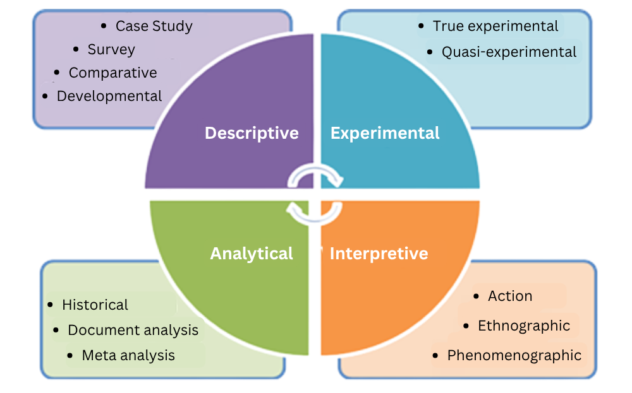

Figure 1. Figure Titles Should be Centered, Each First Letter Capitalized (Arial 10-point font)
Methods
Level 2 heading
Leave one 1.5-spaced blank line before and after each heading. (Exception: Do not leave a blank line between consecutive headings.) Please align all headings to the left. Leave one 1.5-spaced blank line before and after each heading. (Exception: Do not leave a blank line between consecutive headings.) Please align all headings to the left.
For first-level headings, use 12-point bold font; for second-level headings, use 10-point bold font; and for third-level headings, use 10-point italic font. Use capital initials for all proper nouns. Leave one 1.5-spaced blank line before and after each heading. (Exception: Do not leave a blank line between consecutive headings.) Please align all headings to the left.
Level 3 headings
Leave one 1.5-spaced blank line before and after each heading. (Exception: Do not leave a blank line between consecutive headings.) Please align all headings to the left. Leave one 1.5-spaced blank line before and after each heading. (Exception: Do not leave a blank line between consecutive headings.) Please align all headings to the left.
For first-level headings, use 12-point bold font; for second-level headings, use 10-point bold font; and for third-level headings, use 10-point italic font. Use capital initials for all proper nouns. Leave one 1.5-spaced blank line before and after each heading. (Exception: Do not leave a blank line between consecutive headings.) Please align all headings to the left.
Findings
In this section, the findings obtained from the research should be presented. Data collected through different data collection instruments should be included under subheadings, and the above guidelines should be carefully followed.
Table 2. Table Titles Should Be Centered, Each First Letter Capitalized (Arial 10-point font)
Variables |  | N | Mean | Values
Grade | 1. | 47 | 30.3 | 47 | 30.3
Grade | 2. | 60 | 38.7 | 60 | 38.7
Grade | 3. | 48 | 31.0 | 48 | 31.0
Sex | K | 117 | 75.5 | 117 | 75.5
Sex | E | 38 | 24.5 | 38 | 24.5
TOTAL |  | 155 | 100 | 155 | 100

All explanations regarding the data presented in the table should be written in this area below the table. Vertical lines must not be used in tables. In cases where the tables are very large, the font size may be appropriately reduced.

Figure 2. Figure Titles Should be Centered, Each First Letter Capitalized (Arial 10-point font)
The description of the figure should be written in this area. This area can be formatted using the "Paragraph" style section. The text in this area should be justified, with a 1 cm paragraph indentation.
Discussion and conclusions
In this section, the interpretation of the findings obtained in the study should be included by comparing them with the relevant literature, and the above writing guidelines should be carefully followed. In this section, the interpretation of the findings obtained in the study should be included by comparing them with the relevant literature, and the above writing guidelines should be carefully followed.
In this section, the interpretation of the findings obtained in the study should be included by comparing them with the relevant literature, and the above writing guidelines should be carefully followed. In this section, the interpretation of the findings obtained in the study should be included by comparing them with the relevant literature, and the above writing guidelines should be carefully followed.
In this section, the interpretation of the findings obtained in the study should be included by comparing them with the relevant literature, and the above writing guidelines should be carefully followed. In this section, the interpretation of the findings obtained in the study should be included by comparing them with the relevant literature, and the above writing guidelines should be carefully followed.
In this section, the interpretation of the findings obtained in the study should be included by comparing them with the relevant literature, and the above writing guidelines should be carefully followed. In this section, the interpretation of the findings obtained in the study should be included by comparing them with the relevant literature, and the above writing guidelines should be carefully followed.
Suggestions
In this section, suggestions should be presented on how to transform the negative results obtained in the study into positive ones. If desired, the suggestions may be presented in bullet points, and the above writing rules should be carefully followed.
In this section, suggestions should be presented on how to transform the negative results obtained in the study into positive ones. If desired, the suggestions may be presented in bullet points, and the above writing rules should be carefully followed.
Additional information
In this section, each author’s contribution and contribution rate to the submitted article, any support received for the reported research, acknowledgments related to the study, and a conflict-of-interest statement, if any, should be presented. In addition, other supplementary information related to the article (such as the article being derived from a thesis, presented orally at a scientific event, or prepared as part of a project) may also be included in this section.
Example of additional information: The authors contributed equally to the article and declared no conflict of interest in conducting or reporting the study presented in the article.
ORCID and contact
First and Last Names of Author 1 http://orcid.org/0000-0003-1370-0623, E-mail:
First and Last Names of Author 2 http://orcid.org/0000-0002-3321-9290, E-mail:
References
References should be formatted according to APA 7 (American Psychological Association) standards. The sources used in the reference list should be arranged in alphabetical order by the author’s surname. The reference list should be justified on both sides and prepared using 10-point Arial font. A 6 pt spacing should be left between references. The reference list should be written with single line spacing, and a 1 cm indentation should be applied to all lines after the first line of each reference.
For journal articles: (The DOI number should be included if available.)
Al, U., Şahiner, M., & Tonta, Y. (2006). Arts and humanities literature: Bibliometric characteristics of contributions by Turkish authors. Journal of the American Society for Information Science and Technology, 57(8), 1011-1022. https://doi.org/10.1002/asi.20366
Karadağ, E. (2009). Eğitim bilimleri alanında yapılmış doktora tezlerinin tematik açıdan incelemesi. Ahi Evran Üniversitesi Eğitim Fakültesi Dergisi, 10(3), 75-87. https://dergipark.org.tr/en/download/article-file/1494020
Karamustafaoğlu, O. (2009). On the evolution of Journal of Biological Education’s Hirsch index in the new century. Journal of Turkish Science Education, 6(3), 13-18. http://tused.org/index.php/tused/article/view/121/77
McCagg, E.C., & Dansereau, D.F. (1991). A convergent paradigm for examining knowledge mapping as a learning strategy. Journal of Educational Research, 84, 317-324. https://doi.org/10.1080/00220671.1991.9941812
For books: (The DOI number should be included if available.)
Senemoğlu, N. (2007). Gelişim, öğrenme ve öğretim: Kuramdan uygulamaya (13. Baskı). Gönül Yayıncılık.
McMillan, J. H., & Schumacher, S. (2009). Research in education: Evidence-based inquiry (2nd ed.). Pearson.
For conference and symposium proceedings:
Bland, A. (2017, November 12-13). The implementation of a junior Samoan language programme in a South Island, New Zealand secondary school Context [Conference presentation]. Australian Association for Research in Education (AARE) Conference 2017, Canberra, Australia.
Demir, S., Önen, F., & Şahin, F. (2012, Haziran 27-30). Fen bilgisi öğretmen adaylarının yapılandırmacı yaklaşımı uygulamaya yönelik öz yeterlilik inanç düzeylerinin belirlenmesi üzerine bir araştırma [Conference presentation]. X. Ulusal Fen Bilimleri ve Matematik Eğitimi Kongresi, Niğde University, Niğde.
For chapters in edited volumes: (The DOI number should be included if available.)
Cockburn, A. D. (2008). Developing an understanding of children’sacquisition of numberconcepts. In A. D. Cockburn & G. Littler (Eds.), Mathematical misconceptions (1st ed., pp. 86-100). SAGE Publications Inc.
Karademir, A. (2019). Okul öncesi öğretmenlerinin özellikleri. A. Yıldırım (Ed.), Erken çocukluk eğitimine giriş içinde (1st. Ed., p. 164-188). Pegem Akademi.
For published theses and dissertations:
Kabir, J. M. (2016). Factors influencing customer satisfaction at a fast food hamburger chain: The relationship between customer satisfaction and customer loyalty (Publication No. 10169573) [Doctoral dissertation, Wilmington University]. ProQuest Dissertations & Theses Global.
Öztürk, M. (2017). Matematik öğretmeni ve öğretmen adaylarının ispat yapma süreçlerinin bilişsel açıdan incelenmesi (Thesis No. 429635) [Doctoral dissertation, Atatürk University-Erzurum]. Yükseköğretim Kurulu Başkanlığı Tez Merkezi.
For unpublished theses and dissertations:
Deniz, E. (2018). Kaynaştırma eğitimine ilişkin öğretmen görüşleri: bir meta-sentez çalışması [Unpublished master’s thesis]. Dicle University.
Harris, L. (2014). Instructional leadership perceptions and practices of elementary school leaders [Unpublished doctoral dissertation]. University of Virginia.
For reports prepared by institutions and organizations:
Ministry of National Education. (2018). Görsel sanatlar dersi (9, 10, 11 ve 12. sınıflar) öğretim programı. http://mufredat.meb.gov.tr/Dosyalar/2018120204014821-gorsel%20sanatlar%20dop%20(2).pdf

Ethical statement
In this study, all rules specified to be followed under the “Higher Education Institutions Scientific Research and Publication Ethics Directive” have been adhered to. None of the actions listed under the second section of the directive, titled “Acts Contrary to Scientific Research and Publication Ethics,” have been committed.
Information on ethics board approval
Name of the ethics board:
Date of ethics review decision:
Ethics review document number:
Appendices (if any)

