Title of the Study-(The First Letter of Each Word Should Be Capitalized) (You may insert it here without altering the formatting)

First Author’s Full Name
First Author’s Academic Title, Affiliation, City, Country, E-mail Address,
ORCID iD: https://orcid.org/only the numeric part should be provided.

(if any) Second Author’s Full Name
(If any) Second Author’s Academic Title, Affiliation, City, Country, E-mail Address,
ORCID iD: https://orcid.org/only the numeric part should be provided.

(if any) Third Author’s Full Name
If any) Third Author’s Academic Title, Affiliation, City, Country, E-mail Address,
ORCID iD: https://orcid.org/only the numeric part should be provided.

Abstract
The abstract of the study should be placed here. The abstract must be a minimum of 120 and a maximum of 200 words. The heading “Abstract” should be formatted as 11-point, bold, and regular, while the text should be 10-point and italicized. (You may insert the text here without altering the formatting.) (You may insert the text here without altering the formatting.) (You may insert the text here without altering the formatting.) (You may insert the text here without altering the formatting.) (You may insert the text here without altering the formatting.) (You may insert the text here without altering the formatting.) (You may insert the text here without altering the formatting.) (You may insert the text here without altering the formatting.)
Keywords: Keyword 1, Keyword 2, Keyword 3. A minimum of 3 and a maximum of 5 keywords related to the study should be provided.

JEL Codes: M30, M31, M37. The JEL classification codes related to the study should be written here. (http://www.aeaweb.org/journal/jel_class_system.php)

Article Type: Research Paper (Manuscripts other than Research Articles are not accepted)

Research and Publication Ethics Statement: The research part of the study was conducted in accordance with the approval obtained from University, Ethics Committee Name ethics committee by the decision dated Date and numbered Number. (In studies that do not require ethical approval, it should be stated that (Ethical approval is not required)

Submitted: | dd / mm / yyyy
Accepted: | dd / mm / yyyy

Only the date of submission should be provided in this section.

Please pay attention to preserving the formatting of the template.
Manuscripts not prepared in accordance with this template will not be considered for publication review.
Introduction
The Introduction should be written in bold and with the first letters capitalized. No numbering should be given to the heading. In articles, the research problem must be clearly stated within the introduction section. In addition, this section must explicitly indicate which topic or research question the study addresses and which method(s) are employed.
All subsequent sections should be written, as in this section, in 11-point font, single-spaced, with paragraph spacing set to 6 pt before and after, without altering the formatting. The total word count of the manuscript should not be less than 3,000 words and not exceed 10,000 words (the total length of the article should not exceed 25 pages).
Throughout the manuscript, landscape page orientation should not be used. If tables or similar elements do not fit on the page, they should be reduced in size, or the relevant visual should be placed horizontally instead of changing the page orientation.
In order for the study to be included in the evaluation process, the plagiarism rate must not exceed 13%.
(You may insert the text here without altering the formatting.) (You may insert the text here without altering the formatting.) (You may insert the text here without altering the formatting.) (You may insert the text here without altering the formatting.) (You may insert the text here without altering the formatting.) (You may insert the text here without altering the formatting.) (You may insert the text here without altering the formatting.) (You may insert the text here without altering the formatting.) (You may insert the text here without altering the formatting.) (You may insert the text here without altering the formatting.) (You may insert the text here without altering the formatting.)

1. Main Headings
Main headings should be written in bold with the first letters capitalized. All subsequent sections should be written, as in this section, in 11-point font, single-spaced, with paragraph spacing set to 6 pt before and after, without altering the formatting.
The study may be divided into sections according to the authors’ preferences. However, headings and content should be separated using appropriate numbering. (You may insert the text here without altering the formatting.) (You may insert the text here without altering the formatting.) (You may insert the text here without altering the formatting.) (You may insert the text here without altering the formatting.) (You may insert the text here without altering the formatting.) (You may insert the text here without altering the formatting.) (You may insert the text here without altering the formatting.) (You may insert the text here without altering the formatting.) (You may insert the text here without altering the formatting.) (You may insert the text here without altering the formatting.) (You may insert the text here without altering the formatting.)
Quotations of up to 40 words from a source may be used within the text by citing the source. When a quotation exceeds 40 words, it should not be included in the main text; instead, it should be presented in a separate paragraph, indented from both the left and right margins and written in italics, as shown in the paragraph below.
Gümüşhane University Journal of Social Sciences (GUJSS) is published three times a year. GUJSS accepts research articles in the field of social sciences and interdisciplinary studies related to these fields. Manuscripts submitted to the journal must be written in English or Turkish. Articles written in Turkish must include an English Extended Abstract at the end, consisting of the sections Aim and Scope, Methods, Findings, and Conclusion. GUJSS is an international, peer-reviewed academic journal indexed in various databases. Manuscripts submitted to the journal may be published after receiving approval from at least two referees who are experts in the relevant field and following evaluation by the Editorial Board. Submitted manuscripts must not have been previously published or submitted for publication elsewhere. This must be confirmed by signing a declaration of originality. There is no obligation for submitted manuscripts to be published.
(You may insert the text here without altering the formatting.) (You may insert the text here without altering the formatting.) (You may insert the text here without altering the formatting.) (You may insert the text here without altering the formatting.) (You may insert the text here without altering the formatting.) (You may insert the text here without altering the formatting.) (You may insert the text here without altering the formatting.) (You may insert the text here without altering the formatting.) (You may insert the text here without altering the formatting.) (You may insert the text here without altering the formatting.), (Source Author’s Surname, Year: Page). APA format should be used for in-text citations.
(You may insert the text here without altering the formatting.) (You may insert the text here without altering the formatting.) (You may insert the text here without altering the formatting.) (You may insert the text here without altering the formatting.) (You may insert the text here without altering the formatting.) (You may insert the text here without altering the formatting.) (You may insert the text here without altering the formatting.) (You may insert the text here without altering the formatting.) (You may insert the text here without altering the formatting.) (You may insert the text here without altering the formatting.) (Source Author’s Surname, Year: Page). APA format should be used for in-text citations.
1.1. Subheadings
When necessary, subheadings may be used under the main section headings. Subheadings should be written in bold, with the first letters capitalized, and in accordance with the format specified above. As in this section, attention should be paid to this format in all subsections. No blank line should be left before these headings.
(You may insert the text here without altering the formatting.) (You may insert the text here without altering the formatting.) (You may insert the text here without altering the formatting.) (You may insert the text here without altering the formatting.) (You may insert the text here without altering the formatting.) (You may insert the text here without altering the formatting.) (You may insert the text here without altering the formatting.) (You may insert the text here without altering the formatting.) (You may insert the text here without altering the formatting.) (You may insert the text here without altering the formatting.)

2. Another Main Heading
(You may insert the text here without altering the formatting.) (You may insert the text here without altering the formatting.) (You may insert the text here without altering the formatting.) (You may insert the text here without altering the formatting.) (A. S. Akat, personal communication via e-mail, 10.11.2004). Similarly, for information and documents obtained from electronic sources, the access link should be provided along with the date of access (GUJSS, https://dergipark.org.tr/journal/364/settings/submission/, Access Date: 06.08.2019).
Tables included in the article should be prepared in accordance with the example given below, in a format appropriate to their content; the table title should be placed above the table, centered, and written in bold. The font size of the information within the table should be planned to be no smaller than 8 point and no larger than 10 point.

Table 1. The First Letter of Each Word in the Table Title Should Be Capitalized
Variable |  | f | % | Var..
Gender | Female | 333 | 33.3 | Marital Status | Evli | 333 | 33.3
Gender | Male | 333 | 33.3 | Marital Status | Bekar | 333 | 33.3
Gender | Total | 333 | 33.3 | Marital Status | Toplam | 333 | 33.3
Age | 16-20 | 333 | 33.3 | Edu. Lvevl | gggggg | 333 | 33.3
Age | 21-23 | 333 | 33.3 | Edu. Lvevl | ggggg | 333 | 33.3
Age | 24-27 | 333 | 33.3 | Edu. Lvevl | Toplam | 333 | 33.3
Age | 28 and above | 333 | 33.3 | xxxx | aaaaa | 333 | 33.3
Age | Total | 333 | 100 | xxxx | aaaa | 333 | 33.3
Source: GUJSS, 2019:13. The source should be centered. (You may insert it here without altering the formatting.)
The text related to the table or the text that follows it should continue without leaving a blank line between the table and the text. (You may insert the text here without altering the formatting.) (You may insert the text here without altering the formatting.) (You may insert the text here without altering the formatting.) (You may insert the text here without altering the formatting.)For all visual elements such as figures and graphs, the following systematic approach should be followed. All necessary adjustments should be completed during manuscript preparation to ensure that tables and figures do not exceed the prescribed page margins. Since the titles of figures and similar visual elements are placed below the visuals, no blank line should be left above these visual elements.
Tables that appear at the end of a page should be left as they are if they are not visually distorted. Headings and subheadings should not be separated from the table content. Tables, figures, charts, and similar elements should not cause visual strain; if possible, their alignment should be made consistent with one another.

Table titles should be placed above the tables. The titles of visuals such as charts, figures, and photographs should be placed below the relevant visual, and one blank line should be left before the title (and after the title when it is placed below). (You may insert the text here without altering the formatting.) (You may insert the text here without altering the formatting.) (You may insert the text here without altering the formatting.) (You may insert the text here without altering the formatting.) (You may insert the text here without altering the formatting.) (You may insert the text here without altering the formatting.)
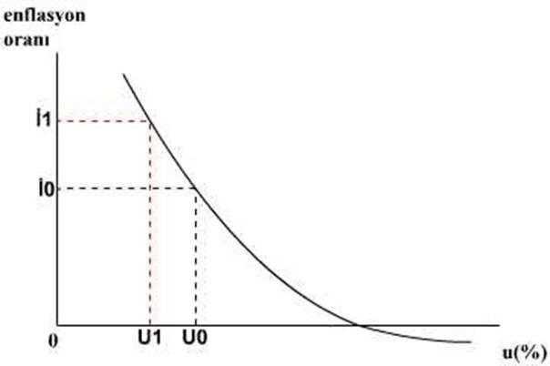

Figure 1. The First Letter of Each Word in the Figure Title Should Be Capitalized
Source: GUJSS, 2019:13. The source should be centered.
(You may insert it here without altering the formatting.)

A blank line should be left between the figure and the explanatory text related to the figure or the text that follows it, and the text should continue from the next line. (You may insert the text here without altering the formatting.) (You may insert the text here without altering the formatting.) (You may insert the text here without altering the formatting.) (You may insert the text here without altering the formatting.) (You may insert the text here without altering the formatting.) (You may insert the text here without altering the formatting.) (You may insert the text here without altering the formatting.) (You may insert the text here without altering the formatting.)

3. Findings
The findings section should be included here for research articles, and the recommendations stated above should also be taken into consideration under this heading. Depending on the research method followed in the study, the headings should be structured appropriately by the author.
3.1. Subheadings First Letters Capitalized
Subheadings should be written with the first letters capitalized and in accordance with the format specified above. As in this section, attention should be paid to this format in all subsections. (You may insert the text here without altering the formatting.) (You may insert the text here without altering the formatting.) (You may insert the text here without altering the formatting.)
The example below may be used for graphical presentation.
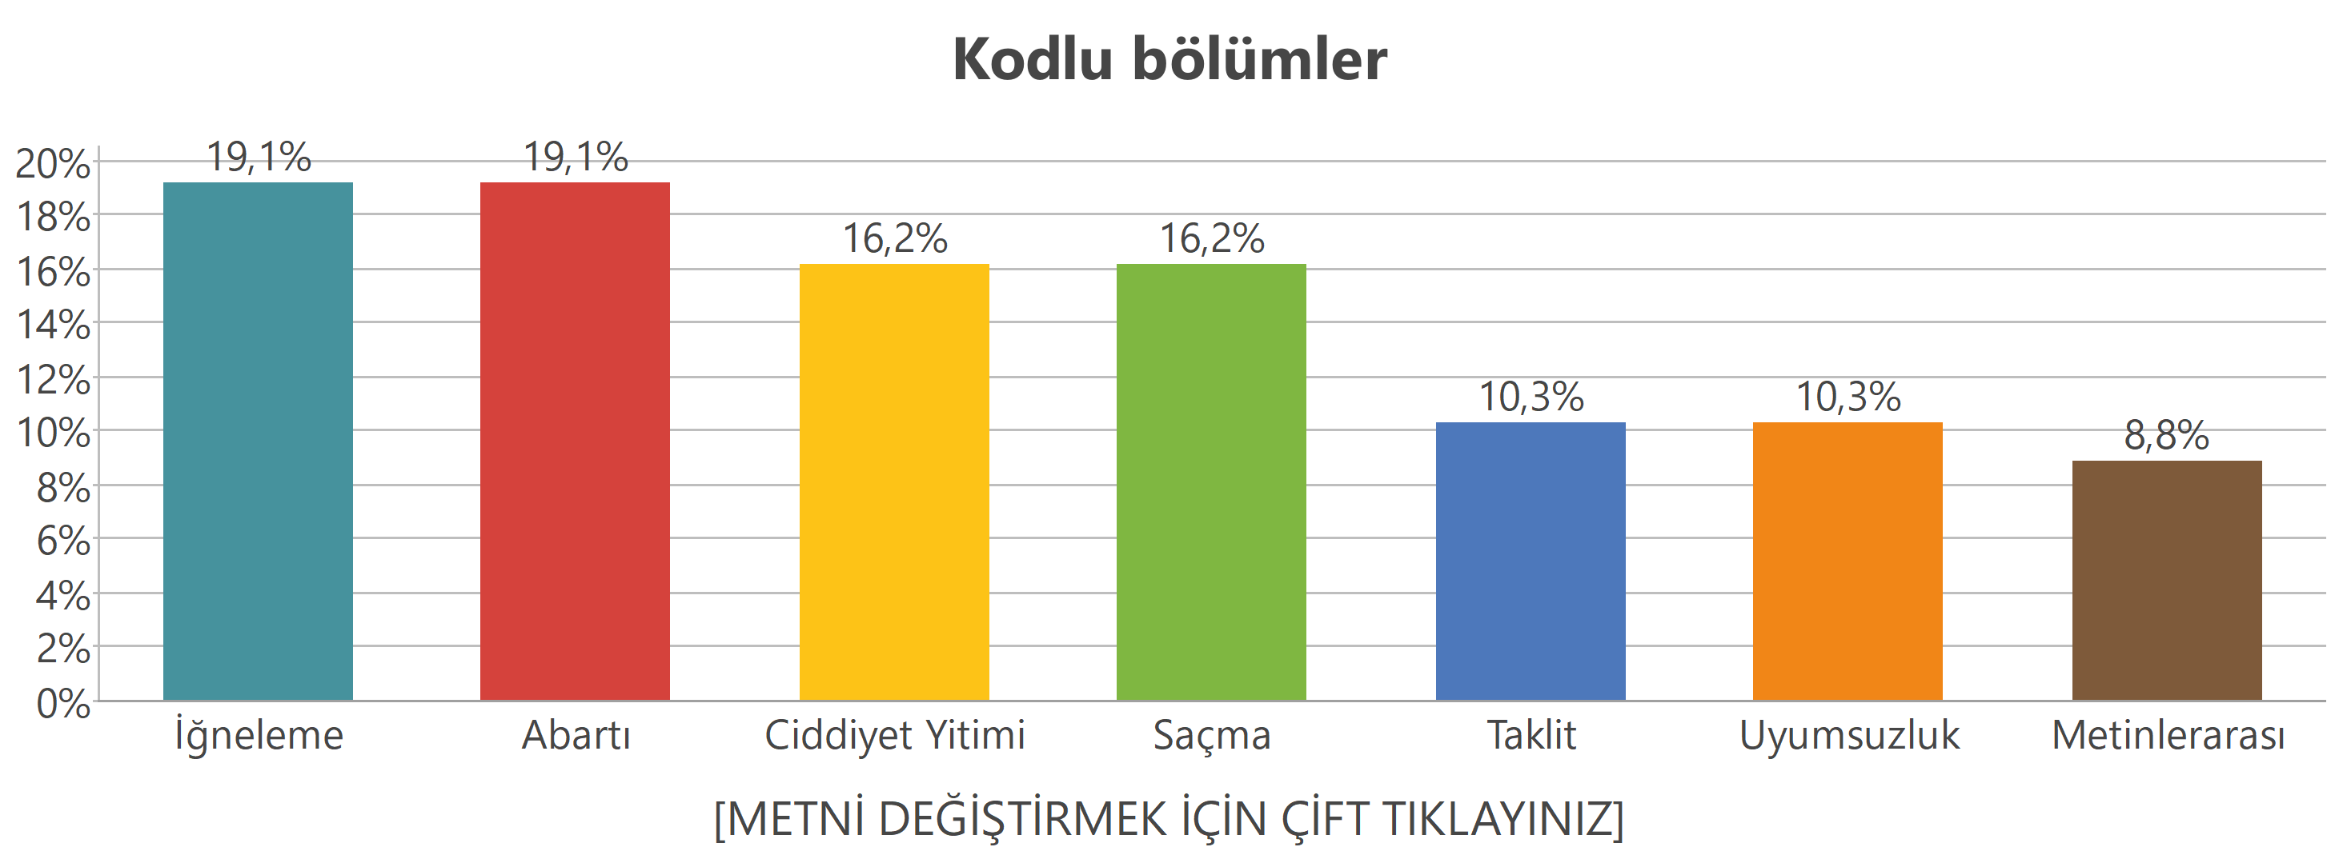
Chart 1. Chart Title
Source: GUJSS, 2019:13. The source should be centered.
(You may insert it here without altering the formatting.)
In the chart description, one blank line should be left after the title. (You may insert the text here without altering the formatting.) (You may insert the text here without altering the formatting.) (You may insert the text here without altering the formatting.) (You may insert the text here without altering the formatting.)
Condition 1: [C1] – The use of equations or formulas in the study should be carried out as shown below. No blank line should be left before or after formulas and equations. (You may insert the text here without altering the formatting.) (You may insert the text here without altering the formatting.) (You may insert the text here without altering the formatting.) (You may insert the text here without altering the formatting.) (You may insert the text here without altering the formatting.)
Q (P1) – Q(P1) ≥ X (A) (1)
Q (P2) – Q(P2) ≥ Y (B) (2)
Q (P3) – Q(P3) ≥ Z (C) (3)
Q (P4) – Q(P4) ≥ P (D) (4)
The visual below may be used as an example of the formatting requirements for formulas.
y=k^α A^β 〖(s_E R/L)〗^φ=k^α A^β 〖s_E〗^φ R^φ L^(-φ) (5)
(You may insert the text here without altering the formatting.) (You may insert the text here without altering the formatting.) (You may insert the text here without altering the formatting.) (You may insert the text here without altering the formatting.) (You may insert the text here without altering the formatting.)

Conclusion and Evaluation
The Conclusion and Evaluation heading should be written in bold and left-aligned. The interpretation/discussion section should be included here, and the recommendations provided above should be taken into consideration. This heading must not be numbered, and no alternative term should be used in its place. In the conclusion section, the general results obtained within the framework of the topic addressed in the introduction of the study should be presented and evaluated. Direct repetition of the findings presented in the previous sections should be avoided. Instead, this section should focus on providing the necessary information within the context of cause–effect and research–outcome relationships. (You may insert the text here without altering the formatting.) (You may insert the text here without altering the formatting.) (You may insert the text here without altering the formatting.) (You may insert the text here without altering the formatting.) (You may insert the text here without altering the formatting.) (You may insert the text here without altering the formatting.) (You may insert the text here without altering the formatting.) (You may insert the text here without altering the formatting.) (You may insert the text here without altering the formatting.) (You may insert the text here without altering the formatting.)

References
References should be written in 11-point font, single-spaced, and arranged alphabetically by authors’ surnames, in accordance with APA 6 (American Psychological Association) standards. For Turkish sources with multiple authors, the conjunction “ve” should be used before the surname of the last author. For foreign sources with multiple authors, “, &” should be used before the surname of the last author.
The entire reference list must be in black color and not underlined. The formatting of internet sources, including their layout, must also be corrected accordingly
For more information on electronic references, you may refer to http://www.apastyle.org/elecsource.html
For general information on all APA 6 rules, you may refer to http://www.uww.edu/documents/library/apacite.pdf
(You may insert the text here without altering the formatting.) (You may insert the text here without altering the formatting.) (You may insert the text here without altering the formatting.) (You may insert the text here without altering the formatting.) (You may insert the text here without altering the formatting.)
Acemoğlu, D. (2003). Finance and developments (5th ed.). New York: Free Press.
Akerlof, A. ve Aron, J. (2000). Limonlar için piyasa. New Jersey: Oxford Press.
De Vaney, A., Stephan, G., & Ma, Y. (Eds.). (2000). Technology and resistance. New York: Peter Lang.
Experimental economics. (1938). New York: Holt.
McIsaac, S., Aşkar, P., & Akkoyunlu, B. (2000). Computer links to the west: Experiences from Turkey. In A. de Vaney, S. Gance, & Y. Ma (Eds.), Technology and resistance (pp. 153–165). New York: Peter Lang Publishing.
Roeder, K., Howdeshell, J., Fulton, L., Lonchhead, M., Craig, K., Peterson, R., et.al. (1967). Econometric analysis. Cambridge, MA: Harvard University Press.
Türk Standartlar Enstitüsü. (1992). Toplam kalite. Ankara: Türk Standartlar Enstitüsü.
Knack, S. ve Keefer, P. (2001). Institutions and economic performance. Economics and Politics, 21, 1-8.
Eğilmez, M. (2009, 13 Ocak). Faiz kararlarının etkileri. Radikal, s. 4.
Meydan Larousse. (1998). Ekonomi dünyasına yolculuk (2. basım, cilt 15, s. 413-418). Ankara: 3B Yayıncılık.
Draude, B., & Brace, S. (1998). Assessing the impact of technology on economics: Economic perspectives. (HS Report. No. 81). Washington, DC: U.S. Department of Economics.
Tüzün, H. (2004). Motivating entrepreneurs in markets. Unpublished doctoral dissertation, Johns Hopkins University, New Delphi, IN.
Yazar Soyadı, A. B., Yazar Soyadı, C. D. ve Yazar Soyadı, E. F. (2000, 7 Mart). Makale ismi. Dergi ya da yayın ismi, Varsa sayı no, Varsa sayfa no. [Çevrim-içi: http://www.aaaaaaaa.com], Erişim tarihi: 01.01.2012.
Yazar Soyadı, A. B. (Web sayfasının yayımlandığı ya da düzenlendiği tarih). Başlık. [Çevrim-içi: http://www.aaaaaaaa.com], Erişim tarihi: 01.01.2012.
Author’s Last Name, A. B. (Date the Web page was published or updated). Title. [Available online at: http://www.aaaaaaaa.com], Retrieved on October 29, 2012.
Cynx, J., Williams, H., & Nottebohm, F. (1992). Dirty exports and environmental regulations. Proceedings of the National Academy of Economics, 89, 1372- 1375.
McDonald, J. T. (2002, Ocak). Using econometric methods in economics. Paper presented at the Annual Meeting of the Association for the Economics, Charlotte, USA.
Mead, J. V. (1992). Looking at the graphs: Investigating the markets (Report No. NCRTL-RR-92-4). East Lansing, MI: National Center for Research on Economics. (NBER Document Reproduction Service No. ED346082)
Borman, W. C., Hanson, M. A., Oppler, S. H., Pulakos, E. D., & White, L. A. (1993). Role of early warning system experience in emerging markets. Journal of Applied Economics, 78, 443-449. Retrieved October 23, 2000, from PsycARTICLES database.
Fournier, M., de Ridder, D., & Bensing, J. (1999). Optimism and adaptation to multiple sectors: What does optimism mean? Journal of Behavioral Economics, 22, 303-326. Abstract retrieved October 23, 2000, from EBSCO database.

If there is an explanation about the study, it should be stated here. You can add it here without altering the formatting.
In book and article titles (except for proper nouns), only the first letter should be capitalized
In books and articles with up to six authors, the surnames and initials of all authors should be written
Edited book
Book with no identified author
Authorship of a book chapter
If there are more than six authors, the surnames and initials of the first six authors should be written; for the remaining authors, “vd.” should be used for Turkish sources and “et al.” for English sources
Book with corporate (institutional) authorship
Two-author journal article
Newspaper
Encyclopedia
Report
Thesis / Dissertation
Online-only journal
Web page (Turkish)
Web page (English)
Conference paper published in conference proceedings
Oral conference presentation not published in proceedings
ERIC document
Electronic copy of an article retrieved from a database
Abstract obtained from an electronic database

